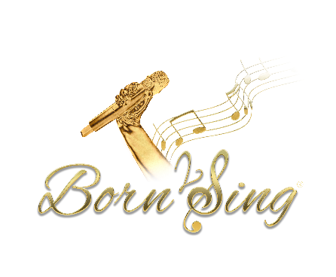

Born2Sing Fully Inclusive Performing Arts School
Terms and Conditions
Effective Date: September 2025
These Terms and Conditions govern participation in all group and private lessons provided by Born2Sing Fully Inclusive Performing Arts School, including singing, drama, and dance classes. By enrolling, all students, parents, and guardians agree to the following:

1. General
- Born2Sing is a fully inclusive performing arts school providing group and private lessons in singing, drama, and dance.
- Our mission is to provide a safe, welcoming, and supportive environment for all individuals, regardless of ability, background, or experience.

2. Enrolment & Fees
- Fees for all group and private lessons are payable monthly in advance, and must be received by the 1st of each month.
- Payments for Academy, Dance, and Musical Theatre classes are calculated as an annual amount and divided equally across 12 monthly payments (January to December), regardless of the number of lessons in any given month.
- A place in a class or private lesson is only confirmed once full payment has been received.
- Missed group or private lessons will not be refunded or carried forward unless the cancellation is initiated by Born2Sing.

3. Cancellations & Notice Period
- One full calendar months’ notice in writing is required to cancel any group or private lessons.
- Notice must be submitted via email to info@born2sing.co.uk or handed in physically with a dated signature.
- Failure to give the required notice will result in full fees being due for the following month.

4. Private Lesson Policy
- All private lessons booked within a given month must be honoured.
- Cancellations or non-attendance due to illness, holidays, or personal commitments will not be refunded or credited.
- Payment for the full month remains due, regardless of attendance.

5. Safeguarding
- Born2Sing is committed to the safety and wellbeing of all children and vulnerable adults.
- All staff members are subject to enhanced DBS checks and follow our internal safeguarding policy.
- Any safeguarding concerns will be dealt with in accordance with local authority guidelines and statutory requirements.

6. Data Protection & GDPR
- We collect and store only the personal information necessary to deliver our services (e.g. names, contact details, medical information).
- All personal data is stored securely and processed in line with the General Data Protection Regulation (GDPR).
- Information will not be shared with third parties without prior consent, unless required by law.
- You may request access to your data or ask for it to be corrected or deleted at any time.

7. Photography & Media
- We may take photographs or videos during classes and performances for promotional use (e.g. website, social media).
- Consent for media usage will be requested at the time of enrolment and can be withdrawn at any time in writing.

8. Code of Conduct
- Respectful behaviour is expected from all students, parents, and guardians at all times.
- Disruptive or inappropriate conduct may result in dismissal from the school, at the discretion of management, without refund.

9. Personal Requests
- Born2Sing are happy to support parents with letters to local authority, DLA, EHCP etc however, these letters are chargeable upon request of £20 as will be completed by Born2Sing’s director Gemma Mills

10. Changes to Terms
- Born2Sing reserves the right to amend these Terms and Conditions at any time. Updates will be communicated in writing.

Contact:
Gemma Mills – Director
Sarah Screaton - Admin
Email: info@born2sing.co.uk
Phone: 07859809350
Website: www.born2sing.co.uk

