 Wizz Kids Parent Newsletter Autumn 1 2025
The Makaton sign for this half term is Help  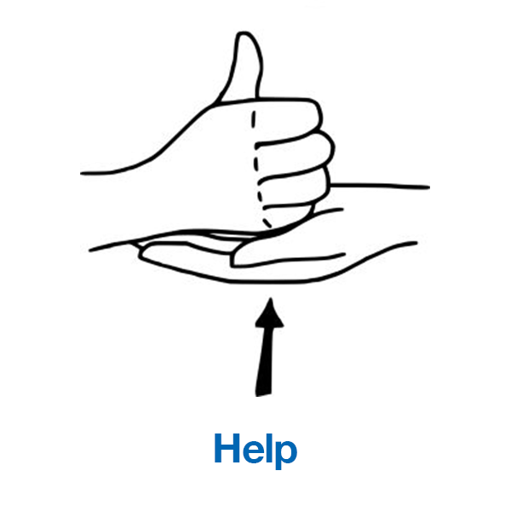 |  | REMINDER-Names in Clothes  Please ensure your child’s name is in ALL the items they bring to nursery. It makes it much easier for us to find them and put them in their tray when they take them off.  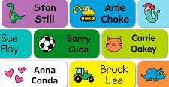
STEM-Science Experiment: Building a Bridge
What you will need-  -Playdough  -A variety of raw pasta shapes such as rigatoni, penne, fusilli, spaghetti  -A toy train | 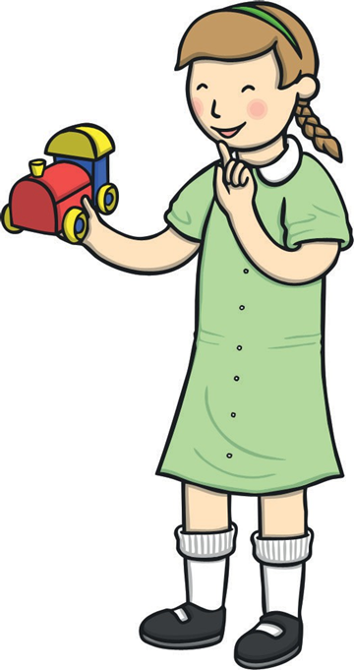 |  | Directions  Pasta and Playdough bridges  1.Explain the train is unable to pass because the bridge has fallen down  2. Can they help by building a new bridge?  3. They can only use the pasta and playdough that you have left out for them  4. Encourage them to experiment with different ways of building a bridge
News
-Amy has started with us and will be working across all the rooms.

Recipe- Autumn Leaf Biscuits

What you will need-  -112g unsalted butter (room temperature)  -1 tsp vanilla extract 1 egg  -280g plain flour 100g caster sugar 3/4 tsp -salt  -Yellow, red, green and orange food colouring  Equipment  -Two mixing bowls Wooden spoon  -Electric mixer (optional) Cling film  -Rolling pin  -Leaf cookie cutters/ knife (optional)  -Baking sheet, greased and lined  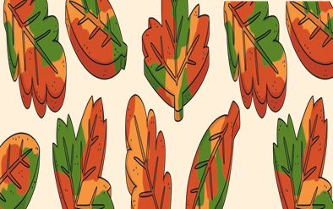 |  | Directions  1.Preheat the oven to 160ºC/325ºF.  2.Place the butter in a bowl and beat until fluffy.  -Separate the egg yolk and add to the bowl along with the sugar and vanilla extract. Bear for another two minutes.  3.In a separate bowl, mix the flour and salt together and add to the butter mixture.  4.Bring the mixture together into a ball using your hands, then divide into four smaller dough balls.  5.Use the food colouring to dye each dough ball a different colour (orange, green, yellow and red).  6.Flatten the dough balls into discs and pile them on top of each other. Then, carefully slice the pile in half and roll into two balls so that the colours swirl together.  7.Wrap the balls in cling film and put them in the fridge for one hour to chill.  8.Roll the dough out on a floured surface until it is about half a centimetre thick. Then, using your cutters/knife, cut out leaf shapes and place them on a greased and lined baking tray.  9.Make leaf ‘veins’ in the biscuits using a knife. Then, place the tray in the fridge for 30 minutes until firm.  10.Bake the biscuits in the oven for 15 minutes.  11.Allow your biscuits to cool and enjoy!
 Phonics Activity-Alliteration
Zoe the Zookeeper wanted to name some of her animals. She wants the names to start with the same letter sound as the animal. So far, she has thought of Charlie Chimp and Tommy Tiger. Can you help her think of some names for her Lion, Snake and Panda? |  |  |  | 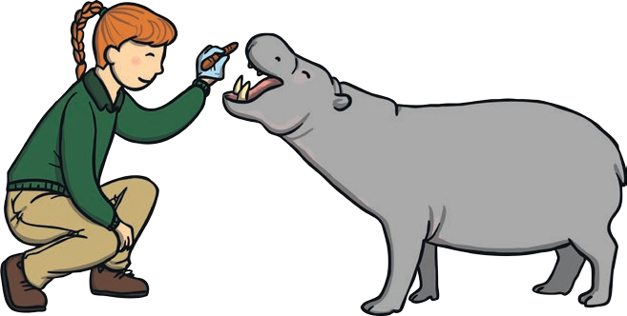
Forest School Activity-Nature Stamping
What you will need:  -Collection of autumn nuts, seeds and seed cases that have fallen from the trees  -Clay, modelling dough or salt dough  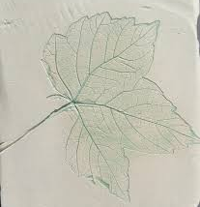 |  | Directions  1.Go on an Autumn Walk, ask if they can see any signs of Autumn.  2.Look up into the branches of trees. Can they spot any seeds, nuts or fruits on the branches?  3.Encourage them to explore the environment. Have any of these nuts or seeds fallen to the ground? Why do they think this happens? What might happen to the nuts and seeds now that they’re on the ground?  4.Collect a selection of autumn treasures, such as conkers, acorns and sycamore seeds. Take care handling these as some can be prickly.  5.Look at them and sort them, feel them, smell them. Do they make a noise? What do they feel like?  6.Using clay, modelling dough or salt dough, investigate the items further. Press your autumn treasures gently into the clay. Can you roll it? Press it? Stamp it? What do you notice? Can you make different patterns or shapes?
Apple Printing Pumpkins
What you will need-  Apple halves  Orange paint  Tray or plate for the paint  Small leaves  Black paint and small brushes or black marker |  | 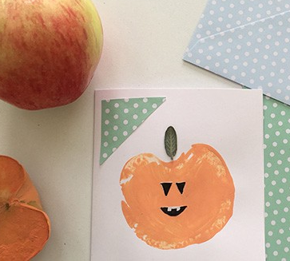
Painting with Mud
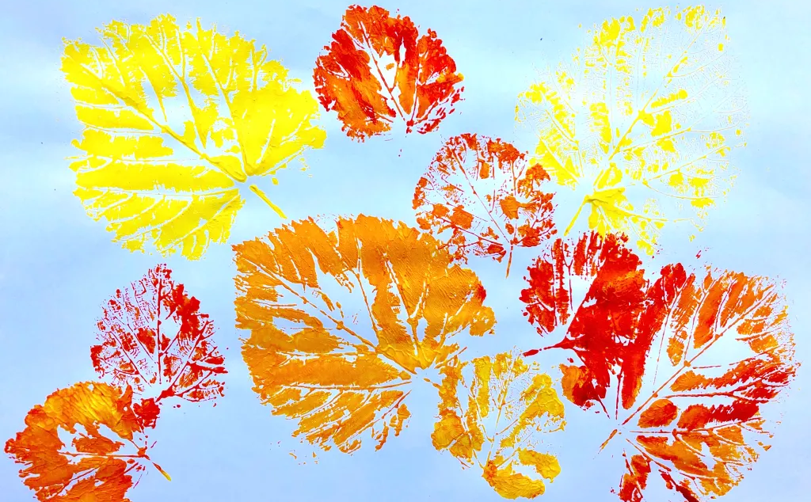 |  | What you will need-  Different sized leaves  Paint  Brushes to brush the paint onto the leaves  Plates for the paint  Paper
Here is a Rhyme to have a go at at Home  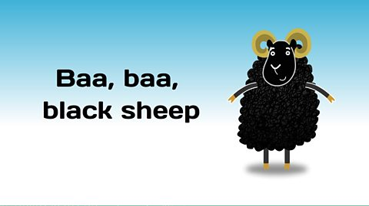 |  |  | Donations  Clean junk modelling (boxes of any size, cardboard tubes, pots, sheets of cardboard and paper of any colour), general household items, melon baller, pestle and mortar and cooking pots please. We also need board books for the new room please.  Thank you






