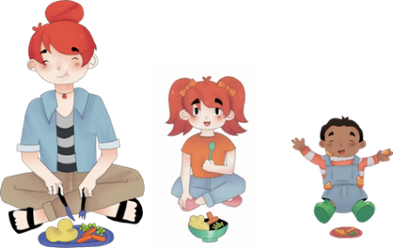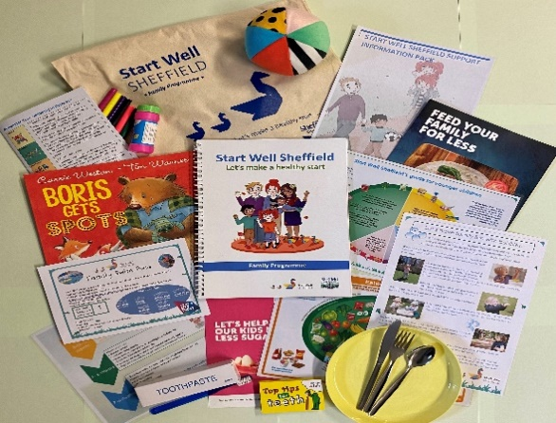

**Unsure about portion sizes?**

**Does your child experience food fussiness?**

**An exciting opportunity to come to the**

**Start Well 5 Week Family Programme**

**starting on Wednesday 5th November 9.00am-11.15 at**

**Stradbroke Community Primary School - S13 8LT**

Let’s make a healthy start: come and join us on Wednesday mornings - we will share information, tips, and easy strategies to support you and your family to think about introducing new foods, portion sizes, develop family routines, boosting your emotional wellbeing and so much more.

**Creche available on request.**

book online at (or scan QR) [www.sheffielddirectory.org.uk/start-well-sheffield](http://www.sheffielddirectory.org.uk/start-well-sheffield)

If you would like more information, please email: [adminstartwell@sheffield.gov.uk](mailto:adminstartwell@sheffield.gov.uk)

Or call the Start Well Advice Line 9am-11am every Friday 0114 2057241

**No Time for yourself? Balancing life isn’t easy!**

**And don’t forget you get all these Free resources when attending our 5 week Start Well Family programme!**

Week 1: Let’s Make a Healthy Start

Week 2: Confident Parent Confident Child

Week 3: Food for a Healthy Lifestyle

Week 4: Emotional Wellbeing

Week 5: Looking After Our Bodies/Oral Health