Our Montessori Bookshelf



The Discovery of the Americas: From Prehistory Through the Age of Columbus
By Betsy and Giulio Maestro

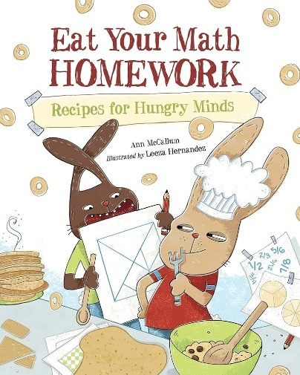

Eat Your Math Homework: Recipes for Hungry Minds
By Ann McCallum, Illustrated by Leeza Hernandez



The Five Sides of Marjorie Rice: How to Discover a Shape
By Amy Alznauer, Illustrated by Anna Bron

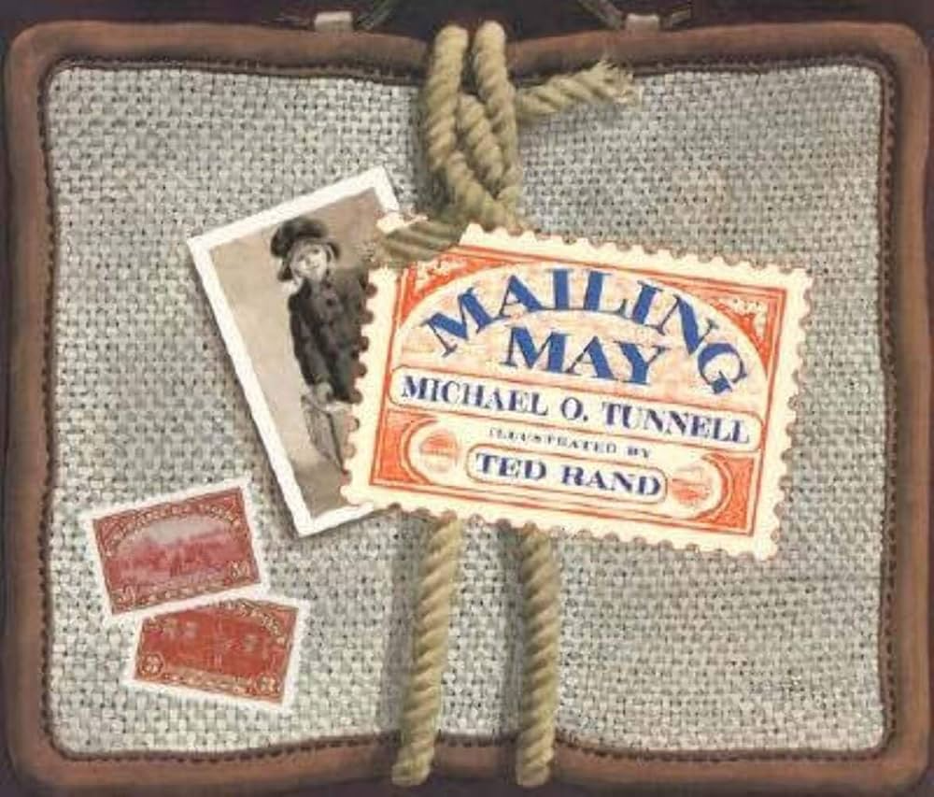

Mailing May
By Michael O. Tunnell, Illustrated by Ted Rand

