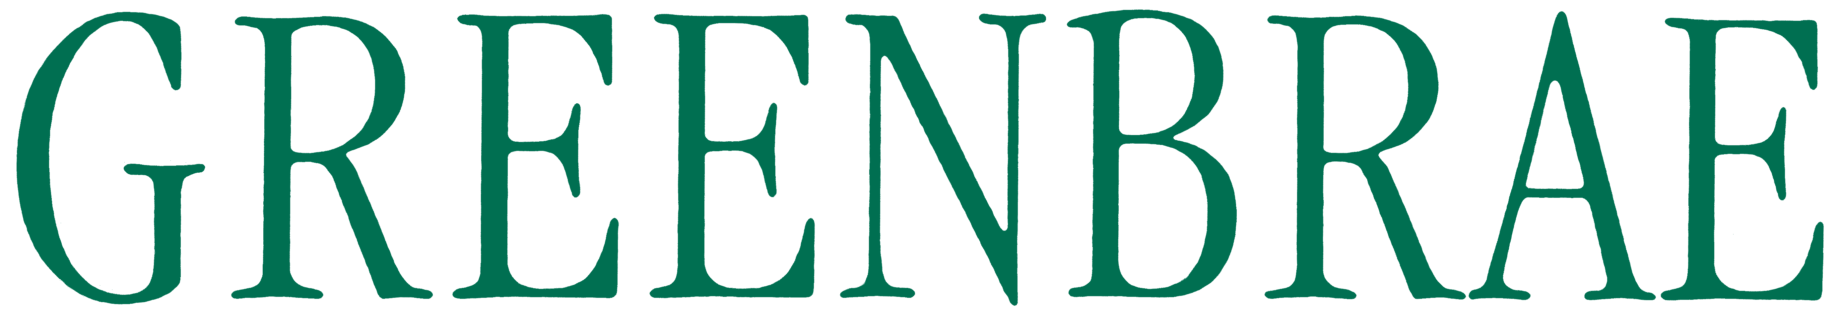

PUBLISHED BY THE GREENBRAE PROPERTY OWNERS ASSOCIATION (GPOA)
POST OFFICE BOX 383, KENTFIELD, CA 94914
info@greenbrae.org; 415-461-7338
www.greenbrae.or g


Hello Greenbrae Residents!

I am writing on behalf of the members of the GPOA’s Board of Directors. I hope you are staying safe and healthy during these difficult Covid-19 times, practicing physical distancing, and doing all you can to follow the advice, guidelines, and recommendations of our state, County, and City officials.

We encourage you to please sign up for the GPOA’s email list by visiting our new and improved website (www.greenbrae.org) and clicking on the “Join Our Mailing List” tab on our home page. The GPOA uses its email list to share news and important community information with you. The more residents that sign up for our mailing list, the better the GPOA can communicate with you. Please sign up today.

Unfortunately, due to the pandemic, we were unable to hold our Annual Meeting this year. We look forward to seeing you at next year’s meeting. We also have decided not to try to schedule our Annual Picnic in 2020 due to the uncertainty surrounding the pandemic. We are disappointed that are missing out on this fun-filled event, but we hope to be able to have a picnic in September 2021.

As volunteers, your Board members (me, Scott Sherman, David Sternberg, Noreen Kimelman, and Ryan Nelson) donate significant time to our community. During the past year, the GPOA Board continued to work with residents and elected officials from the County of Marin and the City of Larkspur regarding issues affecting our community such as safety and traffic, reviewing proposed renovations and remodels, contributing to the plans for the Sir Francis Drake Boulevard Rehabilitation Project, participating in the Kentfield Greenbrae Historical Society’s May Day, checking in on elderly residents during shelter in place, and resolving neighbor-to-neighbor issues relating to fences and obstructed views.

Please be aware that, even though we are very concerned with the presence of Covid-19 in our community, we all need to continue to work to protect ourselves, our homes, and our properties by preparing for the upcoming fire season, which will be upon us before too long. To that end, the GPOA is pleased to announce that we are partnering with the Central Marin Neighborhood Response Group (NRG) organization to help increase our community’s ability to prepare for natural disasters such as earthquakes and fires, and the power safety power shutoffs we anticipate will be forthcoming during fire season. Please review the enclosed informational sheet from the Central Marin NRG.

The GPOA hopes that each household in our community will participate in the Greenbrae Hills NRGs. Please educate yourself about the many benefits of being active in the Greenbrae Hills NRGs. Many of you have already volunteered to be leaders of one of the seven NRGs in the Greenbrae Hills. Others have stepped up and become Block Captains for an individual cluster of homes within an NRG. The GPOA thanks everyone who has already given their time to the effort to organize and prepare our community. We encourage all residents to learn and do more in connection with the Greenbrae Hills NRGs. Please also visit the Central Marin NRG website (nrgmarin.org) and the GPOA’s website (www.greenbrae.org), both of which are loaded with information to help you harden your home and prepare yourself in the event of an earthquake or fire emergency.

Please also review the enclose 2020 Landscaping Report that our long-time Board Member Scott Sherman prepared. The Landscaping Report highlights the work that your CSA 16 funds have allowed the County of Marin to do in our neighborhood, most notably the wonderful renovation and improvement of the medians on Eliseo. The Landscaping Report also provides information relating to fire safety and preparedness.

The Board encourages those residents who have not yet completed and returned the 2020-2021 Dues Coupon enclosed with this Newsletter to do so at this time. Unlike the mandatory CSA 16 parcel tax all homeowners pay, our GPOA dues are voluntary. Please contribute to the best of your ability, in the enclosed envelope with the remittance card. Your contributions are our only source of revenue and are much needed to cover the costs of the Annual Picnic, accounting, storage, and bookkeeping services, insurance, printing and distribution of newsletters, website maintenance, and some landscaping improvements. We thank you for your contributions.

We encourage all of you to continue to be safe and look forward to seeing you around the neighborhood.

Jack Valinoti
GPOA President

