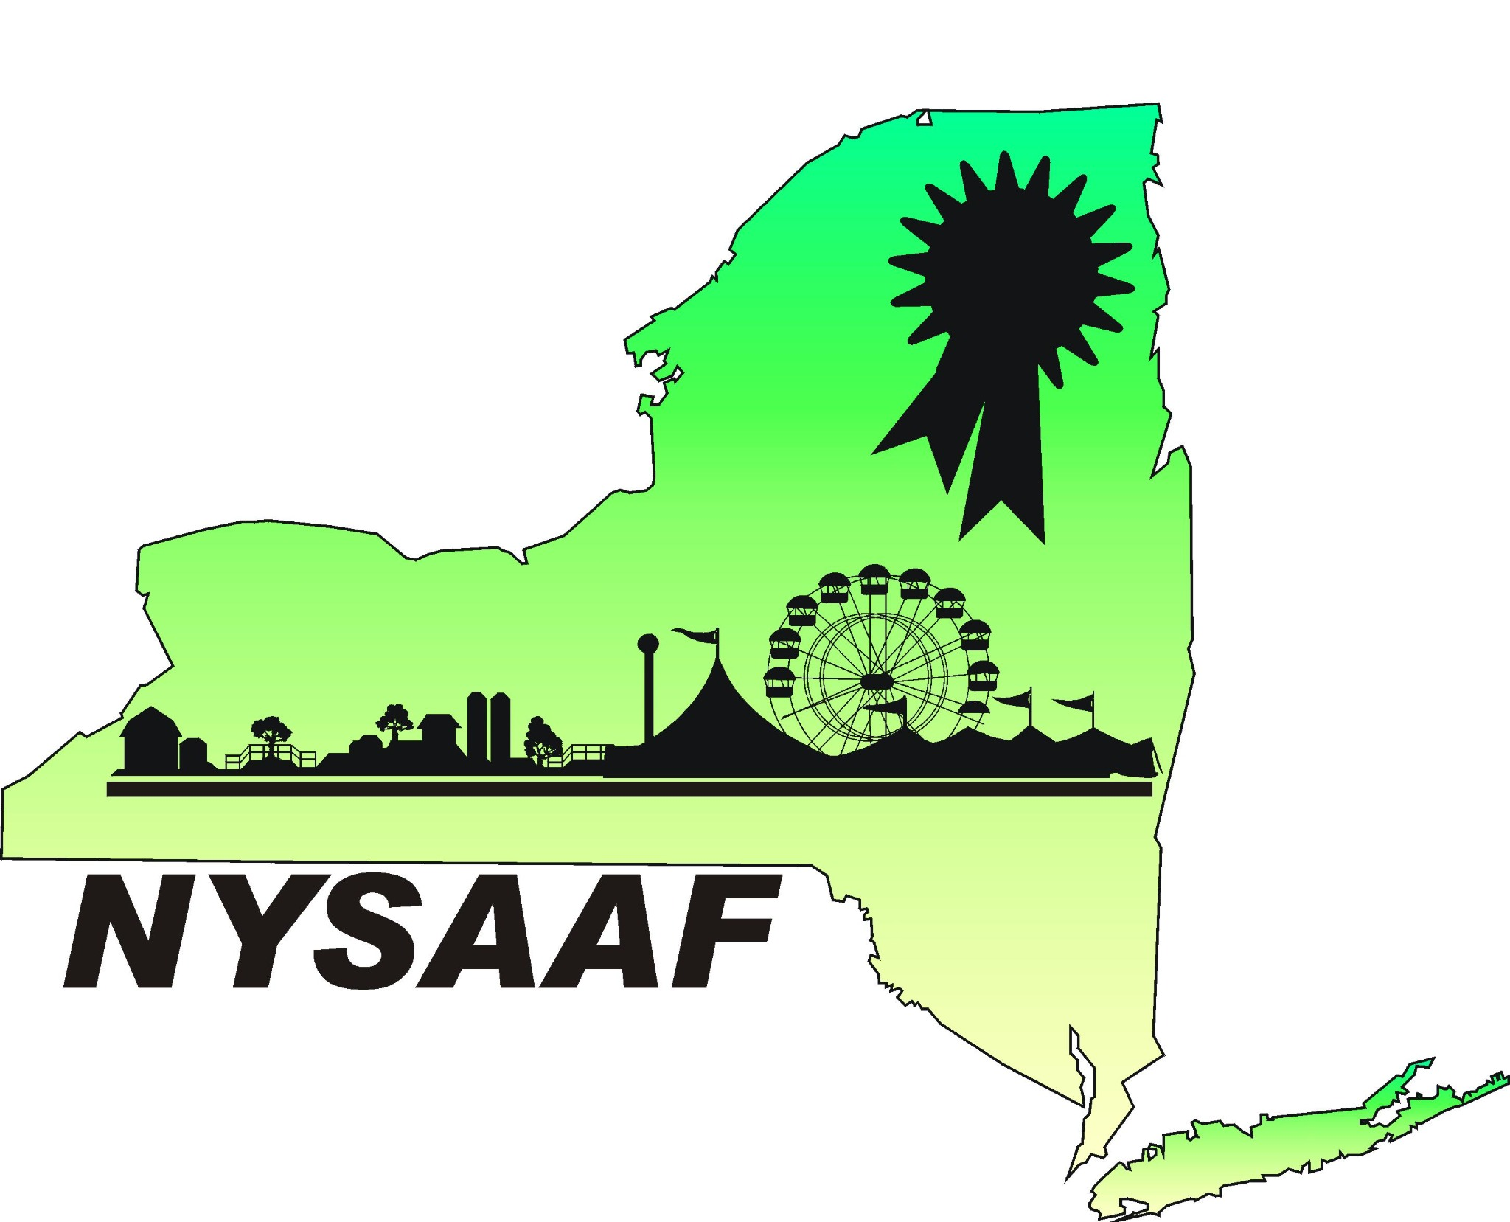
2027 ANNUAL CONVENTION
JANUARY 15–18, 2027 • PROGRAM AT A GLANCE
Education • Collaboration • Celebrating New York’s Fairs
FRIDAY | JAN 15
Opening evening
• YPI — Young Professionals Initiative
President’s Reception
SATURDAY | JAN 16
Keynote, educational sessions and peer networking
KEYNOTE SPEAKER Eddie Slowikowski
Featured keynote presentation • eddiespeak.com

BREAKOUT SESSIONS & LEARNING OPPORTUNITIES
• Modernizing Fair Navigation & More (QR Codes) | Carly Reyna, Schaghticoke Fair
• Form 990s: What You Need to Know Before You File | Kim Skoczylas, Erie County Fair
• Safety & Security Session | NYS Agriculture & Markets and Homeland Security staff
• Ag Awareness Project Panel
• NYS SIRES & Stakes
• Fair History — Part 1 | Carl Trainor
• Whole Group Networking Session
• Fair Jeopardy
• Agriculture & Markets Grants with Fair Examples | Kathryn Davis, Susan Aldger, Boonville Oneida County Fair; additional presenters being explored
• The Great NYS Fair Documentary Showing
FAIR EXCHANGE | FACILITATED CONVERSATIONS
A casual, open-house space to share ideas, ask questions and connect with experienced fair professionals.
• Vendors | Jenny Lang
• Sponsorship | Sarah Jean Hamilton
• Ag & Markets Grant Paperwork | Kathryn Davis; Pat Canaday, Altamont Fair; Kim Skoczylas, Erie County Fair
• Junior Fair Board | Rachel Lisk

Showcase and Scholarship Auction

SUNDAY | JAN 17
Leadership, fair operations and industry insights
KEYNOTE SPEAKER Jeremy Parsons
CEO, Iowa State Fair

BREAKOUT SESSIONS
• Turning Your Board into a Team | Jeremy Parsons, Iowa State Fair CEO
• Fair History — Part 2 | Carl Trainor
• Read to Win and Other IAFE Benefits | Dara Kapaski, Ulster County Fair; Sarah Jean Hamilton, Wayne County Fair
• 4-H Education at Your Fair | CCE staff from Madison, Ulster and Jefferson counties
• NYS Fair Changes from Start to Finish | Julie LaFave and NYS Fair staff
• Master Plans for Your Fairgrounds | Andy Imperati, Dutchess County Fair; Jeremy Dean, Delaware County Fair
• District Meetings

Banquet followed by Showpeople’s Party
MONDAY | JAN 18

Orientation for Executive Committee and Board of Directors

Session times, room assignments and additional convention details will be announced as planning continues.
DRAFT PROGRAM • SUBJECT TO CHANGE

