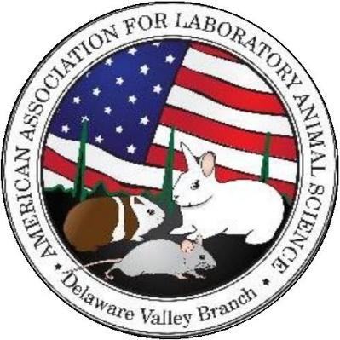
Continuing
Education
Certificate

DELAWARE VALLEY BRANCH AALAS

Non-Traditional Animal Models Speakers

- Dr. Brian Ladman, PhD, MBA, University of Delaware
- Katelyn Rogers, Neuroscience PhD Student, University of Delaware

Wednesday, October 8th, 2025
1 CEU

University of Delaware, Newark DE

The undersigned has attended this educational event and has received 1 hour of Continuing Education Units.

______________ ______________ Issued by: Kaitlyn Worthington
and Cecilia Dyer
Attendee Program Chairs

