 | Marigaux Oboe  Millenium Model  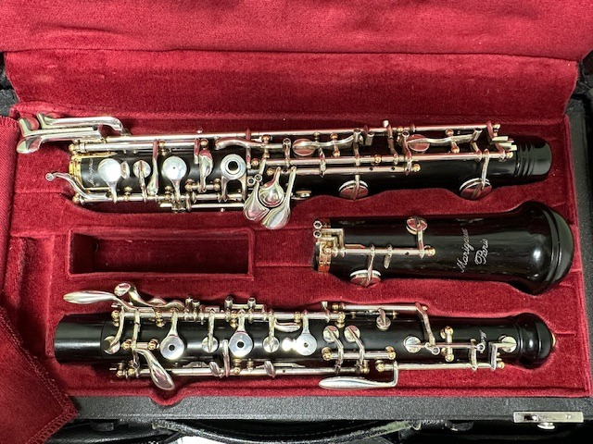  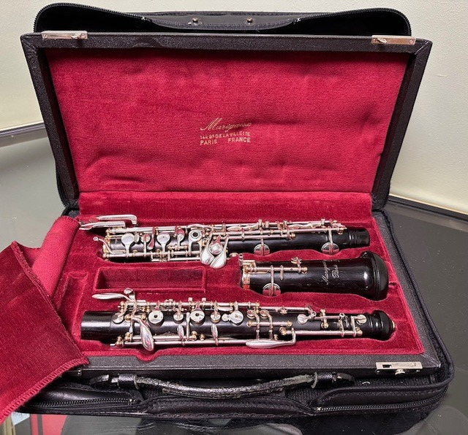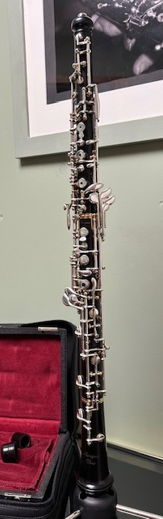
    - Marigaux Millenium Model Oboe
    - £4,900
  Secondhand Professional Oboe, thumbplate, dual system/conservatoire thumbplate, gold-plated pillars, third octave, long F, adjustable thumbrest.
  This instrument plays well and has been oiled and regulated.
  Please call
  Dominic Ball Woodwind Ltd for further details on
  01782 744405
Dominic Ball (Woodwind) Ltd
Instrument Sales
FLUTES/PICCOLO
Yamaha - 211 Flutes, beginners, silver-plated, s/hand, fully serviced - £295
Yamaha - 211sII Flute, beginners, silver plated, s/hand, full serviced - £310
Yamaha - 311 Flutes, beginners, silver plated, s/hand, fully serviced - £575
Yamaha - 381 II Flute, Silver h/joint, open hole, B foot joint, inline G, s/hand - £600
Jupiter - 507-11, Student model, silver plated, s/hand, lovely condition - £195
T J James - 10x, Student model, silver plated, s/hand, lovely condition - £195
Yamaha - Piccolos, YPC32, s/hand, lovely condition, fully serviced – £495

OBOES
Buffet - Oboe - Beginners instrument, thumb plate, s/hand - £600
Loree - Professional model, thumbplate, s/hand, serviced pending - £P.O.A.
Howarth - XM model, professional, lovely condition, s/hand, fully serviced - £ P.O.A.
Marigaux - Millenium models, professional, s/hand, both fully serviced £ P.O.A.
Howarth - S20TP Graduate oboe, fully serviced, s/hand – £ P.O.A.
Rigatout - Professional model, fully serviced, s/hand, lovely condition - £ P.O.A
Buffet - Green-line model Oboe, professional model, fully serviced - £P.O.A.
COR ANGLAIS
Loree - Pro model, thumbplate, s/hand, full service, lovely condition - £P.O.A.
Howarth - S20TP, Student Instrument, lovely condition - £P.O.A.
Howarth - S40, Intermediate, thumbplate, lovely condition, fully serviced - £P.O.A.
Buisson - Student Instrument, second hand, good condition - £P.O.A.
CLARINETS ‘Bb’
Regent - ‘Bb’, beginners instrument, s/hand, pending service - £P.O.A.
Buffet - B12 Clarinets, s/hand, beginners instrument, fully serviced - from £270
Buffet - E13 ‘Bb’ s/hand, upgrade instrument, pending service - £P.O.A.
Yamaha - Clarinet 26 II, s/hand, beginners, serviced, good condition - £295
Yamaha - Clarinet 250, s/hand, upgrade, pending service - £P.O.A.
Yamaha - Clarinet 450, s/hand, advanced, fully serviced, good condition - £560
Yamaha - Clarinet 650, s/hand, upgrade instrument, lovely condition - £P.O.A.
SAXOPHONES
Elkhart Alto - S/hand, student instrument, pending service - £265
Artimis Alto - MkII, S/hand, Beginners instrument, fully serviced - £360
Yamaha Alto - YAS25, Student instrument, s/hand, lovely condition - £P.O.A.
Yamaha Alto - 275, Upgrade instrument, s/hand, fantastic condition - £P.O.A.
Jupiter Alto - JAS-567-565, Student instrument, s/hand, fully serviced - £400
Yamaha Tenor - YTS21, student instrument, s/hand, fully serviced - £P.O.A.
Yamaha Tenor - YTS25, Student instrument, s/hand, fully serviced - £P.O.A.

ALL THE ABOVE INSTRUMENTS CARRY OUR FULL WORKSHOP GUARANTEE
PLEASE NOTE SOME INSTRUMENTS MAY NOT BE ON SITE AND IF YOU WOULD LIKE TO VIEW ANY PLEASE CALL US BEFOREHAND.
OUR INSTRUMENT SELECTIONS ARE ALWAYS CHANGING!
PLEASE CALL TEL: 01782 744405
Email: dominicball321@icloud.com

