Waltham Parish Council
New Cemetery Project & Precept Increase Survey
Please answer the following two questions.
___________________________________________________
Question 1. Are you in FAVOUR of the Parish Council going ahead with the New Cemetery Project
YES / NO
______________________________________________
Question 2. Are you in FAVOUR of the Parish Council going ahead with the New Cemetery Project if it includes a council tax precept increase of 27.5% (equivalent to £12.47 a year) for the purpose of the loan repayments?
YES / NO
Name
Address
Signed

Date

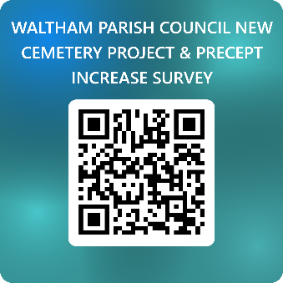
Please send this completed survey form to: clerk@walthamparishcouncil.gov.uk
Waltham Parish Council, Parish Office, Kirkgate Car Park, Kirkgate, Waltham, Grimsby, DN37 0LS
by Monday 16th February 2026
Any survey forms received after the deadline will be disregarded.

