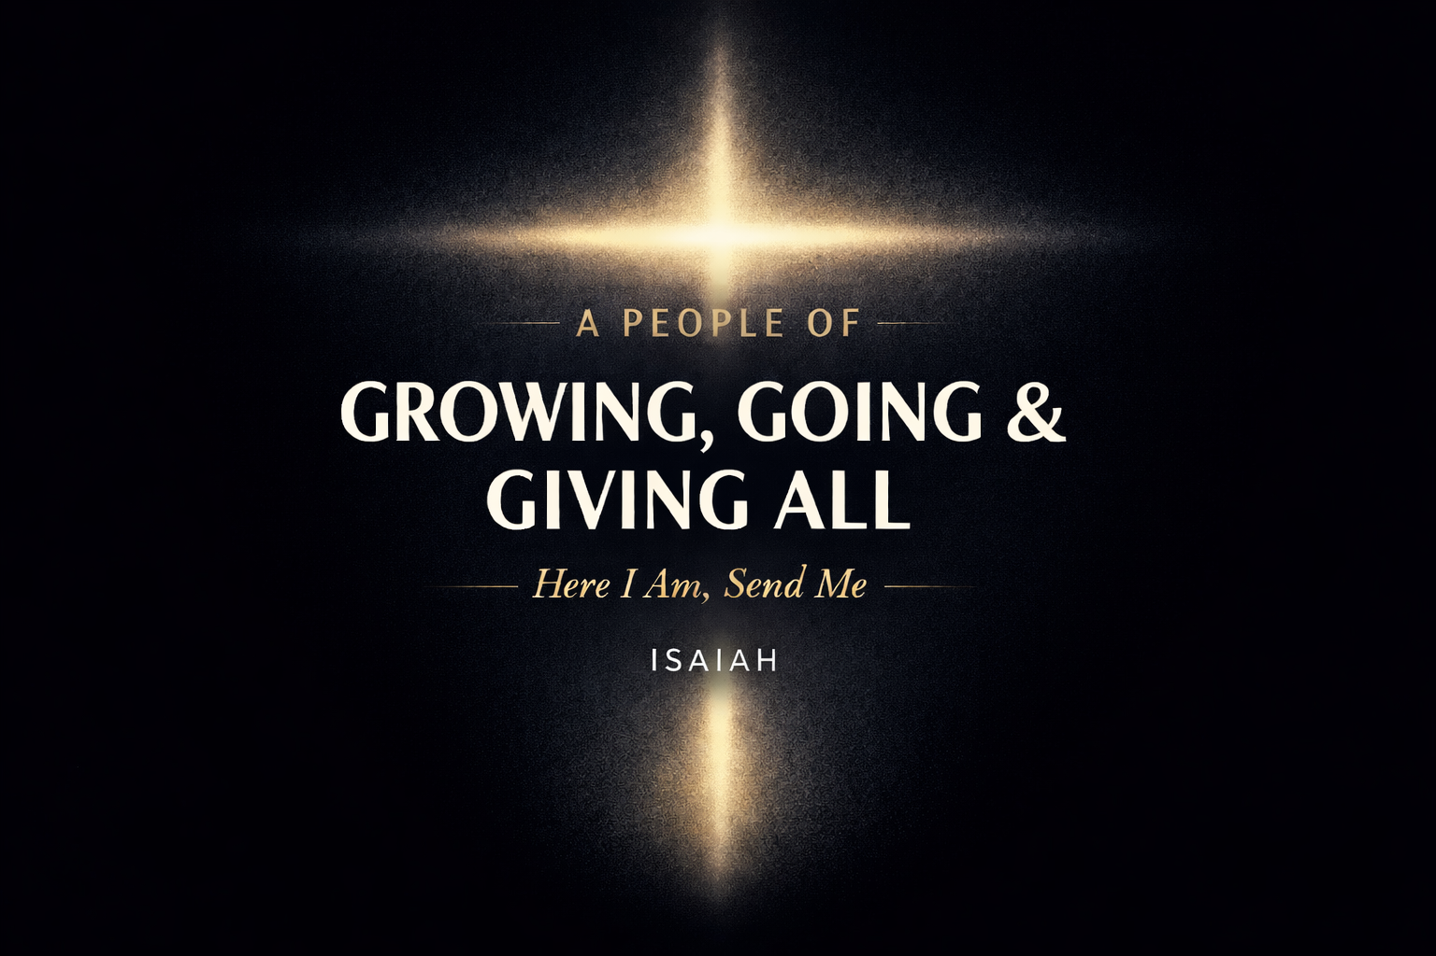
2026 REFLECT & COMMIT
What Will You Commit to This Year?

BELIEVING: Submitting to Christ’s Authority

ASSESS
☐ Yes / ☐ No Am I fully trusting Jesus with every area of my life this year?
☐ Yes / ☐ No Is there any area where fear, control, or comfort is still shaping my decisions more than Christ?

ACT
Where is God calling me to surrender control, practically, not just spiritually?

What would trusting Jesus more fully look like in my daily life this year?

GROWING: Committing to Discipleship

ASSESS
☐ Yes / ☐ No Am I intentionally pursuing spiritual growth, or am I hoping it happens accidentally?
☐ Yes / ☐ No Do I have clear rhythms for Scripture, prayer, and community?

ACT
What specific change will I make this year to ensure intentional discipleship happens?
☐ Join a DNA Group
☐ Commit to Joy Institute
☐ Establish a daily Scripture rhythm
☐ Seek spiritual accountability
☐ Other: ________________________

What talent, gift, skill, or ability does God want to refine and mature in me this year?

GOING: Living Sent

ASSESS
☐ Yes / ☐ No Am I willing to live on mission where God has placed me, or where He may lead me?
☐ Yes / ☐ No Do I see my everyday spaces (home, work, school, neighborhood) as mission fields?

ACT
Who is God placing on my heart to intentionally love, serve, or share the gospel with this year?

What is one step I can take this month to live more sent?

GIVING: Living Generously

ASSESS
☐ Yes / ☐ No Am I willing to give sacrificially, not conveniently, this year?
☐ Yes / ☐ No Do I view my time, resources, and abilities as stewardship from God?

ACT
What is God asking me to give more fully this year?
☐ Time
☐ Talent
☐ Treasure
☐ Testimony
☐ Availability
☐ Comfort

How am I willing to grow in generosity, specifically and intentionally?

Where inside the body, church life, ministry, mission, or facility, am I willing to put my gifts, skills, and abilities to use (greet, kitchen, cleaning, worship, audio/visual, other gather, grow, give, go teams)?

WHO IN THE CHURCH WILL HOLD ME ACCOUNTABLE TO THESE THINGS?

Because Jesus reigns, I will believe. Because He sends, I will go. Because He forms, I will grow. Because He is with me always, I will give all.

