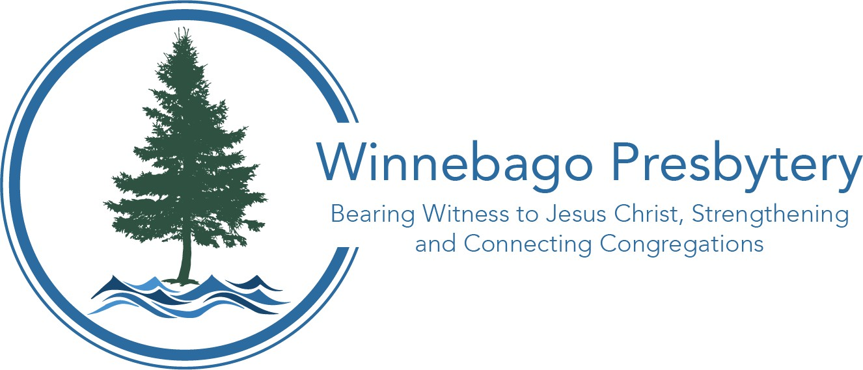
2026 Pastoral Compensation Packet
Presbytery of Winnebago Phone: (920) 886-3598
181 E. North Water St. Ste 207 Email: info@winnebagopresbytery.org
Neenah, WI 54956 Website: WinnebagoPresbytery.org

2026 Minimum Terms of Call

These apply to all new pastoral calls approved by Winnebago Presbytery.


Salary/Housing: Without a Manse - $67,100 (Full-Time) May be prorated for part-time
With a Manse - $51,547 (Full-Time) May be prorated for part-time

Medical Dues: For 2026: The Congregational Pastor’s Participation plan provides healthcare coverage at 17.5% of effective salary (provided within range of $6,500 minimum; $18,500 maximum) for just pastor. Coverage for children can be provided for a flat additional rate of $9,950, coverage for spouse can be provided for a flat additional rate of $12,250; and coverage for family (spouse and children) can be provided for a flat additional rate of $22,200. Winnebago Presbytery encourages congregations to discuss costs for coverage of pastor’s spouse and children. Pastors who were in the “Transitional Pastor’s Participation” dues plan in 2025 and are in the same position remain eligible for the TPP’s phased out coverage for pastor, spouse, and children for 37% of effective salary + 10% for income protection.

Income Protection dues: total 10% of effective salary (Pensions = 8.5%, Death & Disability=
1%, Temporary Disability = 0.5%)

*Medical and pension dues are required for ministers serving congregations. “Employer Agreements” available at www.pensions.org.

Study Leave: 2 weeks annually

Vacation: 4 weeks annually (ordained 0-14 years)
5 weeks annually (ordained 15-24 years)
6 weeks annually (ordained 25+ years)

Continuing Education: $1,500 minimum

Travel Expenses: Mileage vouchered at the current IRS rate: $0.70/mile in 2025
(2026 figure will be released in December 2025)
Professional Expenses: To be negotiated
Moving Expenses: To be negotiated

Family Medical Leave: A minimum of twelve weeks of paid family medical leave must
be included in all MoWS terms of call per G-2.0804. This includes items that had previously been addressed in Winnebago through Sick Leave and Parental Leave policies.

Sabbatical Leave: Eligible for 3 months after 5 years of continuous service to the
Congregation

Winnebago Presbytery’s Commission on Ministry will need assurance from a congregation that they are able to afford at least three years of a minimum compensation and BOP coverage (including anticipated increases for health care coverage) before approving the election of a Pastor Nominating Committee.

Complete policies found at www.winnebagopresbytery.org under “Resources”

