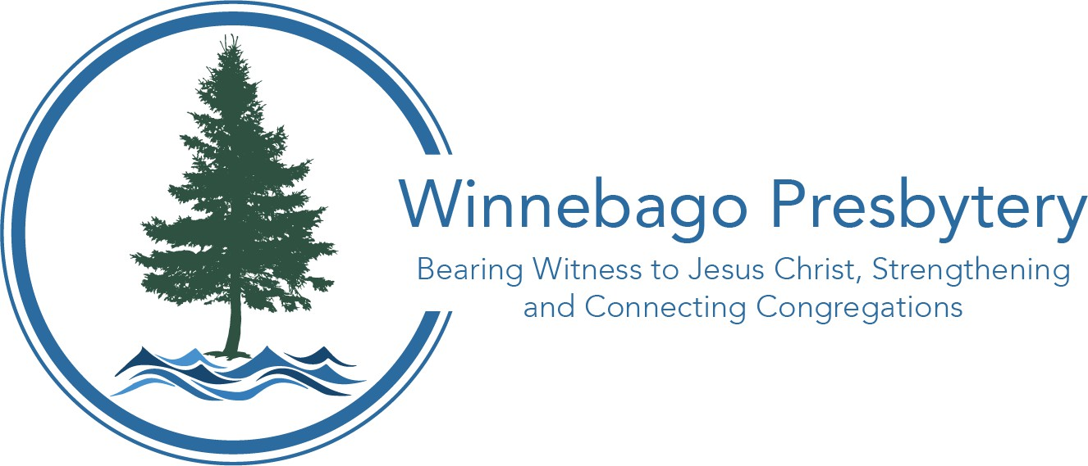
Dear Pastors, Leaders, and Clerks,
2026 Pastoral Compensation Packet
Presbytery of Winnebago Phone: (920) 886-3598
181 E. North Water St. Ste 207 Email: info@winnebagopresbytery.org
Neenah, WI 54956 Website: WinnebagoPresbytery.org

October 19, 2025


As part of the budget process, the congregation must approve changes in the terms of call (terms) for its Minister of the Word and Sacrament (MoWS). The session should review and approve the terms of contract for Ruling Elders Commissioned to a Pastoral Service (CRE). The Commission on Ministry (COM) has prepared this packet to assist you.

NOTE: Effective July 9, 2023, all terms of call for MoWS must include provision for a minimum of twelve weeks paid family medical leave (G-2.0804).

NOTE: All CRE contracts expire December 31, 2025 and shall be reviewed and renewed on an annual basis.

Determining Pastoral Compensation

- Conduct an annual performance review and recommend revised terms or contract to session. If your pastoral leadership is a ruling elder, skip to step 5, since no congregational action is required.

- Session recommends the revised terms for the minister to the congregation. If the designation of a housing allowance or manse is changed, it requires congregational action before it becomes effective. Excerpted from https://www.irs.gov/taxtopics/tc417 : “The minister’s employing organization must officially designate the allowance as a housing allowance before paying it to the minister.”

- The congregation votes on the revised terms for the minister, and the action is recorded in the congregational meeting minutes.

- The Treasurer completes a salary change for the minister or ruling elder (if covered under Board of Pensions Plan) by going to www.pensions.org and logging into “Benefits Connect” and clicking on “Manage Employee” tab. If there are questions regarding pensions, you may also contact the Board of Pensions at 1-800-773-7752 or visit their website at www.pensions.org.

- The revised terms are also reported to the Presbytery office using the terms of call report form. The reports are due March 15, 2026.

This entire packet is available at www.winnebagopresbytery.org under the “Documents & Resources” tab, titled “Pastoral Compensation Packet.”

If you have questions or need other information, feel free to contact Dave Colby, Transitional General Presbyter at dave@winnebagopresbytery.org or 651-269-9363.

