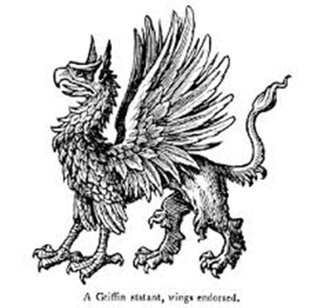
THE GRIFFIN

Starters

Pan fried garlic King prawns, garlic, parsley & warm focaccia £11
Pan fried black pudding hash, oyster mushrooms, fried egg, sage oil & whisky gravy £10
Salt & pepper squid, chilli mayonnaise £8
Loaded fries / chips, cheese & bacon £8
Halloumi fries, sweet chilli dip £8 (v)
Crispy fried buffalo cauliflower, battered, chilli coated cauliflower bites, blue cheese dip (v) no cheese dip (vg) £8
Soup of the day, toasted sourdough £9
Pies
Steak & Ale £21
Chicken & Mushroom £20
Curried butternut squash £19 (v) (vg)
All served with mash, tenderstem broccoli & gravy

Burgers

Choice of; Beef Burger, Chicken supreme, Battered fish fillet burger or Vegetarian burger (v),
served double cooked chips, homemade coleslaw & relish £17
2 toppings of your choice included,
Cheddar cheese, goat cheese, mozzarella, mushroom, bacon, fresh chilli, chilli con carne, fried onions, pulled pork
additional toppings £1.50 each

Mains

8oz 28-day aged ribeye steak, sauteed mushrooms, choice of double cooked chips or fries, choice of sauces: Chimichurri, Peppercorn or whipped garlic butter £28
Haddock & chips, double cooked chips, garden peas & tartar sauce £18
Shoulder of lamb shepherd’s pie, slow braised lamb shoulder topped with cheesy mash, seasonal vegetables £17
Wild mushroom risotto, sunblushed tomatoes & parmesan £17 (v)
Pan seared bavette steak, chimichurri sauce, sauteed kale & fries £21
Bangers & mash, onion gravy £15
BBQ pork spare ribs, whole rack, fries & homemade rainbow coleslaw £18 (gf)
Honey roasted ham, egg & chips £18

