October Birthdays
Dr. Sparkie Allison | 10-Oct
Jeanie Marsh | 10-Oct
Rev. Dr. Joni Paterson | 13-Oct
Sandra Moore | 21-Oct
Dianne Marceau | 27-Oct
Hannelore Allen-Savoie | 28-Oct
Gay Owczarski | 30-Oct
October Anniversaries

Caron, Mary & Carol Smith | 1-Oct
Shultz, Charles & Beverly Weinhold-Shultz | 7-Oct
Allen-Savoie, Hannelore & Joseph | 16-Oct
Crampton Kamukala, Hon. Rebekah & George Kamukala | 18-Oct
Owczarski, Ted & Gay | 20-Oct

SUMMARY FINANCIAL REPORT – As of AUG. 31, 2026

In an effort to keep everyone informed as the year progresses, the
Executive Board publishes this summary financial report in each
edition of the newsletter based on the Treasurer’s most recent reports. The summary report of Income and Expenses through the end of August, 2026 (the seventh month of our church finance year) is as follows:

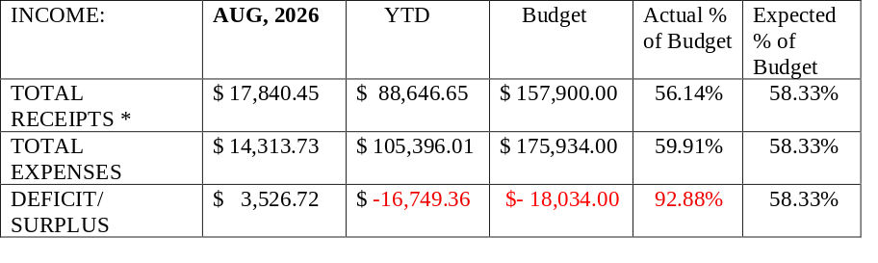
As you can see, we ended the month of August was a very good month with receipts exceeding expenses. For the year to date, receipts remain slightly below expectations and expenses are greater than projected for this point in our finance year. Much of the surplus was due to the great turnout for Pastor Barbara’s retirement service, but with your assistance we might continue to break even or close to it in the remaining 5 months of the finance year. As always, we thank everyone for your continued week-to-week support.

The amount entered for Receipts does not include unplanned transfers from our savings or other accounts needed to pay bills from month-to-month.

THANK YOU FROM PASTOR BARBARA:
Thank you so very much for such a special day on August 30, which marked my final Sunday as pastor of the church. Thank you to Frank and the choir for providing two special anthems during worship. Thank you to Judy and everyone who planned, provided food and hosted the special coffee hour reception after the service.
I appreciate the monetary gift very much. I love the special throw blanket and wall hanging of the church folks gathered at the peace pole. And my heart is filled by the memories and well wishes expressed in separate cards and special journal that was coordinated by Cheryl. I’m leaving many names of people out who did planning and more because you did it all without my knowing! Just please be assured I am so very grateful to all.
It was a day I will always remember, just as you will always be in my heart and prayers. May God bless you as the church moves forward in strength, faith and hope.

Newsletter October 2026

Foster Memorial Church, UCC
1791 Wilbraham Road
Springfield, Massachusetts 01119

Recorded Sunday morning worship:
On our website, Facebook and YOUTUBE

Office Telephone (413) 782-2112

Church Office Email: fostermemorial@msn.com
Pastor ’s Email : fostermemorialpastor@outlook.com
Prayer Chain Email : FMCPrayerChain@outlook.com
Website: www.fostermemorial.org
Facebook: Foster Memorial Church

Choir Director & Organist: Frank Jackson
Administrative Assistant: Heidi Mayfield
Childcare: Hayley LaTaille

OUR PURPOSE STATEMENT
We are a joyful, welcoming, inclusive, and supportive community of Christ followers, eager to shine God's love by connecting people through partnerships and service that foster peace and hope in our neighborhood,
wider community and world.

WE ARE AN OPEN AND AFFIRMING CHURCH &
A JUST PEACE CHUCH


From the Moderator:

The energy that filled our church on August 30, 2026, for Pastor Barbara’s farewell service lingers, along with a sense of calm and optimism. The Friday after, I attended my first quarter auction and was delighted to find a similar atmosphere. (If you haven’t yet come to a quarter auction, I highly recommend you do so and bring a friend!) Our missions continue during this time of transition, with the upcoming Crop Walk, Blessing of the Animals, and more to come this Fall.

Your executive board and teams are hard at work, and our church search profile remains active with the UCC. To view our profile, and share on social media, please use this link: http://oppsearch.ucc.org/id/7192.

One candidate who interviewed with us chose to serve a different church, and left us with these comments “I was greatly impressed with the warmth and preparation ... It was a wonderful gathering and introduction to Foster Memorial ... where God's abiding love is evident everywhere”.

It is not unusual for a church to spend months searching for an interim pastor; we are blessed to have continued pulpit coverage by our retired clergy members, coordinated by Peter Wells.

Pastoral care is being provided by Bob Loesch.

Please contact me or any of the interim search team or executive board if you have any questions or concerns as we move forward together.

All members are also welcome to attend regular board meetings, held on the 2nd Wednesday of each month.
Amy Pawle (email: amy.pawle@gmail.com)
Alice Kempf (email: alicek@kvreteam.com)
Mary Caron (email: mebbohn@aol.com)
Bob Loesch (email: rkloesch@aol.com)
Bruce Moore
Kevin Withers

Please note: This month, part of our Quarter Auction proceeds will be donated to the Crop Walk!

MONTHLY QUARTER AUCTION: Friday, October 2
Doors open at 6 PM, and the auction begins at 7 PM. Everyone is invited to bring quarters and friends for a fun evening and a chance to win some great items from our vendors! This month, a portion of our proceeds will go to: Greater Springfield Crop Hunger Walk. Admission: $5.00 for two paddles. Bring a non- perishable food item for a FREE third paddle! Dinner food and snacks will be available for purchase.
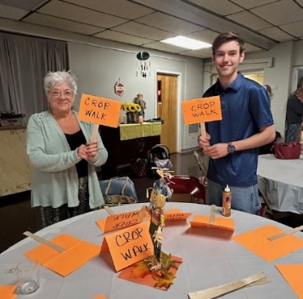

MEN’S BREAKFAST: Saturday, October 3
All men of the church are invited to join on the first Saturday of the month for breakfast at a local restaurant. We meet at 8:20 AM in the front parking lot. All are welcome and invited to bring friends!

Fundraiser: Texas Roadhouse :
Sunday, Oct. 4 from 11:30AM-3PM

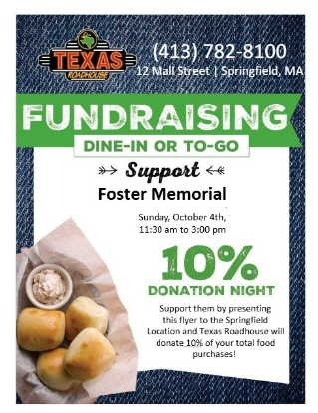


October
Friday, October 2: Quarter Auction: Doors open 6 PM
Saturday, October 3: Men’s Breakfast: 8:20 AM
Front parking lot
Sunday, October 4: Texas Roadhouse Fundraiser
Sunday, October 4: Crop Walk for Hunger 2 pm at Trinity UMC
Saturday, October 10: Food Drive for Open Pantry: 1-3 pm
Sunday, October 11: Just Peace Team Meeting
Sunday, October 18: Grace Baptist Anniversary Celebration
12 – 4 pm
Saturday, October 24: Fosterians Gathering: 1-3 pm
Sunday, October 25: Blessing of the Animals 2 pm
Trick or Treat for UNICEF 10 am


November:
Sunday, November 1: Texas Roadhouse Fundraiser
Saturday, November 7: Men’s Club meet at 8:20 AM
Friday, November 13: Quarter Auction: Doors open 6 PM
Saturday, November 14: Drive Through 1-3 PM
Sunday, November 15: Pancake Brunch for Tenzin: CE Hosting
Sunday, November 22: Thanksgiving/Stewardship Sunday
Sunday, November 29: Prayers for the Nation: 4 PM

Ongoing:

Worship Sundays at 10 AM with God Time (church school) and

childcare provided each Sunday

Waving for Peace: Sunday after worship & Mondays 3:30 – 4 PM
Monthly prep for Fishes and Loaves dinner: Thursday before the third Friday. Serving Dinner on the Third Friday at South Church at 4:30 PM

October Drive Through: Saturday, October 10: 1-3 PM
We collect food for Open Pantry on the second Saturday of each month. This month, we are also collecting donations of pet toys and food in honor of our Blessing of the Animals event on October 25 (see separate article)

Fosterian Gathering: Saturday, October 24: 1:00- 3:00 PM
Fun gathering for the women of Foster and their women guests!!
It’s a Halloween theme and costumes or silly fun apparel are encouraged!! We are also looking for ladies to bring a Halloween themed snack or baked good. Please rsvp to Lori or Judy by Sunday, Oct. 18.

ANNUAL BLESSING OF THE PETS: Sun. Oct 25 at 2PM
Join us for this special event! All pets must be on a leash or in a carrier. Photos of pets also welcome! Everyone is also invited to bring pet food, toys and supplies to be donated to Thomas J. O’Connor Animal Control and Adoption Center. New or gently used towels are especially needed. Everyone is welcome, no matter if you bring pets or just want to enjoy the event. In case of rain, this will be a Drive Through Event in our back parking lot!”

TRICK OR TREAT FOR UNICEF
During worship on Sunday, October 25 everyone is invited to bring donations (coins or bills) for “Trick or Treat for UNICEF.” All children and youth are invited to dress in Halloween costumes.

