Foster Memorial Church, UCC
1791 Wilbraham Road
Springfield, Massachusetts 01119

Recorded Sunday morning worship:
On our website, Facebook and YOUTUBE

Office Telephone (413) 782-2112
Email: fostermemorial@msn.com;
Pastor’s Email: revschenk@comcast.net
Website: www.fostermemorial.org
Facebook: Foster Memorial Church

Minister: Rev. Barbara Schenk
Choir Director & Organist: Frank Jackson
Admin. Assistant: Heidi Mayfield
Nursery Childcare provider: Hayley LaTaille

OUR PURPOSE STATEMENT
We are a joyful, welcoming, inclusive, and supportive community of Christ followers, eager to shine God's love by connecting people through partnerships and service that foster peace and hope in our neighborhood, wider community, and world.

WE ARE AN OPEN AND AFFIRMING CHURCH
We strive to be a congregation that welcomes and embraces all persons of all sexual orientations, including gay, lesbian, bisexual and transgender and persons of all marital status, age, mental and physical health and ability, racial and cultural identity or background, and educational and socioeconomic status.

WE ARE A JUST PEACE CHURCH
(see our complete JUST PEACE DECLARATION
on our website at fostermmeorial.org)

July 2026: Foster Memorial Church

Dear friends,

Earlier in June, a letter was sent to the members and friends of the church, informing everyone about my upcoming resignation, effective August 31. This will mark almost 18 years as pastor of this church. I am also planning to retire after almost 40 years of serving churches in Maine, New York, CT and MA.

From now until the end of August, I will be working with a team of volunteers to assure that things I have been doing are passed on for others to learn and carry out in this “in between time.” We are also finding people to step in to help with things my husband Keith has taken on, including our sound systems, sprinklers and more.

Amy Pawle, our church moderator, and other members of our church leadership are already working with our Area Minister on next steps concerning pastoral leadership for the church. You will be hearing more from Amy about this soon. If you would like to contact Amy directly, her email address is amy.pawle@gmail.com

I thank you all for the privilege of serving among you. You are an amazing congregation. You are so faith-filled, and you have a strong sense of identity as a Just Peace church, an Open and Affirming church and a member church of the United Church of Christ. Your next pastor will be blessed by you and your devotion to serve God through so many ways.

Keith and I will miss you and we wish you all God’s blessings as you move forward together in Jesus’ name.

Blessings,
Barbara

SUMMER SCHEDULE FOR WORSHIP
Our worship services will be held at 9:30 AM for the months of July and August. Please help us spread the word!

Calendar
July
Sunday, July 5: Worship Moves to 9:30 AM
Sunday, July 5 Texas Roadhouse Fundraiser
Saturday, July 11: Food Drive: 1-3 PM
Sunday, July 12: Just Peace Team Meeting: all welcome
Sunday, July 26: Prayers for the Nation: 4 PM

August
Saturday, August 1: Men’s Breakfast: 8:20 AM
Sunday, August 2: Texas Roadhouse Fundraiser
11:30 AM – 3 PM
Saturday, August 8: Food Drive Through: 1-3 PM
Sunday, August 9: 12th Anniversary of Waving for Peace
Ministry
Sunday, August 30: Pastor Barbara’s final service
**
Sundays: Waving for Peace after coffee hour
Mondays: Waving for Peace from 3:30- 4 PM



TEXAS ROADHOUSE FUNDRAISER
Present this to your server on July 5 (or take a photo)
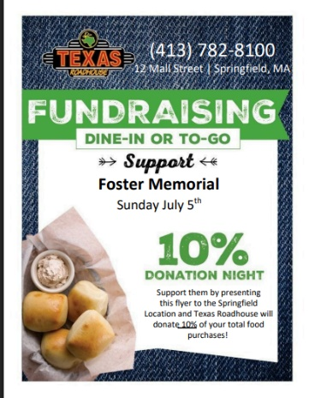

MEN’S BREAKFAST: PLEASE NOTE
The next Men’s Breakfast will be held on Sunday, August 1 because of the July 4th holiday weekend.

JULY SPECIAL RAFFLE
Throughout the month of July
We are going to hold a special raffle throughout July to help fund our Loaves and Fishes ministry. Each month, volunteers prep and serve dinner for the guests at Open Pantry’s Loaves and Fishes at South Congregational Church in Springfield. Thank you for your support!!


SCHOOL SUPPLIES FOR REBECCA JOHNSON
We will be collecting school supplies through August 9. Needed: Everything from pencils to backpacks, notebooks, glue sticks, crayons, colored pencils, two and four pocket folders and more! Thanks to everyone for your support!

MONTHLY FOOD DRIVE
Saturday, July 11 from 1-3 PM in the back parking lot
All non-perishable food collected is donated to The Open Pantry. Our focus foods are rice and pasta. We will also be collecting school supplies for Rebecca Johnson school.

JUST PEACE TEAM MEETING: SUNDAY, JULY 12
FOLLOWING WORSHIP
This meeting is open to everyone.

FOSTER SOFTBALL SCHEDULE
The Inter-Church Softball League's season has begun!
Website https://www.interchurchsoftball.com/
There is also a Facebook page: https://www.facebook.com/WesternMAChurchSoftball
Everyone is always welcome to attend the games! Go, team!

SAVE THE DATES

GARDEN “SOCIAL”
Our Garden Angels, Judy and Gerri, are going to host a “Garden Social” for everyone. The date for this event will be announced soon.


WAVING FOR PEACE ANNIVERSARY
We will mark the 12th Anniversary of our Waving for Peace ministry on Sunday, August 9 following worship.


PASTOR BARBARA’S FINAL SERVICE AND RECEPTON:
SUNDAY, AUGUST 30
Please save the date and spread the word. The reception will follow our 9:30 AM worship service.


 July Birthdays

2 – Bev Aitken, Dianne Hay
17 – Eric Sutter
25 - John Pappanikou
29 – Stephen Turner
29 – Susan Tarantino
30 - Peter Wells Anniversaries

Wilberth Condega Ortiz & Laura Bisbee Condega: July 1

SUMMARY FINANCIAL REPORT – As of May 2026
In an effort to keep everyone informed as the year progresses, the Executive Board voted to publish a summary financial report in each edition of the Chronicle based on the Treasurer’s most recent report. The summary report of Income and Expenses as of the end of May,2025 (the third month of our church finance year), is as follows:
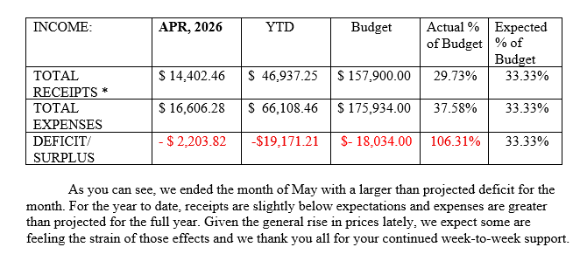
- The amount entered for Receipts does not include unplanned transfers from our savings or other accounts needed to pay bills from month-to-month.
MAY QUARTER AUCTION: THANK YOU
Thank you to Lori, our coordinator, and to everyone who helped with our June Quarter Auction. We raised nearly $1000.00 for the church, and an additional financial donation went to The Gray House, along with donations of toothpaste, toothbrushes and soap.

VENDOR FAIR/YARD SALE: THANK YOU
Thank you to everyone who helped to make our recent Vendor Fair/Yard Sale a success! Grateful thanks to Lori and Judy, our vendors, all volunteers and everyone who came out to support the event! We are so grateful!

SEPTEMBER QUARTER AUCTION
Our next Quarter Auction will be held on Friday,
September 4. Part of our proceeds will go to help fund a special program at Rebecca Johnson, our partner school. Please save the date and spread the word! Speak to Lori LaTaille if you would like to help with this event.

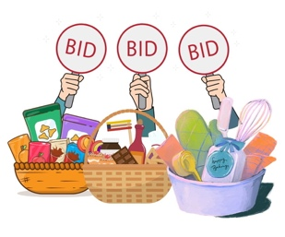
BIG Y GIFT CARDS
See Jeanie Marsh or Alice Kempf to order Big Y gift cards. This is an ongoing fundraiser for the church. Thanks for your support!

