Foster Memorial Church, UCC
1791 Wilbraham Road
Springfield, Massachusetts 01119

Recorded Sunday morning worship:
On our website, Facebook and YOUTUBE

Office Telephone (413) 782-2112
Email: fostermemorial@msn.com;
Pastor’s Email: revschenk@comcast.net
Website: www.fostermemorial.org
Facebook: Foster Memorial Church

Minister: Rev. Barbara Schenk
Choir Director & Organist: Frank Jackson
Admin. Assistant: Heidi Mayfield
Childcare: Hayley LaTaille

OUR PURPOSE STATEMENT
We are a joyful, welcoming, inclusive, and supportive community of Christ followers, eager to shine God's love by connecting people through partnerships and service that foster peace and hope in our neighborhood, wider community and world.

WE ARE AN OPEN AND AFFIRMING CHURCH
We strive to be a congregation that welcomes and embraces all persons of all sexual orientations, including gay, lesbian, bisexual and transgender and persons of all marital status, age, mental and physical health and ability, racial and cultural identity or background, and educational and socioeconomic status.

WE ARE A JUST PEACE CHURCH
(see our complete JUST PEACE DECLARATION
on our website at fostermmeorial.org)

January 2026: Foster Memorial Church, UCC

Dear friends,

When the song of the angels is stilled,
when the star in the sky is gone,
when the kings and princes are home,
when the shepherds are back with their flocks,
the work of Christmas begins:
to find the lost,
to heal the broken,
to feed the hungry,
to release the prisoner,
to rebuild the nations,
to bring peace among the people
--Howard Thurman

As I write this, we are heading into the 12 Days of Christmas, the season of Christmastide. At the end of the twelve days, we begin the season of Epiphany. On Epiphany Sunday, (celebrated January 4 this year) we re-experience the story of the Magi’s visit to the Christ Child and his mother, Mary.

As the season continues, our focus is on the early times of Jesus’ ministry on earth, his teachings, healings, and miracles. Themes for this season include God’s light and AHA! experiences of transformation. The liturgical color for Epiphany is white.

During this holy season, may Jesus, the Light of the World, be revealed to us and through us.
Blessings,
Barbara


BUDGET PRESENTATION FOR 2026/SPECIAL MEETING
We will hold an Informational Meeting about the Budget Proposed for 2026 on Sunday, January 18, following our worship service.

NOTICE OF ANNUAL MEETING: SUNDAY, JAN. 25
Our church’s Annual Meeting will be held on Sunday, January 25 after worship. There will be a special soup luncheon, provided by the Deacons and friends. A free will offering will be collected; all proceeds will help to fund our dinner ministry for Loaves and Fishes. Although voting is limited to church members, we also encourage church friends to attend. The meeting will include the acceptance of annual reports, the election of officers and board and committee members, discussion and voting on the 2026 budget and other business that may be brought before the meeting. Your participation is both needed and appreciated. Please plan to attend.

REPORTS FOR ANNUAL REPORT
All written reports should be completed by January 7. Please email reports to Pastor Barbara. Thank you.

PLEDGES FOR 2026
Thank you to everyone who has already made a financial pledge to the church. All pledges are a blessing and greatly appreciated. Pledge letters and cards are available in the entryway to the sanctuary. Boxed envelopes are in the hallway next to our Friendship Room. Please sign the clipboard if you do not see your box of envelopes and would like to receive them. Thank you for your support!



Saturday, January 3: Men’s Breakfast: 8:20 AM
Sunday, January 4: Epiphany Sunday/Texas Roadhouse
Sunday, January 4: Texas Roadhouse Fundraiser
Saturday, January 10: Food Drive for Open Pantry 1-3 PM

Sunday, January 11: Just Peace Meeting after worship

Sunday, January 18: Martin Luther King Jr. Sunday/

Blankets Offering

Sunday, January 18: Budget Proposal Meeting 11 AM

Sunday, January 25: Annual Meeting/Soup Luncheon

Ongoing: God Time, nursery care Sundays at 10:00 AM

Waving for Peace, Sundays at 11:30 &

Mondays from 3:30-4 PM

MEN’S BREAKFAST
Men's Breakfast will be held on Saturday, January 3. All men are invited to meet in the church’s front parking lot to leave for breakfast at 8:30 AM.


BIG Y GIFT CARDS
See Jeanie Marsh to order Big Y gift cards. This is an ongoing fundraiser for the church. Thanks for your support!

JANUARY FOOD DRIVE
This month’s Drive will be held on Saturday, January 10: 1-3 PM in our back parking lot. We will be collecting Food for Open Pantry. Our focus foods: Soup, pasta and rice.


JUST PEACE TEAM MEETING
Our Just Peace team has an open meeting on the second Sunday of each month, following worship. All are welcome.

COLLECTION OF JACKETS AND COATS
We will continue to collect new and gently worn coats and jackets for all ages throughout this month. All donations will be distributed through Rebecca Johnson School, Gray House and Loaves and Fishes. Thank you for your support!



STAR WORDS
Everyone is welcome to receive a Star Word for the year ahead. We will be distributing them throughout this month on Sunday mornings. These are words we are invited to reflect on during the year to come. You can contact Pastor Barbara to select star word for you if you are unable to come to worship. Or, you are welcome to select a word from the stars below.

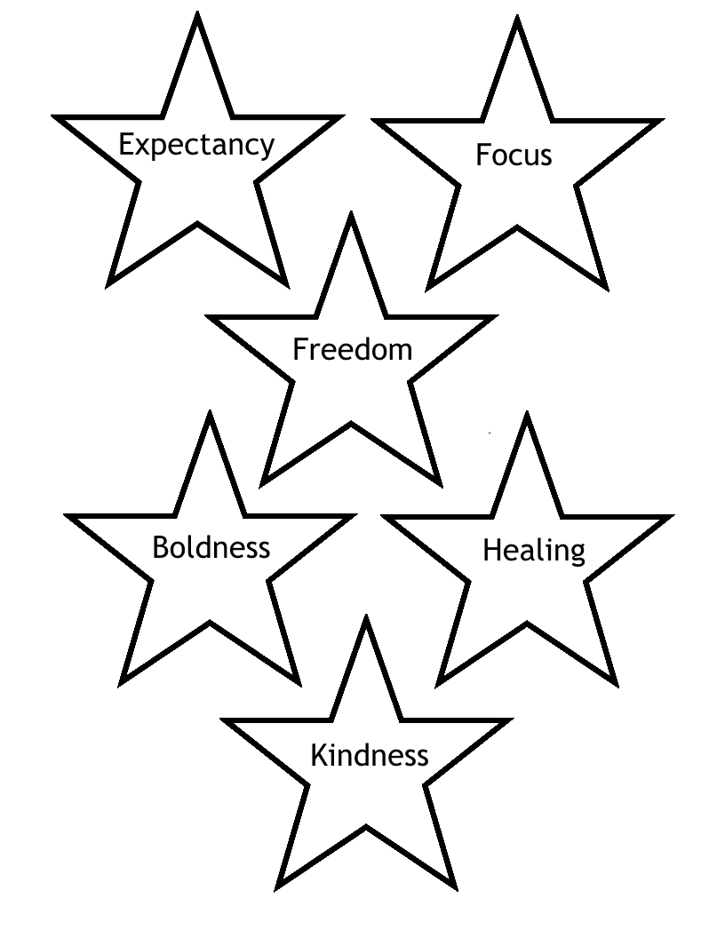

“BLANKETS +” SPECIAL OFFERING
Each year, over 8000 congregations and organizations across the nation collect donations for the offering of CWS (Church World Srvice), providing funds to help people in need around the world. Our donations help provide:
*Blankets, tents, food and other emergency supplies in the wake of a disaster.
*Tools and seeds for refugees returning home to replant their fields
*Wells for families living in drought prone areas
*Literacy training for women struggling to realize their potential
*And much more!
We collect a special offering for Blankets + on Martin Luther King Jr. Sunday, observed this year on January 18.


WAVING FOR PEACE
We witness for peace every Sunday after coffee hour and Mondays from 3:30-4 PM. All are welcome! We don’t wave if the weather is bad (heavy rain or snow or ice). We keep an “eye to the sky” especially in the winter months!


SOUPER BOWL OF CARING
Everyone is invited to start collecting soup for SOUPER BOWL OF CARING outreach ministry. We will be collecting soup throughout January and February. Our donations will help our neighbors who receive services through the Open Pantry, here in Springfield.



EYE TO THE SKY

If we need to cancel in-person worship or another special event during the winter season, we will post on local TV channels. For smaller meetings, please contact the Chair or Facilitator. NOTE: A pre-recorded worship service is available for viewing each week.

January Birthdays
6 - Marti Tyler
12 – Wilberth Condega Ortiz
15 - Gail Foss
21 - Connie Gumlaw
24 - Pam Corey
26 - Rebekah Crampton-Kamukala

If you would like to be included on our Birthday/Anniversary List, please call the church office at 782-2112.

SUMMARY FINANCIAL REPORT – As of November 30, 2025 In an effort to keep everyone informed as the year progress, the Executive Board voted to publish a summary financial report in each edition of the Chronicle based on the Treasurer’s most recent report. The summary report of Income and Expenses as of the end of November (the tenth month of our church finance year), is as follows:
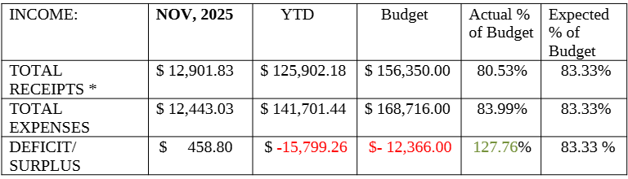
As you can see, we had a balanced month in November with a small surplus, however, our deficit for the year-to-date remains about 27% above our budget prediction for the full year. We did budget taking some money from the Puritan Road investment account which has not yet been done. Doing that will reduce our budget deficit but also reduce our net assets. The amount entered for Receipts does not include unplanned transfers from our savings or other accounts needed to pay bills from month-to-month.

GREATER SPRINGFIELD CAMPAIGN NONVIOLENT
SPECIAL EVENT FOR MARTIN LUTHER KING JR.DAY
Everyone is invited to a special program entitled “Living The Gospel with Dr. Martin Luther King, Jr. and Sister Dr. Thea Bowman.” Guest speaker: Sister Melinda Pellerin

Monday, January 19, from 6:30 PM – 8:00 PM
Location: Mary, Mother of Hope Church
840 Page BLVD, Springfield, MA 01104
Co-Sponsored by PAX CHRISTI MA & Sisters of St. Joseph

Contact Bob Loesch or Pastor Barbara for more information.

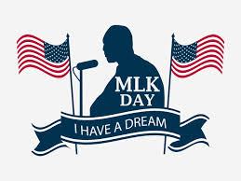

LOOKING AHEAD

February
Sunday, February 15: “Shrove Sunday” Pancake Brunch:
Fundraiser for the Afghan family
Wednesday, February 18: Ash Wednesday service: 7 PM

