Foster Memorial Church, UCC
1791 Wilbraham Road
Springfield, Massachusetts 01119

Recorded Sunday morning worship:
On our website, Facebook and YOUTUBE

Office Telephone (413) 782-2112
Email: fostermemorial@msn.com;
Pastor’s Email: revschenk@comcast.net
Website: www.fostermemorial.org
Facebook: Foster Memorial Church

Minister: Rev. Barbara Schenk
Choir Director & Organist: Frank Jackson
Admin. Assistant: Heidi Mayfield
Nursery Childcare provider: Hayley LaTaille

OUR PURPOSE STATEMENT
We are a joyful, welcoming, inclusive, and supportive community of Christ followers, eager to shine God's love by connecting people through partnerships and service that foster peace and hope in our neighborhood, wider community, and world.

WE ARE AN OPEN AND AFFIRMING CHURCH
We strive to be a congregation that welcomes and embraces all persons of all sexual orientations, including gay, lesbian, bisexual and transgender and persons of all marital status, age, mental and physical health and ability, racial and cultural identity or background, and educational and socioeconomic status.

WE ARE A JUST PEACE CHURCH
See our complete statement at our website.
August 2026: Foster Memorial Church, UCC

Interim Search Update
The Interim Search Team (Amy Pawle, Alice Kempf, Bruce Moore, Mary Caron, Kevin Withers & Rev. Bob Loesch) has completed our church profile, and it is now active with the UCC.

This is the first step in finding an intentional interim pastor to guide is through the search for our next settled pastor.

The profile introduces the church to pastors nationwide who are searching themselves, similar to a job posting. Any candidate who is interested in our profile will send their profile to us through the UCC, and the Interim Search Team will decide whether to interview them. The interim pastor will serve for around two years, and they will be working ¾ time, between 30 and 35 hours per week.

Since it is unlikely that we will find an interim pastor by the end of August, the Executive Board is now working to find people to lead worship for the next few months. We met with our new Area Minister, Rev. David Jones, on Monday, July 20; he will be assisting us with this and the interim search. Rev. Bob Loesch is providing pastoral care starting September 1st. Please contact Amy Pawle, our moderator, with any questions. She can be reached at amy.pawle@gmail.com.

SPECIAL INVITATION
Please join us for the retirement and final worship service of Rev. Barbara Schenk on Sunday, August 30 at 9:30 AM, followed by a special coffee hour at 10:30 AM.


AUGUST
Saturday, August 1: Men’s Breakfast: 8:20 AM
Sunday, August 2: Texas Roadhouse Fundraiser
11:30 AM – 3 PM
Saturday, August 8: Food Drive: 1-3 PM
Sunday, August 9: 12th Anniversary of Waving
for Peace
Sunday, August 9: Blessing of School Supplies
Sunday, August 30: Pastor Barbara’s final
worship service/farewell


SEPTEMBER
REMINDER: WORSHIP CHANGES BACK TO 10 AM
Friday, September 4: Quarter Auction: 7 PM
Saturday, September 5: Men’s Breakfast: 8:20 AM
Sunday, September 6: Texas Roadhouse Fundraiser
11:30 AM – 3 PM
Saturday, September 12: Food Drive: 1-3 PM
Sunday, September 13: Rally Sunday
Sunday, September 13: Just Peace team

ONGOING
Sunday mornings: Church School and Nursery Care
Coffee Hour after worship,
Waving for Peace
Mondays: Waving for Peace: 3:30-4 PM
Wednesdays: Cutting Edge Group: 5-6 PM
Thurs. before 3rd Fri: Prep for Loaves and Fishes Dinner
Third Friday: Serve Dinner at Loaves and Fishes
Last week: Deliver baked goods to Loaves &
Fishes (Bun Runners)

SAVE THE DATES:
Crop Walk for Hunger: Sunday, October 5
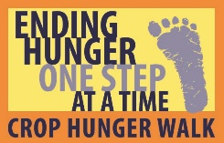

MEN’S BREAKFAST: Saturday, August 1
All men of the church are invited to join on the first Saturday of the month for breakfast at a local restaurant. We meet at 8:20 AM in the front parking lot. All are welcome and invited to bring friends!



TEXAS ROADHOUSE FUNDRAISER:
Sunday, August 2: 11:30 AM – 3 PM
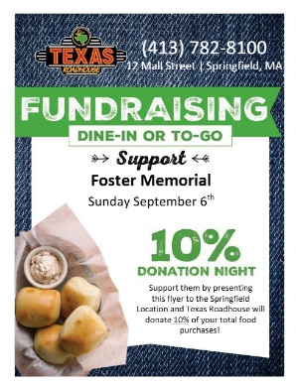

Show this to your server for our fundraising benefit.

BIG Y GIFT CARDS
See Jeanie Marsh or Alice Kempf to order Big Y gift cards. This is an ongoing fundraiser for the church. Thanks for your support!

12th ANNIVERSARY OF OUR WAVING FOR PEACE ANNIVERSARY: SUNDAY, 9
Please join us right after worship for an all-church photo to mark our 12th anniversary of our Waving for Peace ministry. We will also plan to Wave for Peace after coffee hour.


AUGUST DRIVE THROUGH : Saturday, August 8
Time: 1-3 PM in our church parking lot. We will be collecting food for the Open Pantry and School Supplies for Rebecca Johson School. REMINDER: We collect non-perishable food for Open Pantry every Sunday. All donations are so appreciated.


FOSTER SOFTBALL TEAM
Congratulations to our softball team, who has done VERY well this season! Playoffs are on Saturday, August 1 at Bethany Church in Agawam. Stay tuned for what time our team will be playing! Find info at:
https://www.interchurchsoftball.com/
Go team, go!

SCHOOL SUPPLIES FOR REBECCA JOHNSON
We will be collecting school supplies each Sunday through August 9, when the supplies will be blessed during worship. Needed: Everything from pencils to back packs, notebooks, glue sticks, crayons, colored pencils, and two and four pocket folders. Thanks to everyone for your support!


MONTHLY QUARTER AUCTION: SEPTEMBER 4
Doors open at 6 PM, and the auction begins at 7 PM. Everyone is invited to bring quarters and friends for a fun evening and a chance to win some great items from our vendors! There will also be a raffle! Admission: $5 for two paddles. Bring a non-perishable food item and receive a free third paddle. This month, a portion of our proceeds will go to Rebecca Johnson School.
Dinner food and snacks will be available for purchase. Speak to Lori for more information.
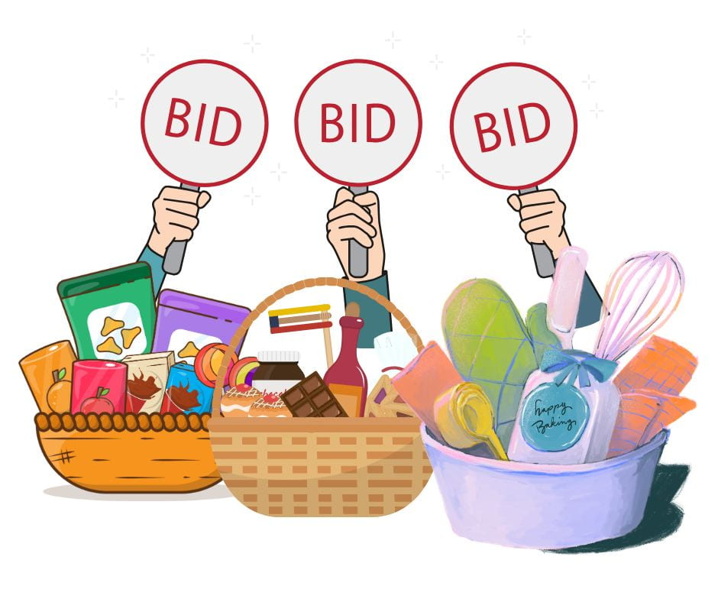

We are once again the hosts for this event!
INTERNATIONAL PEACE DAY: May Peace Prevail
Sunday, September 20: 3- 5 PM Rain Plans: Inside
We need helpers for set up, clean-up and refreshments. Please speak to Rev. Bob Loesch or Cheryl Moynahan if you would be able to help. Our Just Peace Team is one of the participants in this event. We hope you can join us.


GREATER SPRINGFIELD CROPWALK FOR HUNGER
Please save the date for the walk: Sunday, October 4. We gather for the walk at Trinity United Methodist Church on Sumner Ave, at 1 PM. The walk kicks off at 2 PM; we walk through Forest Park (either one or three miles) and return to Trinity for refreshments. We always need helpers with refreshments and our “Welcome Back” team, as well as walkers and sponsors. Please speak to Jeanie Marsh or Judy Milano if you can help.

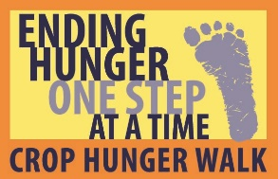

August Birthdays:
5 – Jean Howells
7 – Barbara Erwin
9 – Sally Hawley
12 – Joanne Wells
20 - Peter Broaca
August Anniversaries
August 18 – Jill and Bruce Moore

CANCER CARE SPECIAL OFFERING

Thank you to everyone for your donations to our own special Cancer Care Offering. A total of $691.00 was raised, to be divided between Sister Caritas Cancer Center at Mercy Medical Center and Baystate Health D’Amour Cancer Center. Everyone’s support is greatly appreciated.

GARDEN ANGELS
Thank you to our Garden Angels Judy Milano and Gerri Thompson for all their work on our church gardens. A Garden Slideshow is available on our Facebook page and on our website at
https://www.fostermemorial.org/videos.

SUMMARY FINANCIAL REPORT – As of
June 30, 2026
In an effort to keep everyone informed as the year progresses, the Executive Board voted to publish a summary financial report in each edition of the Chronicle based on the Treasurer’s most recent report. The summary report of Income and Expenses as of the end of JUNE 2026 (the fifth month of our church finance year), is as follows:
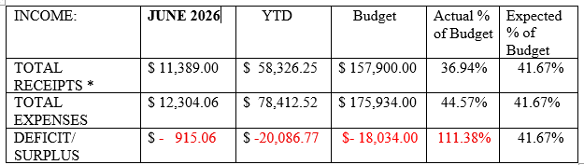
As you can see, we had a relatively small deficit this month. Income continues to be a bit below expectations and expenses have been more than expected, leaving us with a deficit at the end of the fifth month of our financial year that is higher than what we projected for the full year. We will likely offset some of this next month with the transfer of funds from our fund-raising efforts, but, we ask everyone to be mindful with keeping up with your pledges and if you find a bit extra to contribute that will be much appreciated also.
The amount entered for Receipts does not include unplanned transfers from our savings or other accounts needed to pay bills from month-to-month.

