**Foster Memorial Church, UCC**

1791 Wilbraham Road

Springfield, Massachusetts 01119

Recorded Sunday morning worship:

On our website, Facebook and YOUTUBE

Office Telephone (413) 782-2112

Email: fostermemorial@msn.com;

Pastor’s Email: revschenk@comcast.net

Website: www.fostermemorial.org

Facebook: Foster Memorial Church

Minister: Rev. Barbara Schenk

Choir Director & Organist: Frank Jackson

Admin. Assistant: Patrick O’Brien

Nursery Childcare provider: Hayley LaTaille

***OUR PURPOSE STATEMENT***

*We are a joyful, welcoming, inclusive, and supportive community of Christ followers, eager to shine God's love by connecting people through partnerships and service that foster peace and hope in our neighborhood, wider community, and world.*

***WE ARE AN OPEN AND AFFIRMING CHURCH***

*We strive to be a congregation that welcomes and embraces all persons of all sexual orientations, including gay, lesbian, bisexual and transgender and persons of all marital status, age, mental and physical health and ability, racial and cultural identity or background, and educational and socioeconomic status.*

***WE ARE A JUST PEACE CHURCH***

See our complete statement at our website.

**August 2025: Foster Memorial Church, UCC**

Dear friends,

I hope everyone is enjoying the summer – it seems to be flying.

I know we have been very concerned about issues going on that are dividing our nation. Decisions being made can shake us to the core, daily. We have started Waving for Peace on Sunday mornings, in addition to Monday afternoons, and the response from our neighbors passing by has been overwhelmingly positive. We will also be looking for more ways to advocate for God’s justice in the coming days, including our hosting an *International Peace Event* in September.

There are many hymns that can move us onward and upward with hope and conviction of faith. One of these is entitled Community of Christ, with words by Shirley Erena Murray.

*Community of Christ, through whom the world must sound-*

*Cry out for justice and for peace the whole world round;*

*Disarm the powers that war and all that can destroy,*

*Turn bombs to bread and tears of anguish into joy.*

*When menace melts away, so shall God’s will be done.*

*The climate of the world be peace and Christ its sun;*

*Our currency be love and kindliness our law,*

*Our food and faith be shared as one forevermore.*

Blessings,

Barbara

**CALENDAR FOR AUGUST AND SEPTEMBER**

**August**

Saturday, August 2: Men’s Breakfast: 8:20 AM

Sunday, August 3: 11th Anniversary Waving for

Peace

Saturday, August 9: Monthly Food Drive: 1-3 PM

Sunday, August 10: Blessing of School Supplies

Sunday, August 10: Just Peace Team Meeting

Wednesday, August 13: Finance Board/Exec Board

Sunday, August 24: Prayers for the Nation: 4 PM

**September**

Thursday, Sept. 4: FMC Hosts Crop Rally 5 PM

Friday, Sept. 5: Quarter Auction: 7 PM

Saturday, Sept. 6: Men’s Breakfast: 8:20 AM

Sunday, Sept. 7: Worship Resumes at 10 AM

Sunday, Sept. 7: Texas Roadhouse Fundraiser

Wednesday, Sept. 10: Finance Board/Exec Board Saturday, Sept. 13: Monthly Food Drive: 1-3 PM

Sunday Sept. 14: Rally Sunday

Sunday, Sept. 21: FMC hosts Peace Day Event:

3- 5 PM

Thursday, Sept. 25: Pastor hosts local UCC clergy

Saturday, Sept. 27: Fosterians 11:30 AM

Sunday, Sept. 28: Prayers for the Nation: 4 PM

**ONGOING**

Sunday mornings: Church School and Nursery Care

Coffee Hour after worship,

Waving for Peace

Mondays: Waving for Peace: 3:30-4 PM

Wednesdays Cutting Edge Group: 5-6 PM

Third Thursday: Prep for Loaves and Fishes Dinner

Third Friday: Serve Dinner at Loaves and Fishes

Last week: Deliver baked goods to Loaves &

Fishes (Bun Runners)

**SAVE THE DATES:**  
Crop Walk for Hunger: Sunday, October 5

Blessing of the Pets/Animals: Sunday, October 19

Pancake Brunch for Tenzin: Sunday, October 26

Fosterians Gathering: Date TBD

**MEN’S BREAKFAST: Saturday, August 2**

All men of the church are invited to join on the first Saturday of the month for breakfast at a local restaurant. We meet at 8:20 AM in the front parking lot. All are welcome and invited to bring friends!



**TEXAS ROADHOUSE FUNDRAISER:**

**Sunday, August 3: 11:30 AM – 3 PM**

Show this to your server for our fundraising benefit.

**BIG Y GIFT CARDS**

See Jeanie Marsh to order Big Y gift cards. This is an ongoing fundraiser for the church. Thanks for your support!

**11th ANNIVERSARY OF OUR WAVING FOR PEACE ANNIVERSARY: SUNDAY, AUGUST 3**

Please join us right after worship for an all-church photo to mark our 11th anniversary of our Waving for Peace ministry. We will also plan to Wave for Peace after coffee hour.

**AUGUST DRIVE THROUGH : Saturday, August 9**

Time: 1-3 PM in our church parking lot. We will be collecting food for the Open Pantry and School Supplies for Rebecca Johson School. REMINDER: We collect non-perishable food for Open Pantry every Sunday. All donations are so appreciated.



## **FOSTER SOFTBALL TEAM**

Congratulations to our softball team, who has done VERY well this season! Playoffs are on Saturday, August 2 at Bethany Church in Agawam. Stay tuned for what time our team will be playing!

https://www.interchurchsoftball.com/

Go team, go!

## **SCHOOL SUPPLIES FOR REBECCA JOHNSON**

We will be collecting school supplies each Sunday through August 10. Needed: Everything from pencils to back packs, notebooks, glue sticks, crayons, colored pencils, and two and four pocket folders. Thanks to everyone for your support!



**MONTHLY QUARTER AUCTION: SEPTEMBER 5**

Doors open at 6 PM, and the auction begins at 7 PM. Everyone is invited to bring quarters and friends for a fun evening and a chance to win some great items from our vendors! There will also be a raffle! Admission: $5 for two paddles. Bring a non-perishable food item and receive a free third paddle. This month, a portion of our proceeds will go to: Tapestry Health: <https://www.tapestryhealth.org/>

More details to come. Dinner food and snacks will be available for purchase. Speak to Lori for more information.

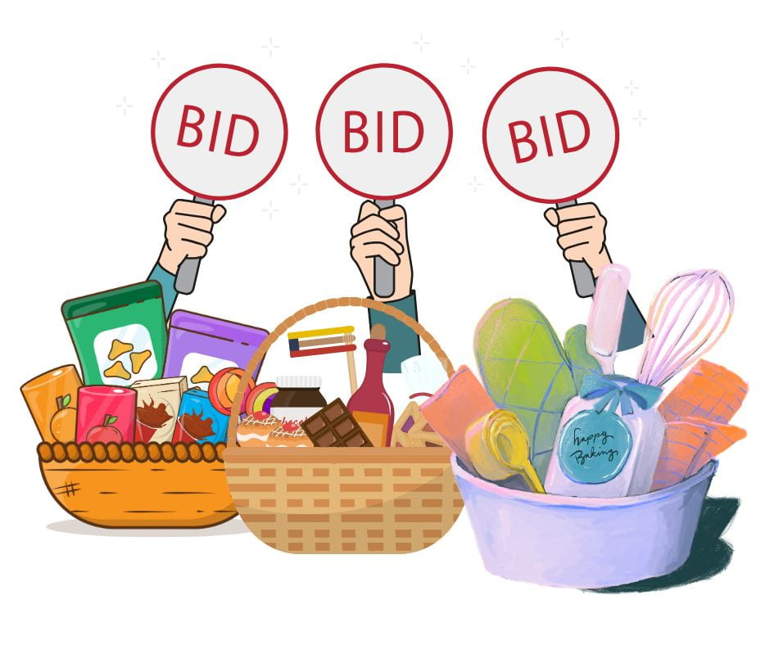

*We are once again the hosts for this event!*

***INTERNATIONAL PEACE DAY: May Peace Prevail***

*Sunday, September 21: 3- 5 PM Rain Plans: Inside*

We need helpers for set up, clean-up and refreshments. Please speak to Pastor Barbara if you would be able to help. Our Just Peace Team is one of the participants in this event. We hope you can join us.



**FOSTERIANS: Sat, September 27 11:30 AM**

All women welcome! Theme: Big E! There will be a Pizza lunch with a free will offering taken to cover costs. More details will be coming soon!



**Looking Ahead to October:**

**GREATER SPRINGFIELD CROPWALK FOR HUNGER**

Please save the date for the walk: Sunday, October 5. We gather for the walk at Trinity United Methodist Church on Sumner Ave, at 1 PM. The walk kicks off at 2 PM; we walk through Forest Park (either one or three miles), and return to Trinity for refreshments. We always need helpers with refreshments and our “Welcome Back” team, as well as walkers and sponsors. Please speak to Pastor Barbara if you can help.

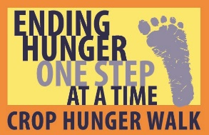

**ANNNUAL BLESSING OF THE PETS**

**Sunday, October 19 at 2:00 PM**

Join us for this special event! All pets must be on a leash or in a carrier. Photos of pets also welcome! Everyone is also invited to bring pet food, toys and supplies to be donated to Thomas J. O’Connor Animal Control and Adoption Center. New or gently used towels are especially needed. Everyone welcome, with your pets, or just come to enjoy!

In Sympathy

Our dear Foster church friend Stella Warner died on July 6 at Baystate Wing Hospital in Palmer after a very short illness. Pastor Barbara officiated for Stella’s memorial service on July 14. Stella lived a long and full 108 years of life. We are so grateful for her friendship and for her faithful support for our church. Please keep Stella’s daughter, Sunny, son Rick and all loved ones in prayer.



August Birthdays:

5 – Jean Howells

7 – Barbara Erwin

9 – Sally Hawley

12 – Joanne Wells

20 - Peter Broaca

August Anniversaries

August 18 – Jill and Bruce Moore

If you would like your birthday or anniversary to be listed,

Please call the church office.

**SUMMARY FINANCIAL REPORT – As of**

**June 30, 2025**

In an effort to keep everyone informed as the year progresses, the Executive Board voted to publish a summary financial report in each edition of the Chronicle based on the Treasurer’s most recent report. The summary report of Income and Expenses as of the end of JUNE 2025 (the fifth month of our church finance year), is as follows:

We had a good month in June, bringing our deficit for the year-to-date back into line with our budget. prediction. Thank you all for your generous contributions this month. The amount entered for receipts does not include unplanned transfers from our savings or other accounts needed to pay bills from month to month.

*Delegates Report*

*6th Annual Meeting SNEUCC*

The Annual Meeting of the Southern New England United Church of Christ Conference was held on Saturday, June 7,  9 am-1 pm by  virtual Zoom and registration only. The theme was "Into the Deep- Leading and Learning at the Intersections". In Luke 5, Jesus calls His disciples to go into the deep waters-to trust, to follow, and to cast their nets wide. We are called to do the same: to lead boldly at the intersections of justice, service, and faith.  The keynote speaker, Jamar Doyle, President and CEO of the Council for Health and Human Services, told stories from churches and agencies across our region and nation about this call.

The business of the meeting included WISE report, election of nominating slate, bylaws changes, church celebrations and recognitions, Silver Lake and Retreat Center report, invitation to Seeds of Hope, Treasurer's report, Authorized Ministers' Celebration and recognitions. All events and reports from the Annual Meeting will be available on the SNEUCC website-- www,sneucc.org.

The next SNEUCC Annual  Meeting will be in person and virtual. at the DCU Center, Worcester,  September 25-27, 2026.

*Respectfully Submitted, Rev. Dr. Robert Loesch*

***NEWS FROM OUR CHURCH OFFICE***

*Thank you:  
We want to thank Patrick O’ Brien for his good work for us as our Admin. Assistant since the spring of 2024. Patrick will be finishing up on August 22.*

*Welcome:*

*Heidi Mayfield has been hired to start on August 27. Heidi is a Foster member who brings extensive office experience to the job. Welcome, Heidi! Office hours: Wednesdays and Fridays, 9 AM – noon.*

***CANCER CARE SPECIAL OFFERING:***

***THANK YOU***

## *Thank you to everyone for your donations to our own special Cancer Care offering. A total of $1051.00 was raised, to be divided between* Sister Caritas Cancer Center at Mercy Medical Center and Baystate Health D’Amour Cancer Center. Everyone’s support is greatly appreciated.

