FOSTER MEMORIAL CHURCH, UCC
1791 Wilbraham Road
Springfield, Massachusetts 01119

Worship Servies held at 10 AM with childcare
and church school provided.
Recorded Sunday morning worship:
On our website, Facebook and YOUTUBE

Office Telephone (413) 782-2112
Email: fostermemorial@msn.com;
Pastor’s Email: revschenk@comcast.net
Website: www.fostermemorial.org
Facebook: Foster Memorial Church

Minister: Rev. Barbara Schenk
Choir Director & Organist: Frank Jackson
Admin. Assistant: Heidi Mayfield
Childcare: Hayley LaTaille

OUR PURPOSE STATEMENT
We are a joyful, welcoming, inclusive, and supportive community of Christ followers, eager to shine God’s love by connecting people through partnerships and service that foster peace and hope in our neighborhood, wider community and world.

WE ARE AN OPEN AND AFFIRMING CHURCH
We strive to be a congregation that welcomes and embraces all persons of all sexual orientations, including gay, lesbian, bisexual and transgender and persons of all marital status, age, mental and physical health and ability, racial and cultural identity or background, and educational and socioeconomic status.

WE ARE A JUST PEACE CHURCH
(see our complete JUST PEACE DECLARATION
on our website at fostermmeorial.org)



APRIL 2026

Dear friends,
We begin this month with Holy Week , and celebrate Easter Sunday on April 5. Following is the season of Easter, which lasts 50 days until Pentecost Sunday, celebrated this year on May 24.

This season focuses on the Easter message that love is stronger than hate and death will never have the last word.

May this focus encourage us and strengthen us to be Easter people, striving to follow Jesus our Savior, who showed and shows us how to shine God’s light of love and justice into the world.

One of my favorite hymns for Easter season was written by Brian Wren:
Christ Is Alive!

Christ is alive! Let Christians sing.
The cross stands empty to the sky.
Let streets and homes with praises ring.
Love, drowned in death, shall never die.

Christ is alive! No longer bound
To distant years in Palestine,
But saving, healing, here and now
And touching every place and time.

Christ is alive! and comes to bring
Good news to this and every age,
Till earth and sky and ocean ring
With joy, with justice, love, and praise

Blessing in this holy season and in every season,

Barbara


Thursday, April 2: Maundy Thursday 7 PM
Friday, April 3: Good Friday FILMED service
Sunday, April 5: Texas Roadhouse
Friday, April 10: Quarter Auction 7PM
Saturday, April 11: Men’s Breakfast 8:20 AM
Saturday, April 11: Drive Through 1-3 PM
Sunday, April 12: Just Peace meeting
*Sunday, April 19: Prayers for the Nation
Monday, April 20: Trustees meeting: 6:30 PM
Saturday, April 25: Fosterians: 1-3 PM
*Please note date change

Maundy Thursday Service: April 2

In-Person Service at 7 PM

This service focuses on the Last Supper Jesus shared with his disciples. There is also a Service of Tenebrae (“Shadows”) including special scripture readings of the Passion of Jesus.

Good Friday Service: April 3

Please note: Filmed Service Only

The focus for this service is the crucifixion of Jesus, through the lens of “The Symbols of Good Friday.” The film will be posted on our website at fostermemorial.org, You Tube, and on our Facebook page.

Easter Sunday Services: April 5

In-Person at 8:00 AM and 10:00 AM

Our early service features the construction of our “Flowing Cross.” Our 10 AM service includes special music by our Chancel Choir and the “Unpacking of our Alleluias!” Please join us as we celebrate the resurrection of our Savior!

Texas Roadhouse Fundraiser
Show this graphic to your server for 10% proceedsfor the church. Thanks for your support!
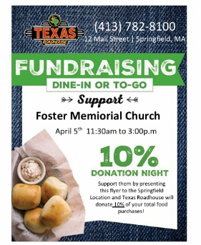

APRIL MONTHLY QUARTER AUCTION
We are holding our next Monthly Quarter Auction on Friday, April 10. Doors open at 6 PM, and the auction begins at 7 PM. Everyone is invited to bring quarters and friends for a fun evening and a chance to win some great items from our vendors! There will also be a raffle! Admission: $5 for two paddles. Part of our proceeds will go to One Call Away Veterans Support Center (OCA). Bring a non perishable food item, to be donated to OCA, for a free third paddle! Dinner food and snacks will be available for purchase.
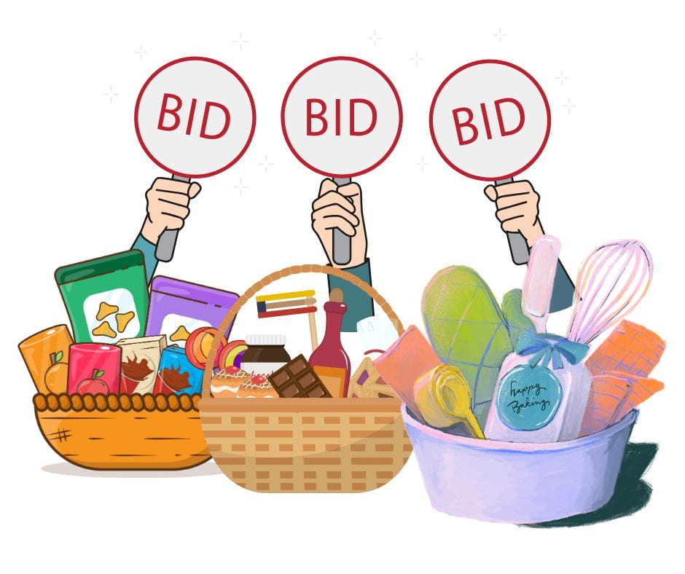
MENS’S BREAKFAST: NOTE DATE CHANGE
Just for this month, the men will meet on the second Sat,
April 11 at 8:20 AM in the front parking lot. All men welcome. (Usually this is held on the first Sunday of the month)


FOOD DRIVE FOR OPEN PANTRY: Sat. April 11 1-3 PM
In our back parking lot
Our focus foods are pasta and rice. All non-perishable food is appreciated.


JUST PEACE TEAM MEETING: Sun. April 12
Our Just Peace Team meetings are held after worship in the Foster Room next to the kitchen. These meetings are always open to everyone.

PRAYERS FOR THE NATION: Sunday, April 19
PLEASE NOTE DATE CHANGE
Because of a wider UCC event happening on our usual date, this will be held on Sunday, April 19. Time TBD.


FOSTERIANS GATHERING: APRIL 25: 1-3 PM
All women are welcome and welcome to bring friends.
We’re having a Spring theme with a Tea Cup Auction. You’re
invited to bring a new or VERY gently used item for the Auction. Help with hosting and donations of desserts are needed. Please contact Lori or Judy if you can help or need more information.


ONGOING
Sunday mornings: Church School and Nursery Care
Coffee Hour after worship,
Waving for Peace
Mondays: Waving for Peace: 3:30-4 PM
Wednesdays: Filming Sunday Service 2 PM
Cutting Edge Group: 5-6 PM
Second Wed.: Finance Board/Executive Board
Thurs. before 3rd Fri: Prep for Loaves and Fishes Meal
Third Friday: Serve Dinner: Loaves & Fishes
Last week: Deliver baked goods to L & F

SOUPER BOWL OF CARING
Thank you to everyone in our church and community for your support for this mission. We collected 303 cans of soup this year! All donations were given to the Open Pantry.

TWELVE MONTH TOTAL FOR FOOD DONATIONS
TO OPEN PANTRY
In the last twelve months, between our weekly collections, monthly food drives, and Quarter Auctions, we have donated approximately 4,000 pounds of food to Open Pantry’s Emergency Food Cupboard! Thanks to everyone!

SHROVE SUNDAY PANCAKE BRUNCH RESULTS
Thanks to our shopping, cooking, set up and cleanup crew for our February Shrove Sunday Pancake Brunch, and to all who came to this fundraiser. We raised over $490.00 as a gift of support for the Afghan family with whom we have had the blessing to walk alongside for the last four years.
APRIL BIRTHDAYS

1 - Rob Gormbley 8 - Sharon Gormbley
13 - Dennis O’Keefe 13 - Joe Rosati
15 – Don Foster 18- Sean LaTerz
19- Karen Coughlin 20 - Marjorie Kenney
22- Sara Coughlin 25 – Sarah Bandoski
27 - Jill Moore
APRIL ANNIVERSARIES
April 12 - Barbara Schenk & Keith Walker
April 27 - Sandy & Robert Moore

SUMMARY FINANCIAL REPORT – As of FEB. 28, 2026
In an effort to keep everyone informed as the year progresses, the Executive Board voted to publish a summary financial report in each edition of the Chronicle based on the Treasurer’s most recent report. The summary report of Income and Expenses as of the end of February 2026 (the first month of our church finance year), is as follows:
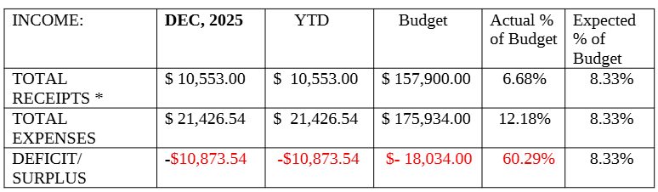
As you can see, we had a difficult month, starting the year with a large monthly deficit. To some extent, this was a result of several larger than average bills, including snow removal, fuel and insurance. Receipts were also slightly lower than expected, due in part to church being closed one Sunday because of a storm. However, we remain confident in the on-going generosity of our entire membership to carry us through to the end. The amount entered for Receipts does not include unplanned transfers from our savings or other accounts needed to pay bills from month-to-month.
REPORT FROM OUR DELEGATES
Installation of The Rev. Dr. Holly Norwick
The First Church of Monson :Sunday March 1, 2026

On Sunday March 1st Pastor Barbara, Rev. Dr. Bob Loesch and I had the pleasure of representing Foster Memorial at the installation of their pastor, The Rev Holly Norwick. Making it extra meaningful, Rev Holly was called exactly one year ago on March 1st. Hampden Association clergy, delegates, church members and friends filled the sanctuary to celebrate her ministry.

The occasion began with a question-and-answer period, and Rev. Holly’s sharing of the journey that led her to Monson. The service then moved to her formal Installation, filled with music, prayer, and scripture. The entire time was punctuated with vocal music highlighting their lively youth group “The Treble Makers” as well as Monson’s Johnson & Son organ. The service moved to Rev Holly’s formal welcome to the Association with the laying-on-of-hands and prayer.

It was a joyful occasion, and we were pleased to represent Foster Memorial.

--Rev. Susan Tarrantino, Foster delegate

RECORDED WORSHIP SERVICES
Along with in-person worship service, we offer pre-recorded worship services, posted each week (and for special services) on YOU Tube, on our Foster Memorial Church Facebook page and on our church website: http://www.fostermemorial.org/videos/
Worship services are also provided in print through the mail each week for people who do not have access to the internet. If you would like to receive printed bulletins and sermons, please contact Pastor Barbara through the church office.

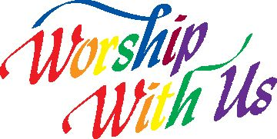


Dorothy (Dotti) Hersham, daughter of Foster member Barbara Tardy, died on March 4 at her home. Pastor Barbara officiated for Dotti’s memorial service on March 14 at Sampson’s Chapel. Dotti was a good friend and supporter of our church. Please keep Barbara, Doti’s husband, Jerry, granddaughter Traci and all family in prayer.

Richard LaPierre, long-time member of our church, died on
March 11 at a local nursing care center. His memorial service was held at our church on March 21. We are so grateful for Richard’s many years of support for our church, most especially as Deacon and visitor and his friendship to all. Please keep his daughters, Mary and Nicole, and all family in prayer.



SAVE THE DATES

Friday, May 1 Quarter Auction
Saturday, May 2 Men’s Breakfast
Sunday, May 3 Texas Roadhouse fundraiser
Saturday, May 9 Drive Through for Open Pantry
Sunday, May 10 Just Peace meeting
Sunday, May 31: Prayers for the Nation
Saturday, June 6 Yard Sale/Drive Through

A NOTE FROM ERIN LUKENBILL
CWS Community Engagement Manager

Friends of Foster Memorial,
Thank you for the many ways you support CWS (Church World Service) including your recent donation to CWS Blankets! Because of you, individuals in need receive a tangible sign of love and hope at the time they need it most. Thank you for continuing to care for neighbors in need – both near and far.
**
NOTE: We also recently received word that our local CROP Hunger Walk ranked 46th in raising the most money out of all the walks around the country!!! Thanks to everyone for your support!
******
Please contact Lori if you would like to be a vendor or would be able to volunteer.

VENDOR FAIR & YARD SALE
Saturday, June 6, 2026
9 AM-3 PM Rain or shine!!
Foster Memorial Church, UCC
1791 Wilbraham Road, Springfield, MA
(Sixteen Acres)

If you would like to be a vendor,
please call Lori at 413-626-9040 or lorilhi@aol.com
Vendors and yard sale! New and gently used items for sale! Something for everyone!
Lunch for purchase and a fun Gift Basket Raffle!

