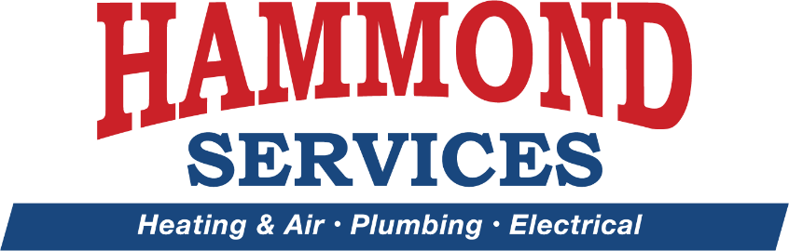

Media Release Agreement
I hereby consent to the use of my name, voice, statements, photographs, and likenesses of me, including motion picture, videotape, and related representations involving use of my voice or pictures of me, or both, by Hammond Services, Inc., or any of its subsidiaries now or hereafter, and their successors and assigns, for any purpose, including in and for purposes of advertising, promotion, television reporting/broadcast news, and trade in any and all media throughout the world, without restriction as to frequency or duration of usage and without compensation to me.
I hereby warrant and represent that I am at least 21* years of age and have the full right to contract in my own name with respect to the matters stated above.

_______________________________________ _______________________________________
NAME (PRINTED) SIGNATURE

_______________________________________ _______________________________________
DATE ADDRESS

_______________________________________ _______________________________________
WITNESS CITY, STATE, and ZIP CODE

*Complete the following if individual is under the age of 21:
I, the undersigned, warrant and represent that I am the parent or legal guardian of __________________________________, whose signature appears above. I have read the Release Agreement above and am fully familiar with the contents thereof and I hereby grant my permission and consent to all of the foregoing.

___________________________________________ ________________________________________
NAME (printed) of Parent or Legal Guardian SIGNATURE

