

P.O. Box 616

803 N. Main St.

Meridian, Texas 76665

(254) 435-2792

lawsonfh@sbcglobal.net
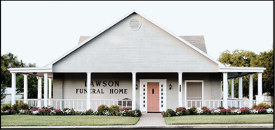
Proudly Serving Families Since 1928

Effective Date of Price List: May 1, 2026
Prices Are Subject to Change without Notice

GENERAL PRICE LIST CASKET PRICE LIST
OUTER BURIAL CONTAINER PRICE LIST URN PRICE LIST
.

There will be a 3% convenience fee for all credit card payments.

TRADITIONAL SERVICES

Traditional Church or Chapel Funeral $5,135
24-hour services of funeral directors and staff to help you and your family; planning and directing the funeral and disposition; overhead; coordinating with cemetery or crematory,
administrative staff to file paperwork, permits and required legal documents, removal, bathing, embalming and other sanitation and care of the deceased, dressing, casketing, and cosmetizing, arranging stateroom, use of our spacious facilities and greeting staff for viewing / visitation, use of Lawson Funeral Home chapel or church of your choice for the funeral service; or staff and equipment for a service held at your church, funeral coach and flower car / utility vehicle within a 25-mile radius, handling flowers, assisting your friends and family at visitation and services, posting the service and visitation schedule, color photograph and obituary on our own website with a place for your friends to send and view email memories and condolences to you.

Traditional Graveside Funeral $4,910

24-hour services of funeral directors and staff to help you and your family; planning and directing the funeral and disposition; overhead; coordinating with cemetery or crematory,
administrative staff to file paperwork and required legal documents, removal, bathing, embalming and other sanitation and care of the deceased, dressing, casketing, and cosmetizing, arranging stateroom, use of our spacious facilities and greeting staff for viewing / visitation,
equipment and staff for the full graveside service, funeral coach and flower car / utility vehicle
within a 25-mile radius, arranging details at the cemetery, setting-up equipment, greeting your friends and guests, posting the service and visitation schedule, color photograph and obituary on our own website for your friends to send email condolences to you.

The above charges are for our professional services only and does not include any funeral merchandise such as casket, outer container, stationery package, temporary grave marker if needed, or any cash advance items.

The total figure does not include the opening and closing of a grave, tomb or crypt. This cost will be added as per the charges of the cemetery or mausoleum. At the present time, our charge for opening and closing of the grave, cemetery equipment is $1050.00 Monday-Friday until 3 P.M., and $1350.00 on Saturday, if work is performed by Lawson Funeral Home. Should rock be hit, and the use of an air compressor and hammer be required a fee of $750.00 will be added to the opening and closing cost.
CREMATION GROUPINGS

Time Honored Service *(Full-Service Cremation) $8,965
With Rental Casket Option ($995) $7,165
- Basic Services of Funeral Director ($2,195)
- other care of deceased ($300)
- embalming ($795)
- crematory fee. ($465)**
- funeral service chapel or your church ($550)
- visitation ($225)
- transportation of deceased ($600)
- classic/rosewood decorative urn ($200)
- stationary package and DVD ($200)
- Longley cremation casket ($2,795)
- five death certificates ($40)**
- casket spray ($400)**
- honorarium(s) ($200+)**
Remembrance Gathering *(Visitation Cremation) $8,215
With Rental Casket Option ($995) $6,415
- Basic Services of Funeral Director ($2,195)
- other care of deceased ($300)
- embalming ($795)
- crematory fee. ($465)**
- visitation ($225)
- transportation of deceased ($600)
- stationary package and DVD ($200)
- classic/rosewood decorative urn ($200)
- Longley cremation casket ($2,795)
- five death certificates ($40)**
- casket spray ($400)**

Celebration of Life Service *(Memorial Service at church or funeral home) $5,435
- Basic Services of Funeral Director ($2,195)
- crematory fee. ($465)**
- alternative container ($95)
- memorial service ($490)
- visitation – 1 hr. prior ($150)
- transportation of deceased ($600)
- refrigeration – 3 days at $200 per day ($600)
- stationary package and DVD ($200)
- classic/rosewood decorative urn ($200)
- five death certificates ($40)**
- flowers ($200)**
- honorarium ($200)**

Remembrance Gathering & Graveside Service *(Visitation and Burial of Cremains same day) $5,430
- Basic Services of Funeral Director ($2,195)
- crematory fee. ($465)**
- alternative container ($95)
- graveside service ($410)
- visitation ($225)
- transportation of deceased ($600)
- stationary package and DVD ($200)
- refrigeration – 3 days at $200 per day ($600)
- classic/rosewood decorative urn ($200)
- five death certificates ($40)**
- flowers ($200)**
- honorarium(s) for clergy and musicians ($200+)**
- cemetery association fee, cost to open and close the grave, cost of tent and chairs (TBD)**
A Gathering of Friends and Family *(Memorial Visitation) $4,820
- Basic Services of Funeral Director ($2,195)
- crematory fee. ($465)**
- alternative container ($95)
- visitation ($225)
- transportation of deceased ($600)
- refrigeration – 3 days at $200 per day ($600)
- classic/rosewood decorative urn ($200)
- stationary package and DVD ($200)
- five death certificates ($40)**
- flowers for urn table ($200)**

Basic Cremation with No Ceremony *(Direct Cremation) $2,995
- Basic Services of Funeral Director ($2,195)
- crematory fee. ($465)**
- alternative container ($95)
- transportation of deceased ($600)
- classic/rosewood decorative urn ($200)
- five death certificates ($40)**
- package discount ($600)

Ceremonial Casket ($995) can be substituted for cremation caskets. Prices are subject to change without notice. Items may be added or subtracted to be personalized to your needs. Cremations over 300 pounds will incur additional crematory fees. If a cremation permit is required, an additional fee of $75.
Any items with ** are cash advance items and those prices are non-guaranteed.

GENERAL PRICE LIST
These prices are effective May 1, 2026, but are subject to change without notice. The goods and services shown below are those we can provide to our customers. You may choose only those items you desire. (However, any funeral arrangements you select will include a charge for our basic services and overhead.) If legal or other requirements mean you must buy any items you did not specifically ask for, we will explain the reason in writing on the statement we provide describing the funeral goods and services you selected. Please note that there may be charges for items such as cemetery fees, flowers, and newspaper notices.

SERVICES OF FUNERAL DIRECTOR AND STAFF $2,195

Our professional service charge includes but is not limited to consultation with family and clergy, arrangement and direction, desired preparation, and filing of necessary notices, authorizations and consents, and other services and attendance prior to, during and following the funeral including coordination with those providing other portions of the funeral (cemetery, crematory, florist, vault companies, musicians, etc.). Also included in this charge are overhead expenses relative to our facility such as insurance, maintenance and utility expenses, administrative costs, and equipment and inventory expenses. This fee for our services will be added to the total cost of the funeral arrangements you select. (This fee is already included in our charges for direct cremation, immediate burial, forwarding and receiving of remains.)

EMBALMING $795

Embalming is not required by law. Embalming may be necessary, however, if you select certain funeral arrangements, such as a funeral with visitation. If you do not want embalming, you have the right to choose an arrangement which does not require you to pay for it, such as direct cremation or immediate burial.

OTHER PREPARATION OF BODY

$300
This service includes the usual cosmetology, dressing and casketing of the body. There is an additional fee for the following services:
Special care of autopsied remains $150
Special care of remains for organ, tissue, or bone donation $150
Per family directive, in the absence of embalming, Refrigeration/Shelter
of Remains up to 3 days (after 3 days, $200 per day) $600
Special care to dress and bathe un-embalmed remains additional $250

FACILITIES AND EQUIPMENT

Use of Facilities & staff supervision for evening visitation (4-6 / 5-7 / 6-8) $225

Use of Facilities & staff supervision for day visitation (1 hour prior to services) $150

Use of staff & Facilities for funeral ceremony $550
Staff supervision in facility other than funeral home $550
Use of equipment and staff for graveside services $410
Memorial Service (facility other than funeral home) $490
*Additional Charge for Sunday Funeral or Memorial Services $500
AUTOMOTIVE EQUIPMENT (25-mile radius of Meridian; additional miles above 25 are
$3.00 per mile one-way).

Transfer of remains to funeral home | $600
Limousine (dependent upon availability) | Rental Price
Funeral Coach (Hearse) | $300
Lead/Clergy Car | $85
Utility Vehicle  Cross country mileage per mile one-way | $85  $3.00
Transportation to or from DFW or Austin Airports | $300
Overnight stay on road trip (one employee for one night) | $350
MERCHANDISE
Stationery Package with one Memorial DVD  (register book $100, memorial folders $75, acknowledgement cards $25) | $200
Additional DVD | $10/e
Temporary Grave Marker | $45
Cremation Urns | $45 to $295

CHILD SERVICES (under age 16)

Transfer of deceased from place of death with a 25-mile radius from Meridian $600.00
Services of funeral director and staff $900.00
Embalming (1/2 of regular charge) $400.00
Viewing and visitation (1 day) $225.00
Funeral director and staff for graveside $325.00
Use of funeral coach (hearse) $250.00
Use of utility vehicle $85.00

The selection of an infant or child casket will be offered to the family at cost.
Along with all cemetery fees and other merchandise.

SPECIAL SERVICES

Forwarding of remains to another funeral home $4,790
Our charge includes basic services of funeral director and staff, removal of remains, necessary authorizations, embalming and other preparation of remains, shelter of remains, receptacle for non- casketed shipping, and transportation to DFW or Austin airport. This does not include the airline’s shipping charges, visitation, rites or ceremonies or newspaper obituary costs.
Receiving remains from another funeral home $3,395 This includes services of our funeral director and staff, transfer of remains from DFW or Austin airport, shelter of remains, and transportation of remains to a local cemetery. This charge does not include visitation, rites or any ceremonies.
Disinterment $1295
This is our professional charge for securing permits, arranging disinterment, state health department fee ($25), etc. Additional charges may include the opening and closing of the grave at disinterment site, container, the opening and closing of the grave at interment site, mileage, cemetery fees, etc.
Immediate Burial $3,695 Our charge for an immediate burial without ceremony, funeral rites, or any other rituals at the funeral home, gravesite, or elsewhere includes our basic services of funeral director and staff, removal of remains, temporary shelter of remains, and transportation to cemetery (40-mile radius). Embalming if desired, funeral rites or rituals, casket, outer burial container, and cemetery charges are not included in this price. *This charge does not include the cost of a casket.

CREMATION SERVICES

If you want to arrange a cremation, you may use our alternative container. Alternative containers encase the body and can be made of materials like fiberboard or composition materials (with or without an outside covering). The containers we provide are cardboard cremation containers. Direct Cremation includes Professional Services, removal, and crematory fees, care of the deceased, and placement into a cremation container, placement of the cremains into a temporary container or urn you can purchase, handling paperwork, filing the death certificate, and assistance of our staff; immediate family only may have a brief viewing if requested.
  - Direct cremation with an alternative container provided by the Funeral Home ~ includes a $360 discount. $2,995
  - Direct cremation with a purchaser supplied container $2,900
  - Direct cremation with a casket purchased
from our showroom (selection of casket not included in price listed) $2,900
  - Expedited Scheduling of Cremation; when available $500
•Alternative Containers $95 to $995
  - Crematory fee $465*
*Additional tiered crematory fee starting at 301 pounds $650 to $1,350
Casket Price List

These prices are effective as of September 1, 2025, but are subject to change without notice.

CASKETS – Described on the following pages in detail. $2,895 to $9,595 Lawson Funeral Home offers a full range of beautiful wood and metal caskets at very competitive prices for all families.
OUTER BURIAL CONTAINERS $1,595 to $13,995
Lawson Funeral Home offers a full range of concrete and metal grave liners and vaults to protect the casket or Urn in the grave.

Accommodation Caskets Also Available**
Bennet – Oak in walnut matte finish - with rosetan crepe 27” wide $3,295 29” wide $3,495 Yale – Softwood poplar in gloss -with beige crepe interior 31” wide $3,395 Extra* – 18 gauge steel in several colors, 29” wide Gasketed - $2,895 Non-gasketed $2,795
* Larger sizes may be available for an extra cost.
** Depends on availability of the particular casket

DISCLAIMER OF WARRANTIES: Lawson Funeral Home makes no representations or warranties regarding the caskets listed. The only warranties expressed or implied granted in connection with the caskets are the express written warranties, if any, extended by the manufacturers hereof. Lawson Funeral Home hereby expressly disclaims all warranties, expressed or implied, relating to the caskets, including, but not limited to, the implied warranties of merchantability and fitness for a particular purpose.

Wood Caskets Available from Lawson Funeral Home
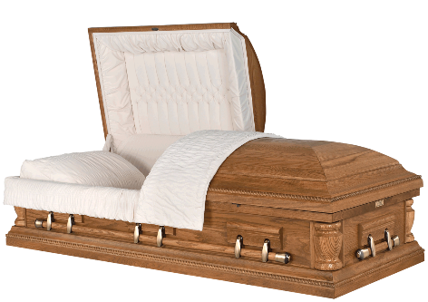  Please ask if you do not see a casket that meets your specific need, such as color, design, style, or price. We have many other selections available. | 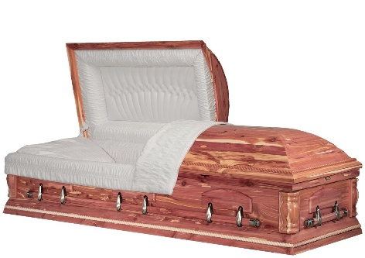  About Our Wood Caskets… compares to the rich, warm glow of well-crafted hardwood. From the elegance of solid hardwood to the simplicity of hardwood veneer, this assortment from Grace Gardens Funeral Home shows a variety of woods and finishes that cater to all tastes and prices.
Ratlin – Satin Oak  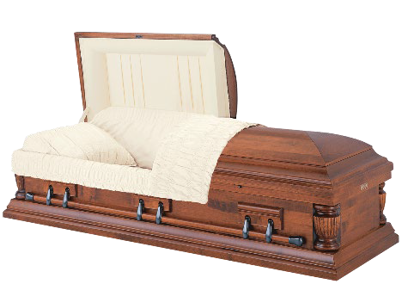  Almond Velvet Interior ~ $6,895 | Sunset - Cedar  Natural Polished Finish,  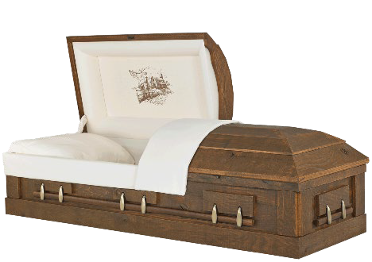  Starlight Velvet Interior ~ $5,495
Clearwood - Maple  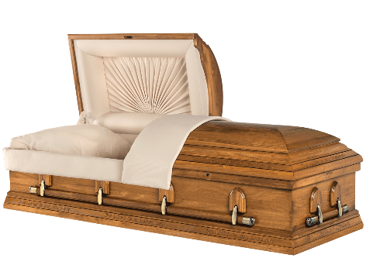  Satin Light Colonial Finish, Rosetan Crepe Interior ~ $5,495 | American Barnwood - Oak  Satin Timber Finish,  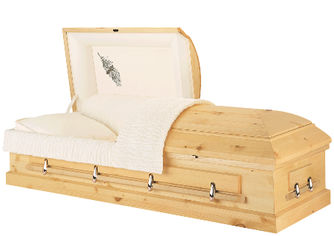  Natural Cotton Interior ~ $4,895
23rd Psalm – Solid Poplar  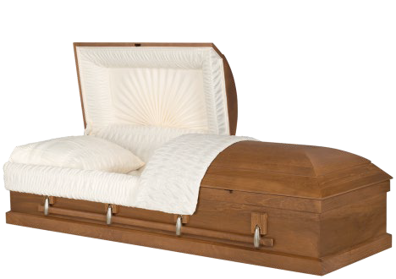  Satin Finish,  Khaki Basketweave Interior ~ $4,695 | 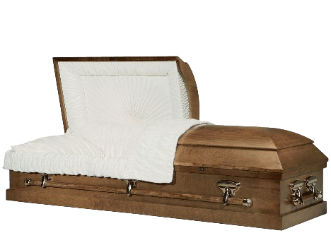  Augusta – Solid Pine  Satin Natural Finish  Rosetan Crepe Interior ~$4,595
Ashford - Poplar Veneer  Satin Medium Walnut Finish Rosetan Crepe Interior ~ $3,695 | Prince - Poplar Veneer  Light Satin Finish  Rosetan Crepe Interior ~ $3,295

Gasketed Metal Caskets Available from Lawson Funeral Home
Solid Copper 32 Oz. ~ $9,595
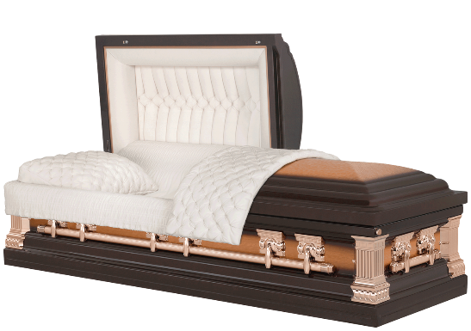
Lincoln: Brushed Natural/Heritage Bronze Finish Velvet Interior

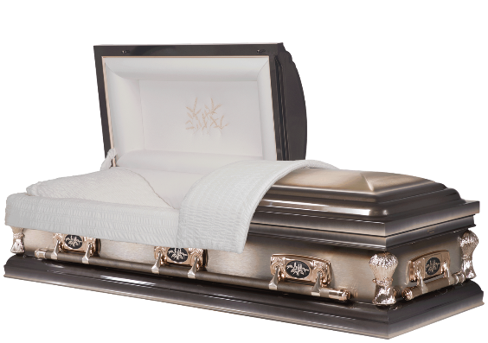 | Harvest -Stainless Steel ~ $6,595  Sage Brushed Finish – Beige Velvet Interior
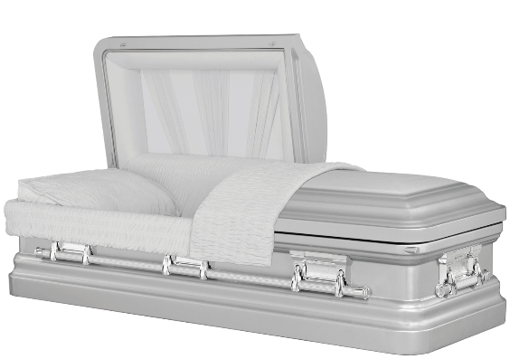  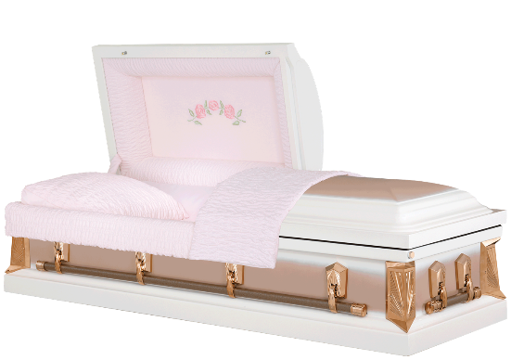 | Springfield-18ga Steel ~ $4,595  Natural Finish with Silver Velvet Interior  London Blue Finish with Almond Velvet Interior  Black Finish with White Velvet Interior  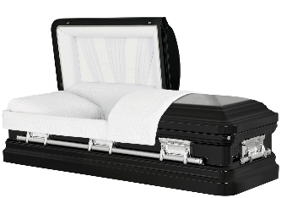  Copper Finish with Cream Velvet Interior  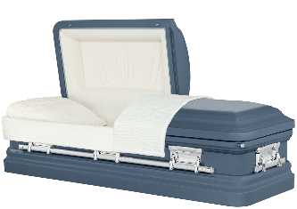  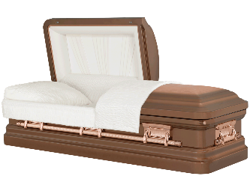  Sierra-18ga Steel ~ $4,495 White and Pink or Gry and Gunmetal Finish Pink or white crepe interior  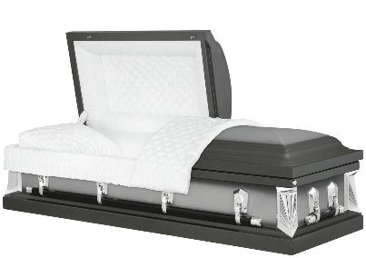

Gasketed Metal Caskets Available from Lawson Funeral Home
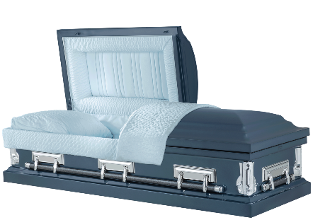

Edson-18ga Steel ~ $4,095
London Blue Finish with Blue Crepe Interior

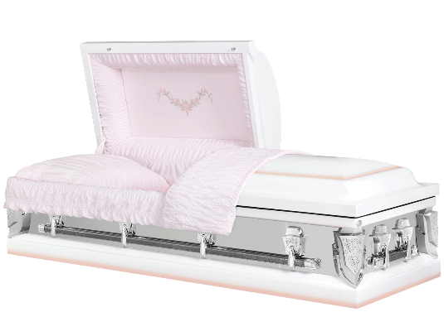
Essex/Mirrorside-20ga Steel ~ $3,895
White Finish with Pink Crepe Interior
Black Finish with White Crepe Interior
Spruce Blue Finish with Blue Crepe Interior

Mercury - 20ga Steel ~ $3,595
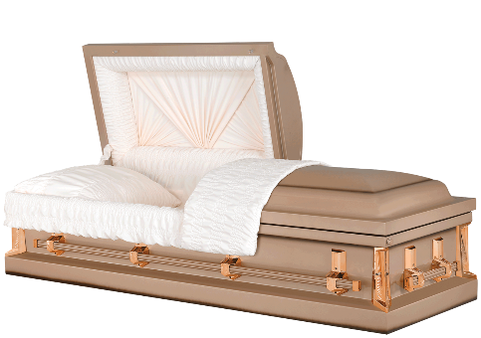
Copper Finish with Rosetone Crepe Interior Orchid Finish with Pink Crepe Interior White/Pink Finish with Pink Crepe Interior
Silver Finish with White Crepe Interior
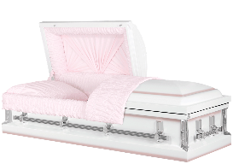
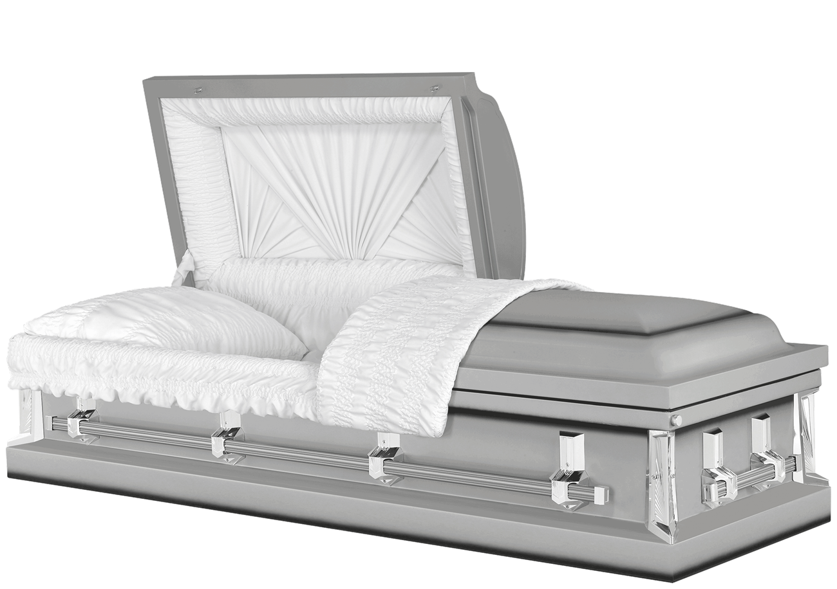
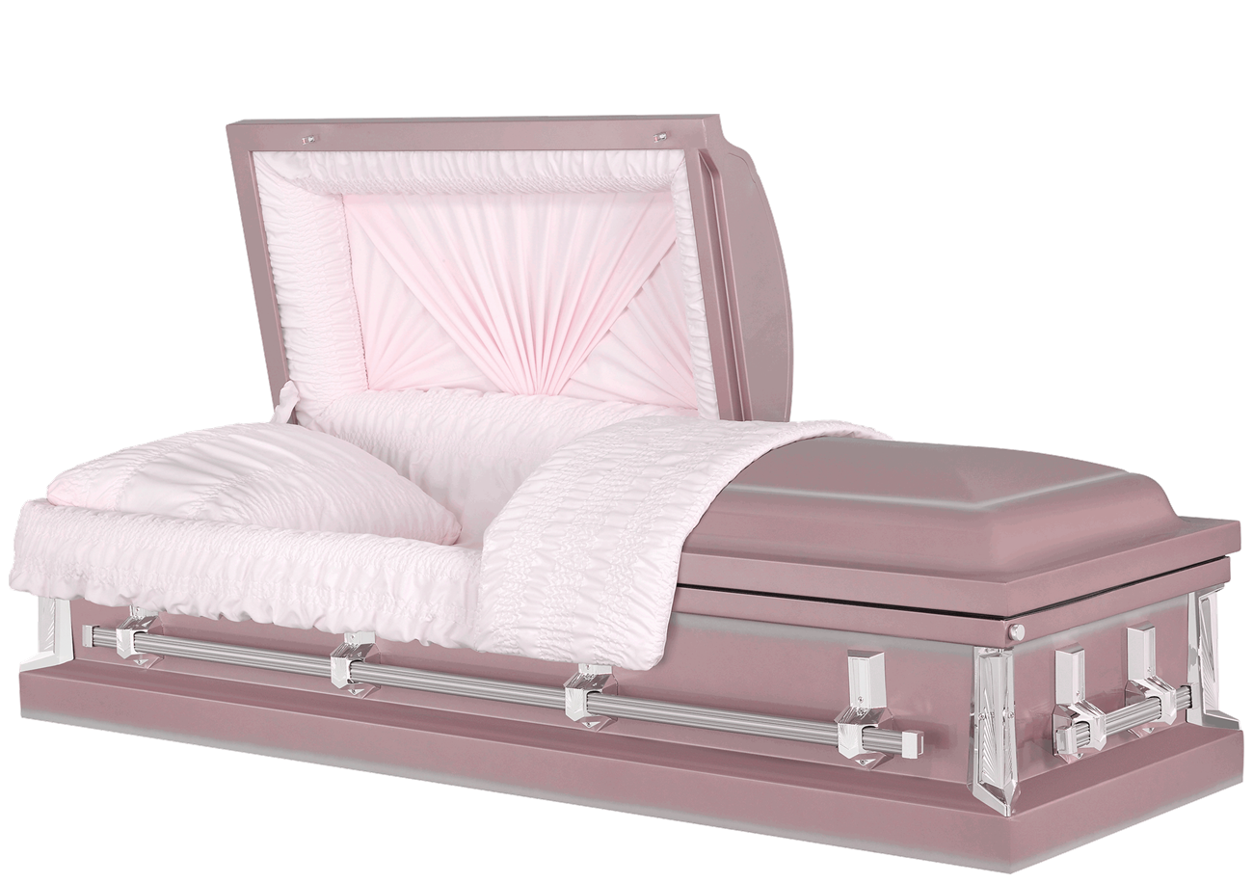

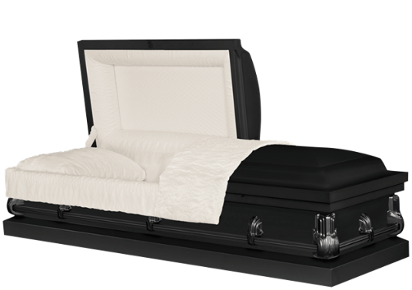

Baron - 20ga Steel, NON-GASKETED ~ $2,895
Blacke Finish with Crepe Interior
Silver Finish with Crepe Interior
Copper Finish with Crepe Interior
White Finish with Crepe Interior
Blue Finish with Crepe Interior
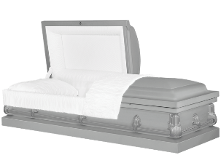
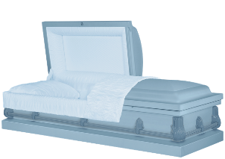
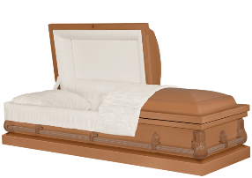
Alternative Containers

Cremation container; cardboard, no covering or interior
(meets minimum requirement of the crematory) $95
Combination casket/shipping container $300
Air tray (used in conjunction with a casket for shipping purposes) $300
Oversize Air Tray $375
Vinyl disaster pouch $150
Ziegler case, metal shipping container, sealed $625

Cremation Casket,
Longley, Carte Veneer, Cherry Finish, with Rosetan crepe interior -------------------------------------- $2,795
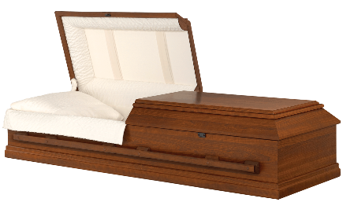

Rental Casket,
Oak Finish
shown below, with required cremation insert $995

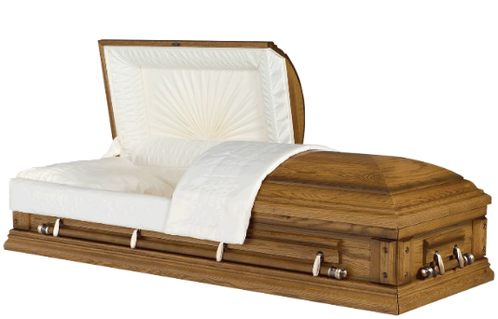

Steel Burial Containers Price List
These prices are effective as of September 1, 2025, but are subject to change without notice

13-gauge non-sealing steel grave liner, brown exterior color $1,595 This steel grave liner supports the weight of the surrounding soil and protects the casket. It does not seal!
.0125 Aluminum Vault $2,995
10-gauge galvanized steel Clark vault $3,195
7 – gauge galvanized steel Clark vault $4,195

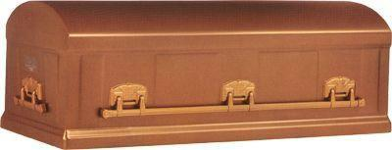
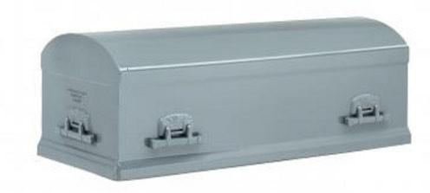
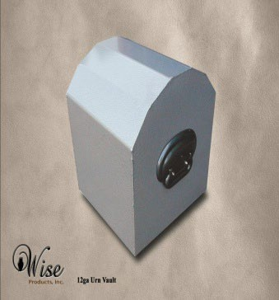  12-gauge steel Clark Economy vault –  $2,195 | 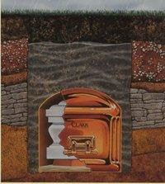  7 -gauge steel Clark standard vault - $4,195
Wise 12 gauge Urn Vault - $525 Polymer Urn Vault (not pictured) - $275 | Vaults help protect the casket from water and the weight of the grave dirt (about 1 ton) or cemetery tractors from damaging the casket.

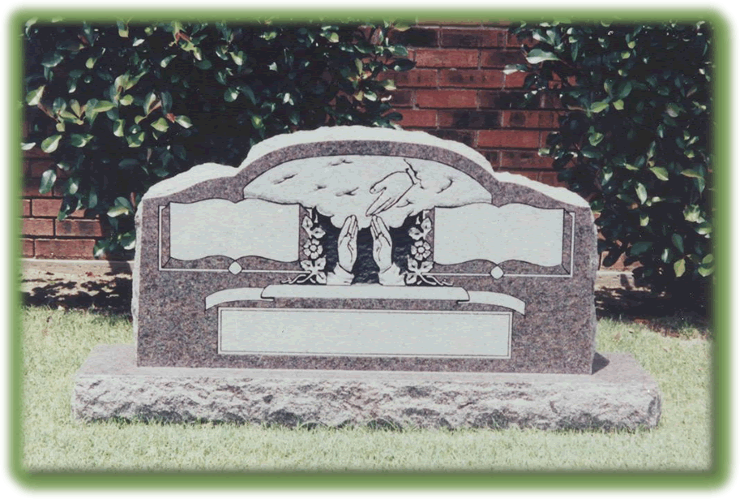
Monuments - Lawson Funeral Home offers a large variety of monuments for a lasting memorial to your loved one. Our full monument display at the funeral home includes a large variety of markers available in many sizes, colors, styles and prices. We also have a collection of artwork samples to customize the front of your marker at no extra charge. Call us at 254-435-2792 for details.
Outer Burial Container Price List
These prices are effective as of September 1, 2025, but are subject to change without notice.
A casket is commonly considered the final resting bed of a loved one. However, caskets are not designed to support the weight of the surrounding soil. Burial vaults are outer enclosures designed to support the weight of the soil and cemetery equipment. A burial vault should offer you peace of mind.

State or local law does not require that you buy a container to surround the casket in the grave; however, some local cemeteries require that you have such a container so the grave will not sink in. Either a concrete or steel grave liner or a burial vault will also satisfy these requirements.

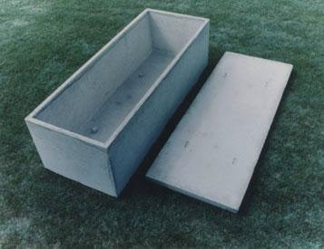  Concrete Non-sealing Grave Liner – The concrete liner is placed into the grave. After the service, the casket is lowered into the liner, and then the one-piece lid is positioned on top of the liner. This helps support the weight of the surrounding soil and protects the casket. | $1,795
Concrete Wilbert Monticello vault -- Approximate weight 2,500 lbs (Shown below)  Concrete Wilbert Continental vault (thicker concrete walls and lid)  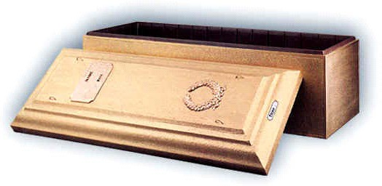  This sealing vault has a double wall construction: Steel reinforced concrete with a seamless, ribbed Durapreme lining.  The exterior is a hand-coated exterior with a personalized nameplate and symbol placed on the lid. The price includes  transporting the vault to the cemetery, set-up by the vault company, and vault personnel handling the actual sealing and lowering of the vault after the service ends.  OTHER CONCRETE SEALING VAULTS AVAILABLE | $2,395  $2,695
- Premium concrete vault, double lined, plastic / stainless steel ------------- | $4,595
- Premium concrete vault, double fined, plastic / copper --------------------- | $5,295
- Premium concrete vault, double lined, plastic / bronze ---------------------- | $5,995

Urn Price List
These prices are effective as of September 1, 2025, but are subject to change without notice.
Standard keepsakes $30
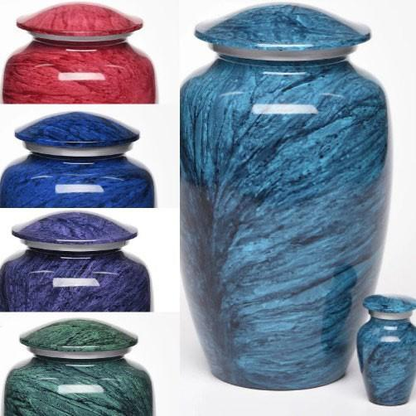  Jewel Marbled $185 | 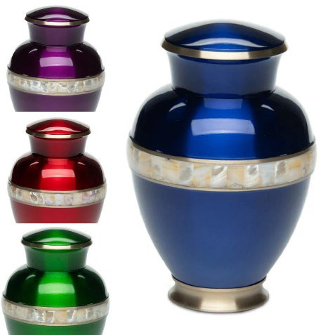  Mother of Pearl $175 | 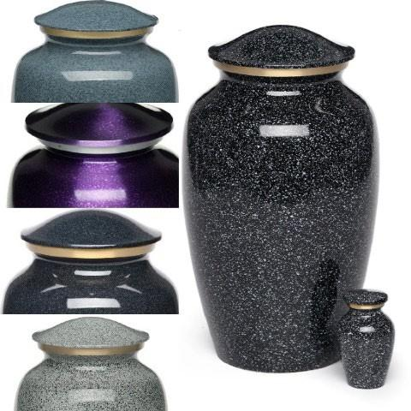  Speckled $175
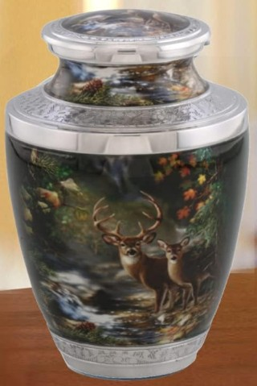  Deer in Forest $265  Rosewood Tower $200 | 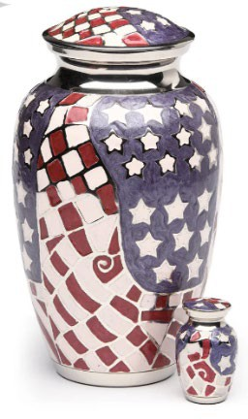  Stars and Squares $195  Classic Camo $195 |   Diamond Cut $215  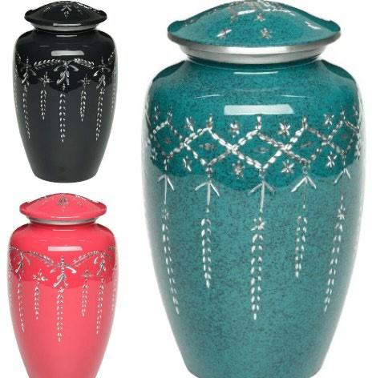  Silver Bands $185
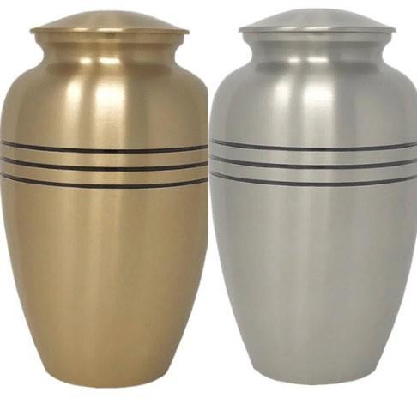
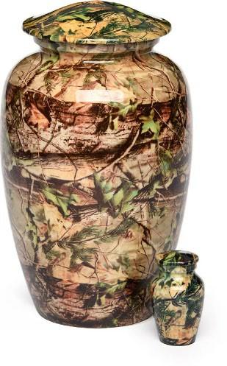
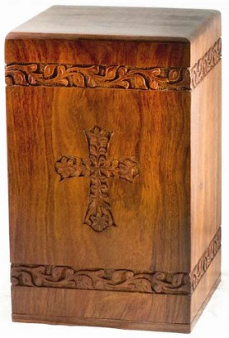
WORK SHEET

CHARGES FOR THE FUNERAL OF ________________________________________ DATE___________________
FUNERAL HOME CHARGES
- Service Charge……………………………………………………………………...$__________________
- Casket Cost…………………………………………………………………..….......$__________________
- Outside Container Cost……………………………………………..……………...$__________________
- Stationery Package………………………………………………..………………...$__________________
- Temporary Grave Marker…………………………………………........................$__________________
- DVD………………………………………………………………….………………$__________________

TOTAL………………………………………………………….$__________________

CASH ADVANCE/NON-GUARANTEED ITEMS:
- Open and Close Grave at…………………………………………………………..$__________________
- Cemetery Fee……………………………………………………………………….$__________________
- Rock Charge………………………………………………………………………...$__________________
- Flowers……………………………………………………………….……………...$__________________
- Death Certificates _____@$24.00 (1st)________@$4.00 each……………………$__________________
- Monument…………………………………………………………………………...$__________________
- Death Date Lettering……………………………………………………………….$__________________
- Minister Honorarium………………………………………………………………$__________________
- Musician Honorarium……………………………………………………………...$__________________
- Hairdresser/Barber…………………………………………………………………$__________________
- Newspaper Obituaries……………………………………………………………...$__________________
- Funeral Notices…………………………………………………………...................$__________________
- Other………………………………………………………………………………...$__________________
- TOTAL……………………………………………………………………………...$__________________

TOTAL CHARGES…………………………………………………………….$__________________

