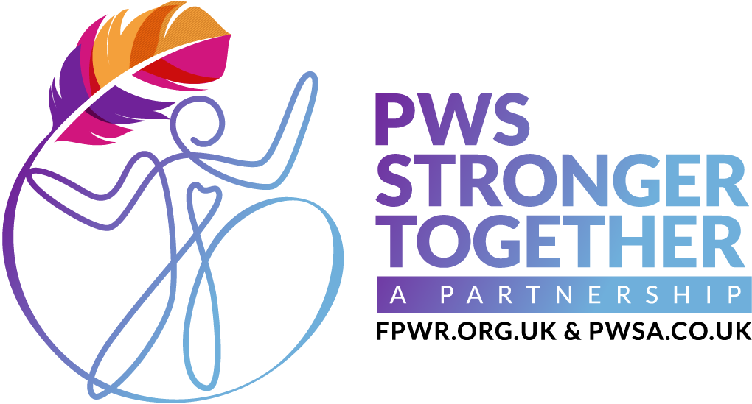
www.pwsstrongertogether.co.uk
E: info@pwsstrongertogether.co.uk

PWS Awareness Day 2026

Dear teachers,

As you have a pupil with Prader-Willi Syndrome at your school, we’re inviting you to participate in PWS Awareness Day on 15th May 2026.

On this day we’re asking schools to ‘Go orange for PWS’ and invite pupils to wear something orange,
(or brightly coloured) instead of their uniform and donate £1 to provide vital funds for support services and research into new treatments.

We will provide educational resources including assembly packs, so the day can be a learning opportunity for pupils, helping them understand the condition and how they can support people with PWS.

As you may know, PWS is a lifelong condition that affects physical health, cognition, and behaviour. One of the most distressing aspects is hyperphagia, an insatiable hunger that can lead to severe health complications. The condition is complex, requiring specialist medical care, structured support, and urgent advancements in treatment options.

Children and families with PWS can feel isolated and parents face a huge burden of care, coping with the complexity and demands of the syndrome alone.

Your school’s participation in this event would help to alleviate some of that suffering by educating the school community about how they can help support this family, and contribute vital funds to provide specialist services, and research into potential treatments.

Please go to https://bit.ly/PWSSchoolResources to register your school’s interest and find all the information and resources you need to participate in the day.

Thankyou

PWS Stronger Together team

