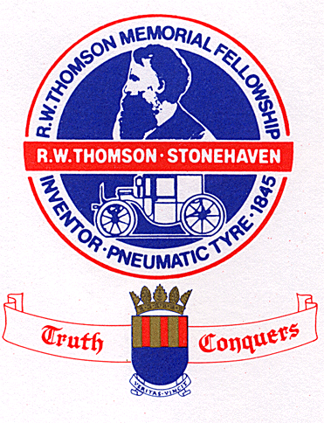
R W THOMSON MEMORIAL RALLY
MINERALWELL PARK STONEHAVEN AB39 2RD
SUNDAY 28th JUNE 2026

ALL exhibitors are asked to arrive between 08:00 - 10:00
Late arrivals will be judged at the organiser’s discretion but will NOT be admitted after 11:00
ENTRY CONDITIONS
An administration fee of £5.00 is payable for each entry.
Cheques should be made payable to – R W THOMSON MEMORIAL FELLOWSHIP.
Entries to be submitted by Monday 8th June 2026. Late entries will be accepted at the organiser’s discretion.
Entry numbers must be displayed prominently in all exhibits.
As a member of the Scottish Vintage Vehicle Federation (SVVF) the R W Thomson Memorial Fellowship are obliged to pass on details of any prize winners to the SVVF for the purpose of the preparation of the Champion of Champion event.

REGULATIONS
- I declare that the particulars given on this entry form are correct.
- I agree to save harmless and keep indemnified the R W Thomson Memorial Fellowship, Aberdeenshire Council and their respective officials, servants and representatives and agents from and against all actions, claims, costs, expenses and demands, in respect of death and injury to myself, my driver, my passenger or my mechanic, however caused, arising out of or in connection with this entry, or my taking part in this event and not withstanding that the same may have been contributed to or the occasioned by the negligence of the same promoters, their officials, servants, representatives or agents.
- I declare that the use of the vehicle hereby entered is covered by insurance as required by the Road traffic Act (1972) which is valid for such parts of this event as shall take place on roads as defined in this act.
- I declare that the vehicle hereby entered has passed the appropriate test under the Ministry of Transport Regulations (1960) and that I hold the appropriate current MOT certificate (where necessary)
- I agree to regard the ruling of the organisers as final and binding in all disputes, etc. Signature

TIMETABLE
ASSEMBLY 08:00 - 10:00
JUDGING 10:00 - 12:00
ROAD RUN 12:00 - 13:00
AWARDS PRESENTATION - 16:00

ENTRY FORM
The R W Thomson Memorial Rally was first held in 1967 to honour R W Thomson (1822-73) the inventor of the pneumatic tyre in 1845
(UK Patent 10990). It has been organised since 1976 by the Robert William Thomson Memorial Fellowship which was formed to perpetuate his memory in 1975.
CAR CLUB’S , ONE CONTACT NUMBER,EMAIL ADRESS , NUMBER OF CARS ENTERING
NAME ______________________________________________________
ADDRESS ______________________________________________________
______________________________________________________
______________________________________________________
POST CODE _______________________ TELEPHONE NUMBER ___________________________
EMAIL ADDRESS______________________________________________
MAKE & TYPE ________________________________ HP/CC ______________________________
YEAR OF MANUFACTURE ______________________ REGISTRATION ______________________________
_____________________________________________________________________________________________________
Entry form to be completed and returned by Monday 8th June 2026 with the appropriate fee to:
John Gillies
51, Forest Park,
Stonehaven
AB39 2GF. 07492370074
Gillies31@googlemail.com

