Name of child  (Including birthday child) | Sandwich choice  (Ham, cheese or jam) | Any additional notes:  (allergies/preferences)
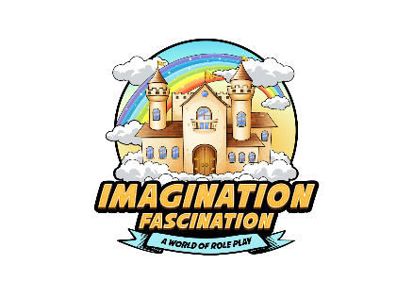
Imagination Fascination’s Party Package Food Information
Date and time of party: _______________________________________
Name of birthday child________________________________________

