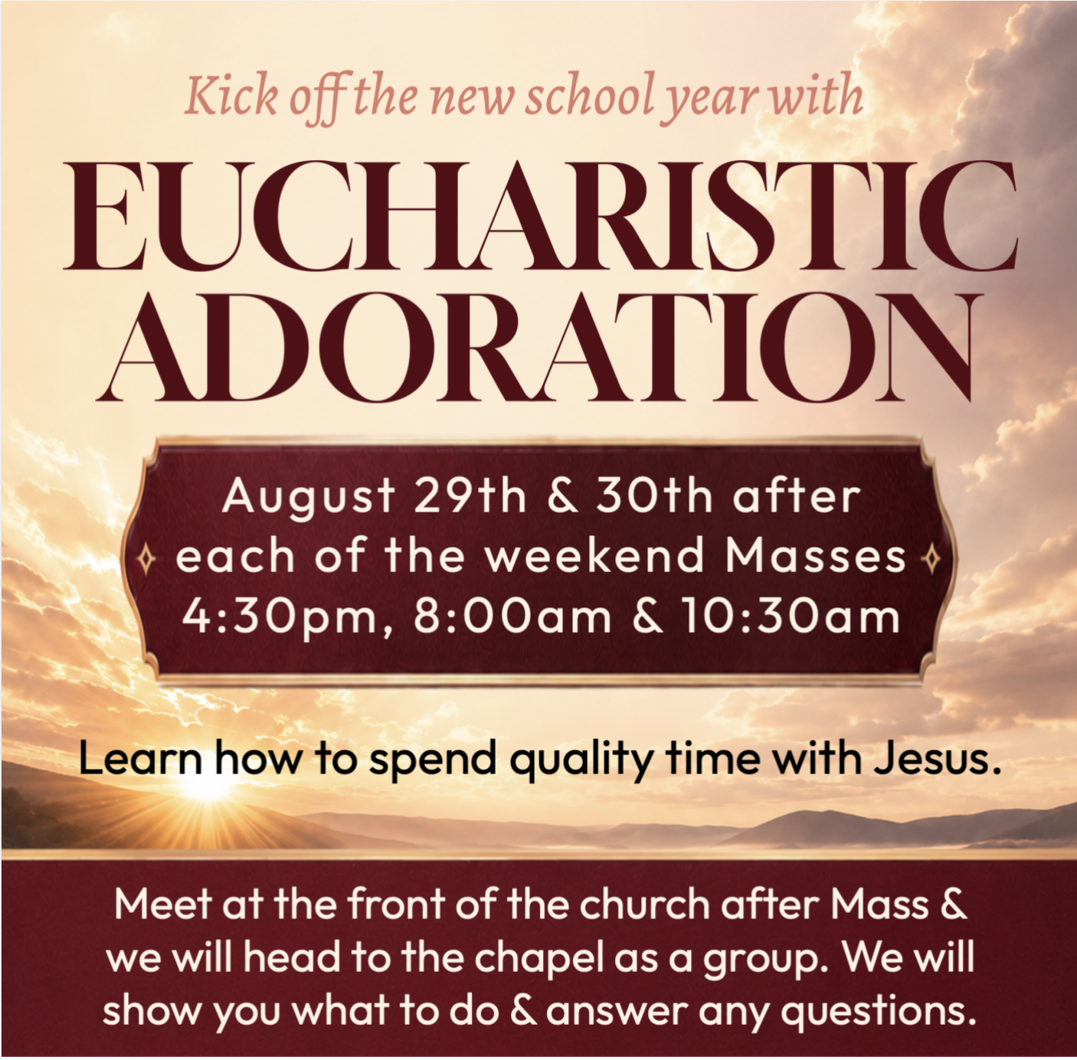

Adoration Chapel Testimonials:

What was at St. Benedict Church, a cry room for hungry crying babies and young children, is now St. Benedict Cathedral Adoration Chapel. A quiet and peaceful room adorned with a beautiful Tabernacle, housing our Blessed Lord, Jesus Christ in the monstrance. It could not be a more perfect setting to be at peace in prayer and reflection for what our Lord has provided us. We can sit or kneel and look right at Him in thanksgiving. I’m very grateful for this place to pray in thanksgiving. It’s one of my favorite places in our Cathedral. Remember, “you did not choose me, but I chose you…” John 15:16
Anonymous St. Benedict Parishoner
The reason I love Eucharistic Adoration so much is because sometimes life can beat you down and have you feeling low, but you can take comfort in knowing that the Lord is waiting for you in our Adoration Chapel. He wants you to come visit Him. If you can’t be there for an hour, that’s alright, He will take any time you have to give. Up until a couple of years ago, I really didn’t know anything about Eucharistic Adoration, and I have been Catholic since birth. There is no shame in not knowing, there is no wrong way in going to Adoration. Read the Bible, pray the Rosary, or just sit in silence. Every time I visit our Adoration Chapel, I always come out feeling better about my situation and have a stronger relationship with our Lord. Come visit the Lord in our Adoration Chapel. It is a very special place.
Anonymous St. Benedict Parishoner

When I first made Adoration of the Blessed Sacrament a habit, I prayed the Rosary, the Divine Mercy Chaplet, and other devotional prayers, along with personal prayers of praise, adoration, thanksgiving, and song. I would tell God what was on my mind and what I was struggling with. Over time, I was also, led to encounter God in stillness and in silence. At times God has made known to me His desires for me, who I am, and how much He loves me. When I enter the chapel with peaceful anticipation to spend time with our Lord, He has no expectations of me. He is just glad I am there.
Anonymous St. Benedict Parishoner

