Snow Removal Contract & Guidelines

Colonial Woods Association, Inc. (CWA) in Plainfield, Connecticut is now accepting snow removal bids for the upcoming 2026-2027 snow season. CWA will entertain bids that include rates per snow storm, per hour, and per complete season. CWA will also entertain Street Sweeping bids for the end of the season as well. A copy of CWA guidelines and the contract can be viewed at www.ctcolonialwoods.com or by calling 860-230-0556. Please note this number is not monitored 24-7. In order to bid, the below contract must be completed in its entirety and sent to CWA at 5 Colonial Road, Plainfield, CT 06374 by October 15, 2026. Please attach your bid as “Exhibit D.”

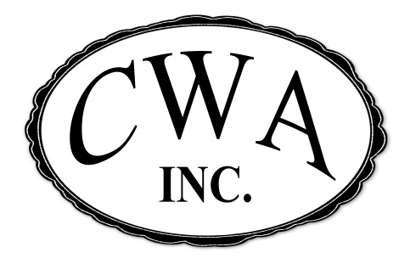
Colonial Woods Association, Inc.
5 Colonial Road
Plainfield, CT 06374
(860) 230-0556

Snow Removal Contract

This snow removal contract (“Agreement”) is entered into this ______ day of ______________, 20___, by ________________________________ (“Agent”) acting as the official agent of Colonial Woods Association, Incorporated (“CWA”) located at 5 Colonial Road, Plainfield, Connecticut and _________________________________ (“Contractor”) acting as the official agent and/or owner of __________________________________________.

Contractor’s Contact Name: ______________________________________________________
Contractor’s Address: ______________________________________________________
Contractor’s Phone #: (_____) _____-_______ FAX# (_____) _____-_______
Contractor’s Email: ______________________________________________________
Contractor’s Tax ID #: ______________________________________________________
Commencement Date: ______________________________________________________
Termination Date: ______________________________________________________

- Scope of Services: The Contractor shall perform these services outlined for CWA automatically and without need for any request: Salt/Sand mix all drive lanes, fire lanes, parking areas and sidewalks (Calcium Chloride on Sidewalks) on the property shown on Exhibit B attached hereto during ice accumulation. Plow drive lanes, fire lanes/hydrants, parking areas, and shovel sidewalks once two (2) inches of snow or ice accumulate. Snow removal shall be pursuant to the Snow Removal Guidelines attached as Exhibit A. Contractor’s prices for materials and rates are attached as Exhibit D.

- Terms: The term of this agreement starts on the Commencement Date set forth above and ends on the Termination Date set forth above.
- Payment: The contractor shall submit a “Snow Control Sheet” at the completion of each de-icing or plowing. This form can be found on Exhibit C of this contract. The Agent will not authorize payment unless this is completed. The Agent agrees to pay the Contractor after receiving invoice at the end of each month detailing/specifying each service date to include materials and the start/end time of each de-icing and plowing. This will be matched up with the Snow Control Sheet.

- Performance: The Contractor shall perform all Services diligently and in a good, professional and first class manner, using good quality materials, equipment and workmanship and sufficient trained personnel (including supervisors when appropriate) to complete the Services in a safe and timely manner which does not unduly interfere with the operation of CWA. The Contractor shall obtain and maintain, at its expense and at all times during the term of this Agreement, all necessary licenses, permits, training or other authorizations which may be necessary to perform the Services.
- Insurance: Throughout the term of this Agreement, the Contractor shall maintain insurance according to applicable laws including liability insurance. The Contractor shall deliver to the Agent a certificate of insurance evidencing that all such coverages are in full force and effect before starting to perform Services, and if Contractor’s insurance shall expire or terminate before the Termination Date, Contractor shall deliver a new certificate of insurance evidencing the new policies of insurance not less than ten (10) days before the new policies go into effect.
- Sub-Contracting: The contract shall not engage subcontractors to perform services without the Agents consent.

- Indemnification: Contractor assumes the entire responsibility and liability for, and agrees to pay, indemnify, defend and hold harmless Owner, Agent, and their respective principals, agents, affiliates, stockholders, directors, partners, members, officers, managers, employees, trustees and beneficiaries (collectively, the “Indemnified Parties”) from and against any loss, expense, liability, damage or cost (including, without limitation, judgments, attorneys’ fees and costs, court costs and the cost of appellate proceedings) which any of the Indemnified Parties incur because of injury to or death of any person or on account of damage to property (including, but not limited to, damage to buildings, curbs, parking blocks, islands, sidewalks, light poles, signs, landscaping, paving or striping of the Property or equipment used in connection therewith), including the loss of use thereof, or any other claim arising out of, in connection with or as a consequence of the performance of, or the failure to perform, the Services by Contractor, its agents, employees, subcontractors or any one for whose acts Contractor may be liable with respect to the Services. Contractor, for itself and its agents, employees and subcontractors, and any party claiming through any of them, also waives all right of recovery, claim, action or cause of action against the Indemnified Parties for any matters described in the preceding sentence. This indemnity shall not be limited by any limitation on amount or type of damages, compensation or benefits payable by contract or by any federal or state law.

- Default and Remedies: If Contractor fails to perform the Services as required by this Agreement or otherwise defaults under this Agreement, Agent, on behalf of CWA, may, in its sole discretion and in addition to any other rights at law or in equity, (1) send notice of the default to Contractor and demand strict performance of the terms of this Agreement; (2) cancel this Agreement by notice to Contractor; or (3) cure the default, without notice to Contractor, and deduct the cost to cure and any direct and consequential damages from any payment due to Contractor at the time of default or coming due thereafter; provided, if no further payments are due to Contractor, then Contractor shall, immediately on presentation of Agent’s invoice, reimburse Agent or CWA for the cost of curing Contractor’s default and such direct or consequential damages.

- Exculpation of Agent and CWA: The Contractor acknowledges that the Agent is acting solely as the managing agent for CWA and shall not be personally responsible for the payments due by CWA and/or performance by CWA of its obligations hereunder. Contractor agrees to look solely to CWA interest in the Property for such payment and performance and further agrees that no manager, director, member, partner, shareholder, officer, trustee, employee or agent of Owner shall be liable to Contractor beyond such interest.
- Miscellaneous: No failure of Agent or CWA to enforce the terms of this Agreement shall constitute a waiver by Agent or CWA of any contractual right under this Agreement. This Agreement may only be modified by a writing signed by Agent and Contractor. The rights and duties arising under this Agreement shall be governed by the law of the state in which the Property is located.

AGENT: CONTRACTOR:

________________________________________ ________________________________________
Signature Signature

Title: ___________________________________ Title: ___________________________________

Colonial Woods Association, Inc. Business: ________________________________

Subscribed and sworn to me this ________ day Subscribed and sworn to me this ________ day
of ________________________, _________. of ________________________, _________.

Exhibit A: Snow Removal Guidelines
Exhibit B: Property Map
Exhibit C: Time & Materials Form
Exhibit D: Payment Terms

Exhibit A
Snow Removal Guidelines

- Contractor shall provide its own employees, equipment, and supplies necessary to complete the services described hereunder which include clearing all drive lanes, fire lanes/hydrants, parking areas, sidewalks in front of mail house and clubhouse.

- Contractor will comply with all federal, state and local governmental laws, regulations, codes and ordinances.
- Contractor must maintain all applicable liability insurances and must not subcontract work without prior approval of CWA.

- Contractor shall not store any vehicles or equipment on CWA property when the vehicle is not in use. Equipment/vehicles can be staged on-site one day before anticipated snowfall.

- Contractor will begin plowing in Colonial Woods Association, Inc. as soon as the snow or ice reaches a depth of 2 inches, regardless of the time of day or night or the day of the week. For snowfall of less than 2 inches, sleet, or icy conditions, all roadways and walkways shall be sanded with sand/salt mixed. Contractor shall spread calcium chloride on concrete walkways as this will not harm concrete and landscaping.
- Depending on the intensity of the storm, the contractor may repeat plowing options at appropriate intervals. Note: Must maintain intersections/corners low for visibility.

- To prevent damage as in the past, CWA recommends the installation of stakes at all catch basins, intersections, and driveways at 196 /200 Colonial Road.

- All work shall be completed in a workmanlike manner consistent with customary industry practices, for the amounts agreed upon.

- Contractor shall supply and mechanically spread deicing rock salt and sand mix at Contractor’s own discretion.

- Contractor shall be responsible for damage to the Property caused by snow removal operations including, but not limited to, buildings, curbs, parking blocks, islands, sidewalks, light poles, signs, landscaping, paving or striping of the Property or equipment used in connection therewith.

- Contractor agrees to contact Colonial Woods Association, Inc. if for some reason the entire Property cannot be completely plowed within four (4) hours after snow or ice has stopped falling.

- Contractor agrees to complete the Snow Control Sheet attached for each plow and salting. To receive payment, this sheet must be completed immediately after the snow has been removed and placed in the box at the clubhouse (5 Colonial Road, Plainfield, CT 06374).

- Contractor agrees to provide Colonial Woods Association, Inc. with all current after hours telephone numbers.

Exhibit B
Property Map

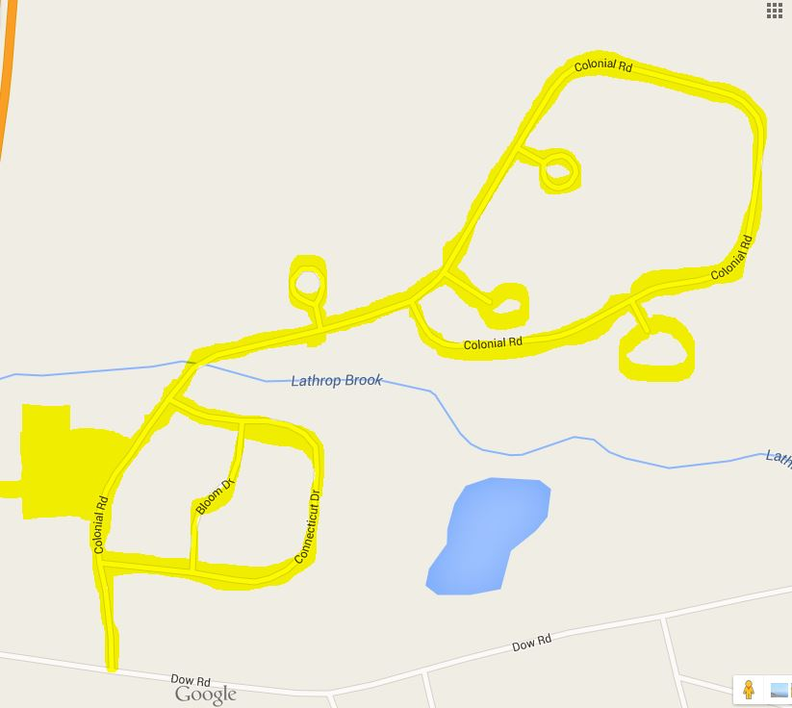
Clubhouse Parking Lot, Mailbox Area, and Sidewalks
Roadways and parking lot within Colonial Woods Association, Inc.

Exhibit C
Snow Control Sheet
(Each Section Must be completed after each job and placed in the box at the Clubhouse in order to receive payment.)
---------------------------------------------------------------------------------------
Start Date & Time: ____/____/____ @ ____:____ P.M./A.M.
End Date & Time: ____/____/____ @ ____:____ P.M./A.M.
____ Snow Plowing ____ Sand/Salting ____ Both
Please check One or Both if you completed both.
Amount of Product (Sand/Salt) and Notes (Any Problems, Etc.)
__________________________________________________________________________________________________________________________________________________________________________________________________________________________________________
---------------------------------------------------------------------------------------
Start Date & Time: ____/____/____ @ ____:____ P.M./A.M.
End Date & Time: ____/____/____ @ ____:____ P.M./A.M.
____ Snow Plowing ____ Sand/Salting ____ Both
Please check One or Both if you completed both.
Amount of Product (Sand/Salt) and Notes (Any Problems, Etc.)
__________________________________________________________________________________________________________________________________________________________________________________________________________________________________________
---------------------------------------------------------------------------------------------------------------------
Start Date & Time: ____/____/____ @ ____:____ P.M./A.M.
End Date & Time: ____/____/____ @ ____:____ P.M./A.M.
____ Snow Plowing ____ Sand/Salting ____ Both
Please check One or Both if you completed both.
Amount of Product (Sand/Salt) and Notes (Any Problems, Etc.)
__________________________________________________________________________________________________________________________________________________________________________________________________________________________________________
Exhibit D
Payment Terms

Pending: To be agreed upon.

