
Smile Therapy Corner
- • Why did the sun go to school in August?
Because it wanted to get brighter! ☀️
- 
☀️ Oil of the Month: OnGuard
August’s featured doTERRA oil is…..doTERRA On Guard®—a warm, spicy blend that feels perfect as summer begins to transition into fall. Its bright, inviting aroma makes it a wonderful addition to your home, diffuser, and everyday wellness routines. As schedules get busier and a new season approaches, On Guard is a great reminder to focus on healthy habits and self-care.

🍎 August Diffuser Blend:
• 2 drops On Guard
• 2 drops Wild Orange
• 1 drop Cinnamon

A warm, bright, and welcoming blend to help you savor the last days of summer! ☀️🍂

"🌿 Summer Vibes - Fresh Energy, Fresh You"
By Richard Oliver, LMT, Yin and Yang Massage
August is a month for making the most of summer, but busy schedules, travel, and outdoor activities can leave your body feeling tired and tense. Take time to listen to your body and give it the care it needs. Massage can help ease muscle tension, support recovery, and improve mobility so you can continue enjoying the activities you love. This month, remember to stay hydrated, stretch regularly, and make time for rest and recovery. Your body works hard for you—be sure to take care of it!
Business Community Spotlight: - Ink Nutz
Hi, we’re Ink Nutz, your local source for promotional products, branded apparel, business gifts, and recognition awards. We help businesses, organizations, teams, and individuals bring their ideas and brands to life with products that make a lasting impression.
From logoed shirts and hats to promotional giveaways, drinkware, bags, tech accessories, office supplies, custom awards, trophies, plaques, and personalized gifts, we offer an extensive selection to help businesses promote their brand, recognize their team, thank their customers, and stand out at events and trade shows.
At Ink Nutz, we understand that finding the right promotional product can sometimes feel overwhelming. That’s why we’re here to help you find products that fit your brand, your goals, and your budget. Whether you know exactly what you’re looking for or need inspiration, our team is ready to help you find the perfect way to make your message memorable.
Our goal is to make promotional products easy, creative, and effective. From employee recognition and corporate gifts to branded apparel and event giveaways, we help turn everyday items into opportunities to build brand awareness and connect with your customers.
If you're looking for a unique way to promote your business, recognize your team, or make a lasting impression, Ink Nutz can help you find the perfect product. Contact Ink Nutz at 425-327-0200 or andre@inknutz.com to get started, or visit www.inknutz.com to explore their extensive selection of promotional products, apparel, awards, and gifts.

Health & Vitality Report — August 2026
💕 THINGS TO DO AROUND TOWN 💕
🌞 August Wellness Tips & Tricks 🌞

August is the perfect time to enjoy the last stretch of summer while preparing your body for the busy months ahead. Stay hydrated, stretch before and after outdoor activities, and listen to your body when it needs rest. Small aches and muscle tension can build up over time, so don’t wait until discomfort becomes a bigger problem. A little movement, regular self-care, and massage can help keep you feeling balanced, mobile, and ready to enjoy the rest of summer!

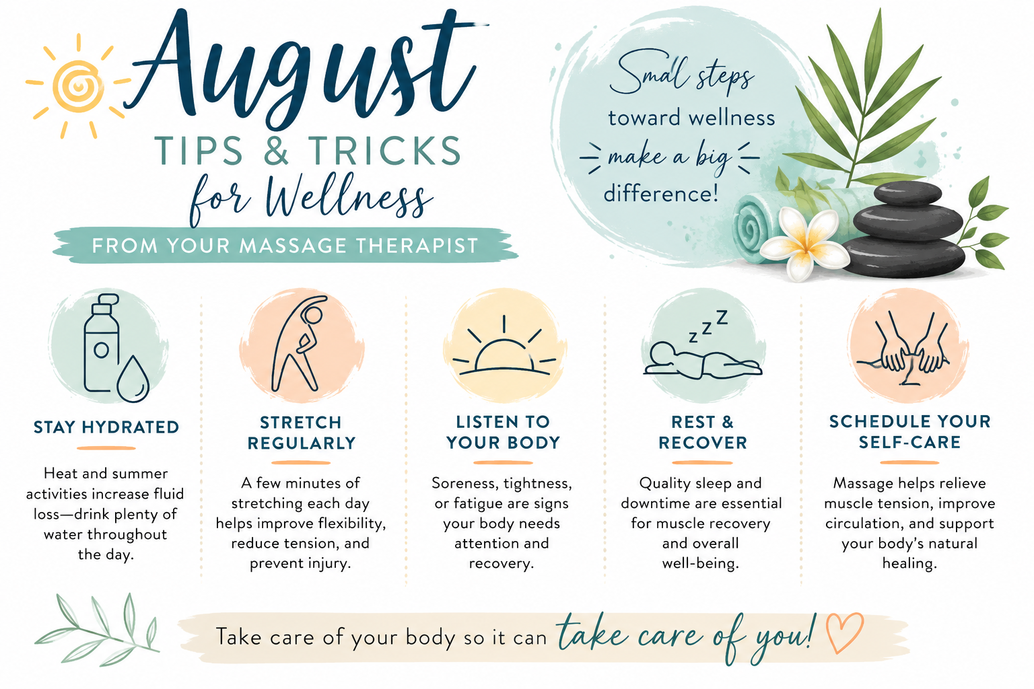

07/31-08/02- Tasty Nights, 2-10:00pm at Evergreen State Fair Park
08/01- Lake Tye Triathlon, 8:00am at Lake Tye Park
08/01- Granite Cup-Wing Sprints, 6:00pm at Evergreen Speedway
08/01-02- Washington Midsummer Renaissance Faire, at Sky Meadows
08/04- National Night Out Against Crime, 5:30-8:30pm at Lake Tye Park
08/04- Getting Back to Health with Dr. Rod Dahlinger, 6:00pm at Healthy Family Chiropractic
08/07- Movies under the Moon: A Minecraft Movie, dusk at Lake Tye Park
08/07-09- 37th Annual Sky Valley Stock & Antique Tractor Club Show & Threshing Bee, 9:00-5:00pm at Bob’s Corn & Pumpkin Farm
08/08-09- Washington Midsummer Renaissance Faire, at Sky Meadows
08/11- Getting Back to Health with Dr. Rod Dahlinger, 6:00pm at Healthy Family Chiropractic
08/14- Movies under the Moon: Zootopia 2, dusk at Lake Tye Park
08/14- Sound Bath with Stacie Cahill, 6:30pm at Healthy Family Chiropractic
08/14-15- NASCAR Tire Pros Summer Showdown, 6:00pm at Evergreen Speedway
08/15-16- Washington Midsummer Renaissance Faire, at Sky Meadows
08/18- Getting Back to Health with Dr. Rod Dahlinger, 6:00pm at Healthy Family Chiropractic
08/21- Movies under the Moon: Superman, dusk at Lake Tye Park
08/22-23- FairFest 3on3 at Galaxy Theatres
08/25- Getting Back to Health with Dr. Rod Dahlinger, 6:00pm at Healthy Family Chiropractic
08/27-09/07- Evergreen State Fair (Closed 09/02), at Evergreen State Fair Park
08/28- Movies under the Moon: How to Train Your Dragon, dusk at Lake Tye Park
08/29- Fair Days Parade & Market, 11-1:00pm, W Main St




Client Testimonial: A Journey to Relief and Renewal
If you are in need of a great massage look no further! I went after a car accident and although at that time it was not relaxing it was so beneficial! I know I recovered much faster because of the techniques used. Now I go to enjoy a relaxing massage that always helps me relax a bit more. – Staci C.

- Paul G.

Social Media

Check our pages for daily tips!
04/02 Getting Back to Health with Dr. Rod Dahlinger, 6:00 pm at Healthy Family Chiropractic
04/03—04/07 Spring Inaugural Hunger Jumper Show, Evergreen State Fairgrounds
04/05—04/07 Evergreen Spring RV Show, 10:00am—5:00pm at Evergreen State Fair Park
04/06 NASCAR Season Opener, Evergreen Speedway, 6:00pm
04/09 Getting Back to Health with Dr. Rod Dahlinger, 6:00 pm at Healthy Family Chiropractic
04/12—4/14 NW Model Hobby Expos, 9:00am—3:00pm at Evergreen State Fairgrounds
04/16 Getting Back to Health with Dr. Rod Dahlinger, 6:00 pm at Healthy Family Chiropractic
04/19 doTerra class with Staci Cahill, 6:00 pm -6:45 pm at Healthy Family Chiropractic
04/19 Sound Baths with Staci Cahill, 7:00 pm—8:30 pm at Healthy Family Chiropractic (registration required)
04/20 Superhero Bingo!, 5:00 pm—10:00 pm at Monroe Senior Center
04/20—04/21 Oddmall Emporium of the Weird “Sprung”, 10:00 am –4:00 pm at Monroe State Fairgrounds
04/23 Getting Back to Health with Dr. Rod Dahlinger, 6:00 pm at Healthy Family Chiropractic
04/26 Arbor Day Celebration, 12:00 pm—2:00 pm at Lake Tye Park
04/26—04/28 Evergreen Spring Home Show, 12:00 pm—6:00 pm at Evergreen State Fairgrounds
04/30 Getting Back to Health with Dr. Rod Dahlinger, 6:00 pm at Healthy Family Chiropractic

Client Success Stories

We’d love to hear your success story!
Email us at yinandyangmassage9@outlook.com.

Tips, Tricks, and Recipes for Better Health

