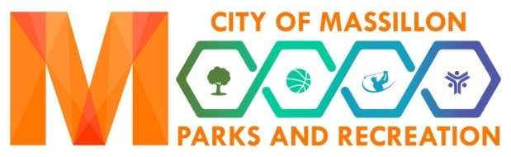

SWIM INSTRUCTOR, PART-TIME
WAGE RANGE: $11.05 - $13.00
DESCRIPTION:
This position is to teach children how to swim, keep them safe while in lessons, create and execute lesson plans, communicate with the parents, fill out evaluation forms, and other assigned duties.
REQUIREMENTS:
- Must be at least 18 years of age or have the approval of the Supervisor.
- Preferably a high school diploma or equivalent and some training in teaching swim lessons. (Will receive additional training onsite).
- Experience with customer service,
- Verbal and written communication skills.
- Previous experience teaching, ability to swim, and CPR/First Aid certification.
- Maintain First Aid & CPR Certifications. (MPRD will offer First Aid/CPR/AED courses to give you the opportunity to get certified).
- All applicants will be required to complete a background check.
RESPONSIBILITIES:
- Daily lesson plans
- Filling out Course Record forms accurately
- Filling out progress/completion cards for participants
- Enforce all pool rules and policies
- Be on time and prepared for class.
- Attending all trainings and in-service meetings.
- Other duties as assigned

This position reports directly to the Aquatic Supervisor.

