

August 17, 2026

Members in attendance: Tim Brown, Rebecca Ferguson, John Janas Edward Metzger, Marlene North, Virginia Nuzum

Members absent/excused: Jerry Miller

Guests: Julie Sprague, Amy Brinkman, Rachel Smith, Scott McKeown, Charese Botjer, Kristin Nagel, Audrey Stock, Danielle Perkins, Joanne Hayward, Stacy Cox, Lynne Beard, Stacey Rife, Melissa Coe, Amy Knauss, Brent Baer, Rhonda Kendall

Approval of Minutes
On a motion made by Edward Metzger and seconded by Marlene North, the Board approved the June 15, 2026, meeting minutes. All ayes recorded. Motion carried.

Wood County Fair Update
Ms. Charese Botjer, Communications and Community Engagement Manager, announced that the Wood County Fair co-hosted Let Your Abilities Shine Day for the third consecutive year, welcoming individuals with developmental disabilities, along with their families, guardians and staff, from across Ohio for a free, sensory-friendly and inclusive fair experience.

Ms. Botjer also shared that the excitement continued with two additional events:
- Ring of Dreams: More than 90 participants of all ages had the opportunity to showcase their hard work from throughout the summer and shine in the ring.
- Kiddie Pedal Pull: Hosted by the AKtion Club, this year’s event welcomed more than 100 participants!

Ms. Botjer noted that accessibility remained a priority throughout the entire fair week, helping ensure an inclusive and welcoming experience for all.
announced that accessibility remained a priority throughout the entire fair week.

Policy Updates
Superintendent Baer announced that the Wood County Board of Developmental Disabilities routinely reviews the practices of its daily operation with a focus on increasing efficiency. Superintendent Baer announced that the following policies have been identified for creation, updates, and/or obsoletion:

On a motion made by Rebecca Ferguson and seconded by John Janas, the Board approved the creation of the following policy:

- Artificial Intelligence -The Wood County Board of Developmental Disabilities has determined the need to create a policy to establish clear guidelines for the ethical, responsible, and compliant use of artificial intelligence (AI) technologies. All use and utilization of artificial intelligence must comply with:
- HIPAA (Health Insurance Portability and Accountability Act)
- FERPA (Family Educational Rights and Privacy Act)
- Ohio privacy and cybersecurity laws
- WCBDD confidentiality and records retention policies

All ayes recorded. Motion carried.

On a motion made by Rebecca Ferguson and seconded by Marlene North, the Board approved to update the following Health Information Portability and Accountability Act Policies in conjunction with the Artificial Intelligence Policy:

- HIPAA Privacy
- HIPAA Security
- HIPAA (Identity Verification for PHI Release)
- HIPAA (Minimum Necessary Use and Disclosure)
- HIPAA (Permissive Information Disclosure)
- HIPAA (Requests for Extra Restriction on Use and Disclosure of PHI)
- HIPAA (Use and Disclosure of PHI for Personal Representatives, Minors, and Deceased Individuals)

All ayes recorded. Motion carried.

On a motion made by Rebecca Ferguson and seconded by Edward Metzger, the Board approved the following policy for updates:

- Transfer/Promotion Salary Placement – The policy is updated to reflect consistent language with the agency salary schedule.

All ayes recorded. Motion carried.

On a motion made by John Janas and seconded by Rebecca Ferguson, the Board approved to obsolete the following policy:

- Nutrition Standards for WLS – The policy for Nutrition Standards for WLS should be obsoleted as a new policy for Food Service Standards was developed and approved by the board at its April 2026 meeting to meet updated requirements by the Ohio Department of Education and Workforce. The new policy addresses the information contained in the Nutrition Standards for WLS therefore creating the opportunity for obsoletion.

All ayes recorded. Motion carried.

Board Training Opportunities
Superintendent Baer announced that the Ohio Administrative Code OAC 5123:2-1-13, in-service training for members of county boards of developmental disabilities, states that board members must complete a minimum of four (4) hours of in-service training annually. The rule also states that the director would identify topics related to the developmental disabilities service delivery system to be addressed during in-service training. Lindsay Nash, Director of the Ohio Department of Developmental Disabilities (DODD) has identified the following topics for 2026 County Board Member Training: DODD Director updates (1 hour) and System Funding Overview (1hour). It should be noted that Director Nash has identified that the Superintendent may choose any topic they feel would be most helpful for board members.

Superintendent Baer stated that the board has completed two (2) hours of the required annual training hours. Superintendent Baer also stated that the board would complete the remaining two (2) hours immediately following the September and October board meetings.

Personnel Actions
The Board reviewed the personnel actions as submitted.

Bus Transportation Manifest
On a motion made by John Janas and seconded by Rebecca Ferguson, the Board approved the Bus Manifest. All ayes recorded. Motion carried.

Wood Lane School Playground Sitework – Accept/Reject Bid
Mr. Scott McKeown, Director of Operations, announced that the 2026 Capital Plan includes renovating the Wood Lane School Playground. Mr. McKeown stated that the Wood County Board of Developmental Disabilities contracted with OHM Advisors to design and specify this project. The 2026 Capital Plan appropriated $1,935,000 for this project.

Mr. McKeown stated that after two unsuccessful bid openings, the Board authorized a third bid opening, structured as a Base Bid with five alternates:

- Electrical installation – power from the school to the gazebo area
- Basketball Court plus trees and landscape
- Reflexology Path (sensory) plus crushed gravel path, trees, and landscape
- Pavers (sensory) adjoining a traditional concrete walking/biking surface
- Entrance/Path from Pool parking lot to playground plus trees and landscape

The site work construction estimate was also increased from $745,350 to $845,350.

Mr. McKeown announced that three bids were received:

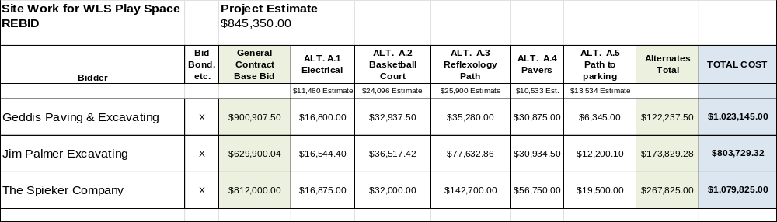
Mr. McKeown announced that after meeting with the Wood County Board of Developmental Disabilities Personnel Committee, it was determined not to recommend Alternate A-3 Reflexology Path for acceptance by the Board, for the following reasons:

- At a cost of $77,632.86, this Alternate is priced three times higher than the architect’s estimate.
- By accepting the less expensive Alternate A-4 Pavers, the playground retains sensory surface elements for students.
- Elements of this section of the playground can be installed in the future without limiting the immediate utilization of the playground.

On a motion made by Rebecca Ferguson and seconded by Edward Metzger, the Board authorized the Superintendent to enter into a contract with Jim Palmer Excavating, Inc. in the amount of $726,096.46 for the Wood Lane School Playground Site Work as well as a ten percent project contingency fund in the amount of $72,609.00. This authorization includes acceptance of the Base Bid and Alternates 1, 2, 4, and 5. All ayes recorded. Motion carried.

Expenditures and Receipts
On a motion made by Edward Metzger and seconded by John Janas, the Board approved the expenditures and receipts as presented in the Fiscal Report. All ayes recorded. Motion carried.

Adjournment
On a motion made by Rebecca Ferguson and seconded by Marlene North, the Board approved to adjourn the meeting at 3:25pm. All ayes recorded. Motion carried.

___________________________ ______________________________
President Secretary

