September 1, 2026 Executive Committee Minutes
Attendance
Members Present: George Thompson, Casey Wilkinson, Kevin Harris, Wendy Andersen, Charlene Sauer
Staff Present: Brooke Lovelace, Carlyn Crowe, Melissa Thomas
Call to Order
The meeting was called to order at 10:34 a.m. by Thompson. Sauer joined the meeting later.

Council Recognition
Thompson shared that Easterseals Iowa will recognize the Iowa Developmental Disabilities Council for its advocacy work. The award event will be November 12, 2026, after the full Council meeting. Council staff and Wilkinson and Thompson will attend. We have five additional seats. Members who want to attend should contact Thompson or Council staff.

2026 Budget Review
Lovelace reviewed the 2026 budget through July. August costs were not final yet. Staff will share the August report at the September full Council meeting.
The committee reviewed Capture Management and Campbell/Patterson invoices, contract work summaries, and quarterly reports. Lovelace explained that Capture supports the website, Zoom, accessible reading tools, events, publications, conferences, the mailing and email database, annual survey and other outreach work. Campbell/Patterson supports public policy work. Both contractors report how their work supports the state plan.
Members asked about the post office box, conference exhibit fees, database costs, hard-copy mail, and whether some contract work could be done by staff. Lovelace said the post office box is in the current Capture contract. The database tracks the DD Council network, event attendance, and legislative districts. Hiring additional staff to replace contract work has historically been hard to do. We would still need to have a contract to do manage and host website
Lovelace said the Council will need to make choices about future contracts in November and January. Members were asked to review the quarterly reports and send questions to Lovelace.

2027 Budget Approval
Lovelace reviewed the proposed 2027 budget. HHS and Human Resources costs are expected to be lower. Cell phone and internet costs will be higher because some costs moved out of the HHS cost line. Even with salary increases, the full budget is lower than last year.
Members discussed Workday fees, computer replacement, and new state cell phones. Andersen made a motion to approve the 2027 budget. Wilkinson seconded the motion. The motion passed unanimously. The 2027 budget will go to the full Council for a vote.

Council Evaluation Review
Thompson reviewed themes from the Council survey. Feedback was mostly positive. Members asked for clearer ways to suggest meeting topics and understand which choices are made by the Executive Committee or the full Council. Wilkinson did a data analysis of the council evaluation and shared the charts included in an addendum to the minutes.
Thompson and Wilkinson also met with HHS Human Resources about a new performance review process. They are working on six questions tied to six job skills. The goal is a clearer and more fair review process. The Executive Committee will review the plan before any survey is sent. More information is expected by the November Executive Committee meeting.

State Plan Progress Committee
Wilkinson suggested keeping a State Plan Progress Committee to track how the five-year state plan is working. The group could meet every few months, review reports already prepared by staff, and give a short update at full Council meetings.
Members supported the idea and said the group should not repeat staff work. State agency members may also serve on the committee. Wilkinson will present the idea at the September 10 full Council meeting and ask who wants to join.

Bylaw Changes
The committee reviewed bylaw changes that had been discussed before. The membership section would allow a member to be an employee of a state agency. The Public Policy Committee section would add a vice chair, set the number of at-large members at three, and make voting roles clear. The meeting section would add the $50 stipend for self-advocates and family advocates and require a stipend reminder at each Council meeting.
Sauer made a motion to approve the bylaw changes as listed. Harris seconded the motion. The motion passed unanimously. Staff will make sure the full Council has the proposed changes. The changes will go to the full Council for a vote in November.

November Executive Committee Meeting
The committee agreed to use a Doodle poll to choose the November Executive Committee meeting date and time.

Future Meeting Topics
Members supported having Iowa Medicaid staff speak at the November full Council meeting about community engagement requirements, also called work requirements.
Members also asked for an update on the delay to the HOME project and waiver redesign. Lovelace will ask Andrea Maher to share an update at the September full Council meeting and will ask when a longer presentation would be helpful.

Member Update
Sauer said she will attend fall Council meetings online and may join late because of a teaching job.

Adjournment
With no other business, the meeting adjourned at 11:53 a.m.

Action Items
Task | Responsible
Finish the August budget report for the September full Council meeting. | Lovelace, Thomas
Review Capture and Campbell/Patterson quarterly reports and send questions. | All Members
Send Council survey charts for the meeting notes. | Wilkinson
Share the Council survey charts with the meeting notes. | Thomas
Prepare the updated performance review plan for Executive Committee review. | Thompson, Wilkinson
Present the State Plan Progress Committee idea and ask for members at the September 10 full Council meeting. | Wilkinson
Send the approved bylaw changes to the full Council for a November vote. | Staff
Send a Doodle poll for the November Executive Committee meeting. | Thomas
Add Iowa Medicaid community engagement requirements to the November full Council agenda. | Lovelace
Ask Andrea Maher to share a HOME project and waiver redesign update at the September full Council meeting. | Lovelace

Zoom link:
https://capture.zoom.us/j/88360257901?pwd=aPE4aBaJut0Y6DrF1nwaCAthSQaEeU.1
Passcode:
420695

Addendum to minutes:
Casey’s charts

Addendum to Minutes

Chart 1
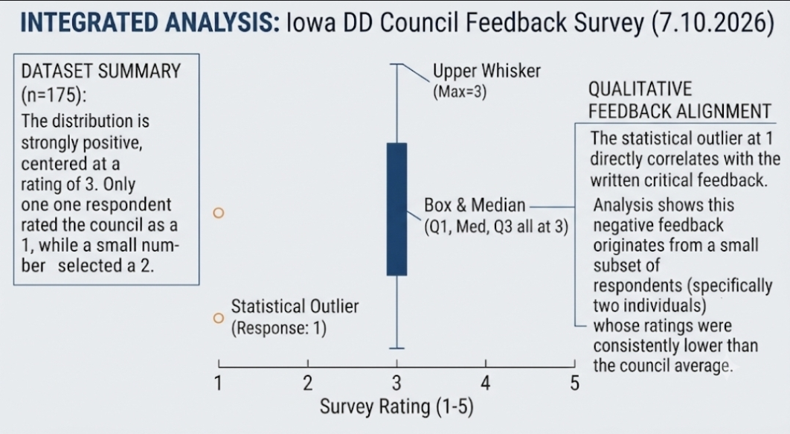

Chart 2
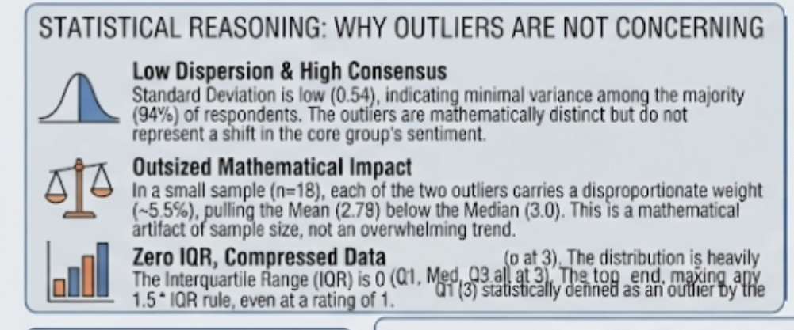

Chart 3
