Bumblebee Class
Autumn Term Newsletter 2025
Welcome to Bumblebee Class!

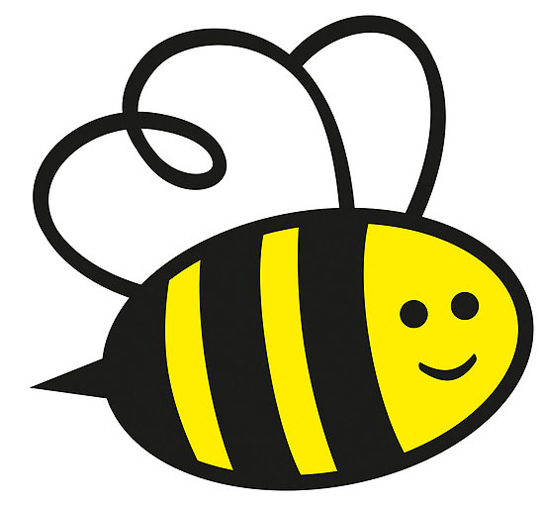
We are very excited about the new school year and are very much looking forward to teaching your children. If you have any questions or concerns, then please come and have a chat with Mrs Hooper or Mr Boote, before or after school. Alternatively, please email us on: Bumblebees@ashill.norfolk.sch.uk

Mrs Hooper will be teaching Monday-Wednesday and Mr Boote will be teaching Thursday-Friday. Our teaching assistants are Mrs Baker and Mrs Mower.
Mrs Grigg will be in Bumblebees on Monday afternoons from 1:00, to cover Mrs Hooper’s planning time. PE sessions are to be confirmed.

In the mornings, please arrive between 8:45 and 8:55am. Please say goodbye to your child on the playground. At the end of the day, your child will be sent out to you from the hall doors and onto the playground at 3:15pm. Please let us know if someone different will be collecting your child from school, either in person or by phone to the school office. Please do not let your child or their siblings play on the climbing equipment before or after school. Thank you.

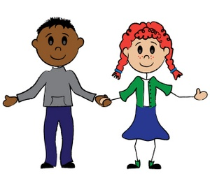 |  | Our first topic is “Ourselves”. If you haven’t done so already, please bring in the “All About Me” booklet which we gave out before the summer holiday. We will be sharing these in class together. Don’t worry if you have misplaced yours, just ask us for another one!  Please see the Bumblebee page of the school website for more information on our topic.
Phonics | We will be sharing lots of different story books and the children will also be taking part in a range of speaking and listening activities. In the coming weeks, we will begin teaching children the letter sounds (phonics).  Further details about how Phonics is taught in Bumblebee Class will follow shortly.
Maths | To start with, we will sing number rhymes, such as ‘5 Little Ducks’ and ‘5 Little Speckled Frogs’. We will also be looking at some simple number stories together.
What to bring | We will provide all of the stationery your child will need.  Please keep toys safely at home.  Bring in a named water bottle each day – containing water or weak sugar free squash if required.  A packed lunch and drink if your child is not having a school lunch.  A pair of wellies – ideally these will be left at school.  A waterproof coat as we spend a lot of time outdoors. Please provide a sunhat and apply suncream before school on sunny days. Please make sure you provide a warmer coat when the weather turns colder, as well as a hat and gloves.  A backpack or school book bag big enough for your child’s reading book and diary.

