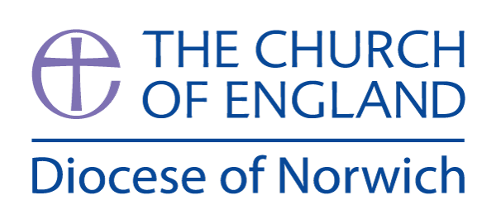
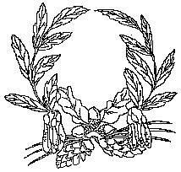

Ashill V.C. Primary School
My Learning Discovery
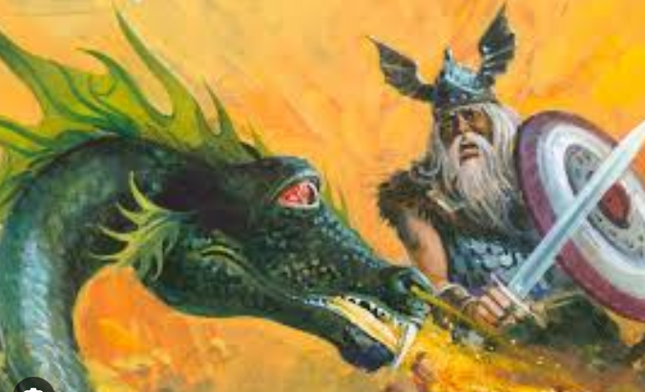
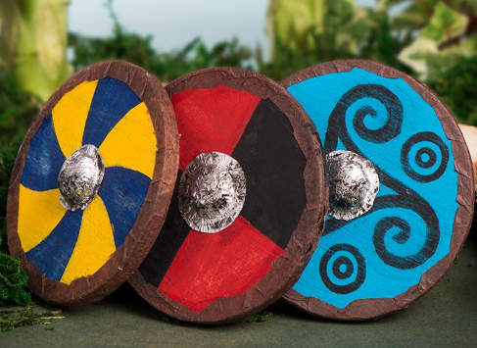

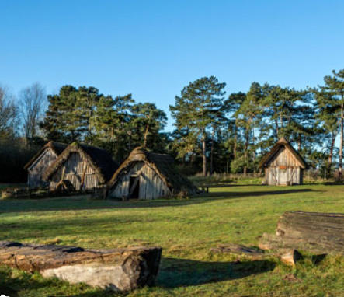
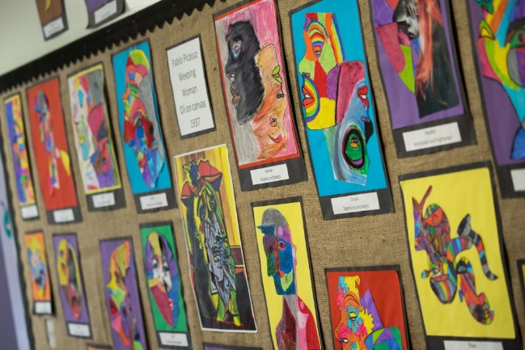

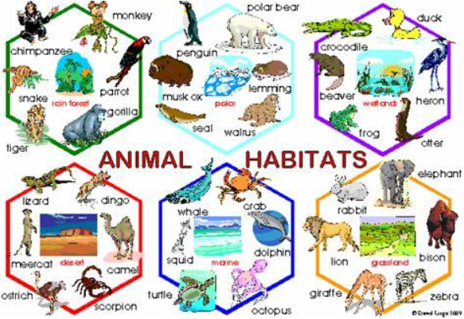
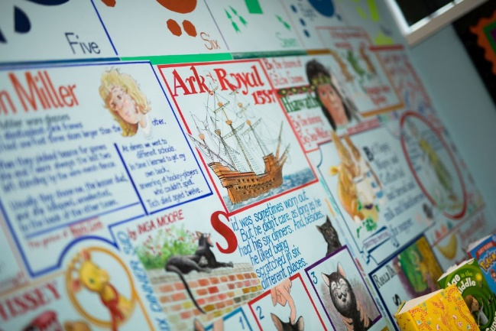

Year 5/6
Invaders and Settlers - Summer Term 2026

Invaders and Settlers
We have chosen the text ‘Beowulf’, as it is an epic Anglo-Saxon legend that is brilliantly recreated by an award-winning author/illustrator team. In fifth-century Denmark, a murderous monster stalks the night, and only the great prince of the Geats has the strength and courage to defeat him. Beowulf's terrifying quest to destroy Grendel, the foul fiend, a hideous sea-hag and a monstrous fire-dragon is the oldest surviving epic in British literature. Artfully retold and magnificently illustrated, this companion volume to Sir Gawain and the Green Knight is made instantly accessible to children by a formidable children's book partnership.

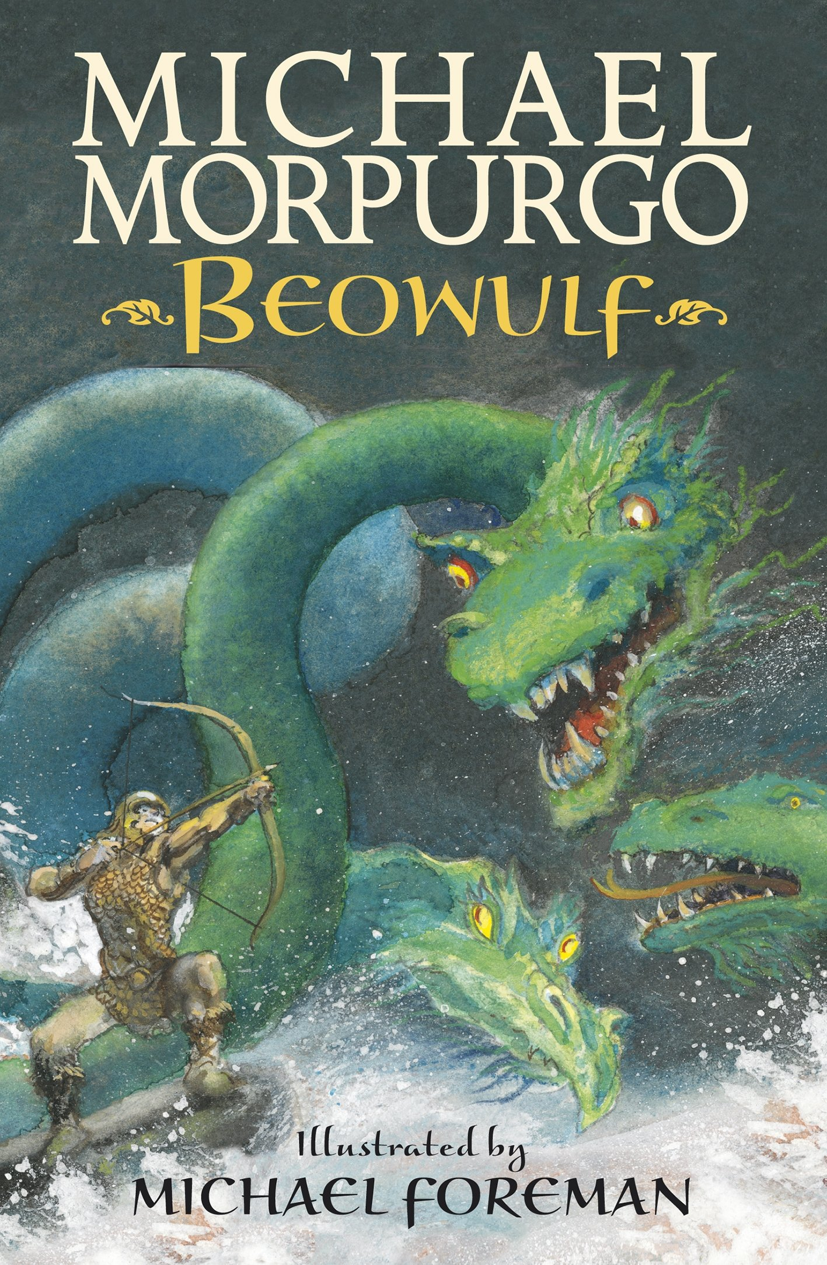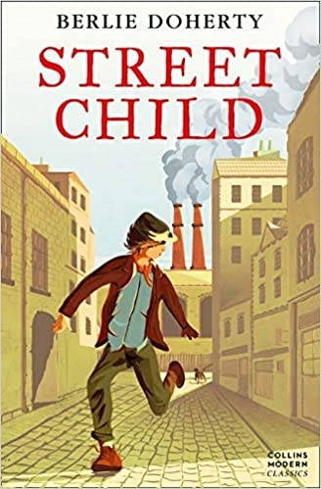

During the second half of the terms, we will be reading The Vikings: Raiders, Traders and Adventurers! We will travel back in time to the amazing world of the Vikings with award-winning author-illustrator Marcia Williams. We will meet legendary warriors, daring explorers and clever kings in this colourful introduction to the Vikings. We will join Marcia Williams and discover incredible stories of Viking raids, voyages of discovery and conquered kingdoms. Told in comic-strip style and packed with jokes and facts, this is the perfect guide to the Viking world.

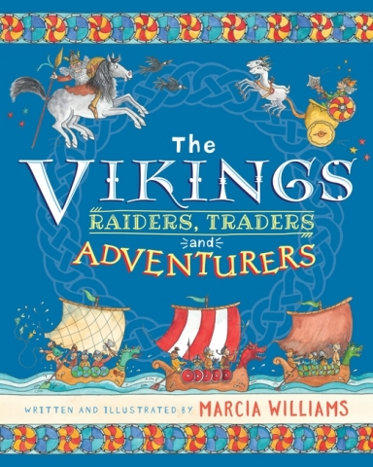

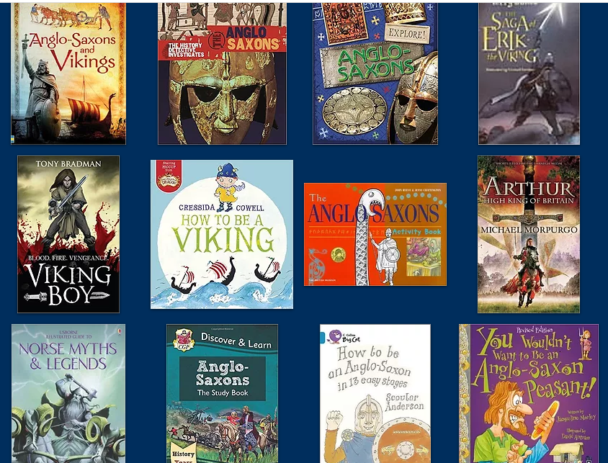

Further opportunities in Maths and English:
Maths | English
- Calculating distances between UK and Scandinavian countries | - Writing our own myths  - Comic-strip stories based on historical events

During the first half term, in Science, we will be continuing to focus on 'living things and their habitats'. We will continue our work on classifying animals, plants and micro-organisms. We will learn about the Linnaeus classification system, how it works and how different species of organisms that are closely related can be identified.
Science
Year 5 | Year 6
- I know that organisms can be grouped according to their characteristics.
- I can describe the characteristics of different classifications of animals.
- I can match animals to their group according to their characteristics.
- I can classify organisms according to broad characteristics.
- I can find ways to distinguish between organisms that are similar.
- I can use appropriate scientific vocabulary to describe organisms and their features.
- I know that plants can be sorted into groups according to their characteristics.
- I can explain the difference between vascular and non-vascular plants.
- I can explain the difference between flowering and non-flowering plants.
- I know who Carl Linnaeus is and how he contributed to science.
- I can give reasons for why classification systems are important.
- I know what micro-organisms are.
- I know that micro-organisms can be classified into groups.
- I understand that some micro-organisms can be harmful and others can be helpful.
- I can identify and classify a variety of different organisms found in their local environment.
- I can use a variety of sources of information to identify organisms I am unfamiliar with.

In Design Technology in the second half term, we will be making the staging and costumes for our end of year production, The Wizard of Oz. We will also be learning interesting information and practical activities to help us learn all about great British food. We will explore some sweet and savoury national dishes of England, Scotland and Wales, before moving on to developing an understanding of how cuisines from other countries have influenced what is eaten in Britain today.
Design Technology
Year 5 | Year 6
Developing, planning and communicating ideas  - I can produce a detailed step-by-step plan for their design method  - I can suggest some alternative designs and compare the benefits and drawbacks to inform the design process and outcome  Working with tools, equipment, materials and components  - I can choose appropriate tools and materials to ensure that the final product will appeal to the audience  - I can use a range of tools and equipment with good accuracy and effectiveness, within established safety parameters  Evaluating processes and products  - I can assess how well their product works in relation to the design criteria and the intended purpose and suggest improvements  - I can evaluate appearance and function against the original design criteria?  Construction  - I can use a range of measurements improves accuracy  - I can demonstrate that their product is  strong and fit for purpose | Developing, planning and communicating ideas  - I can use a range of information to inform their design  - I can consider culture and society in their designs  - I can consider the use of the product when selecting materials  Working with tools, equipment, materials and components  - I can choose appropriate tools and materials to ensure that the final product will appeal to the audience  - I can use a range of tools and equipment with good accuracy and effectiveness, within established safety parameters  Evaluating processes and products  - I can test and evaluate my final product  Construction  - I can use measurements that are accurate enough to ensure precision  - I can demonstrate that my product is strong and fit for purpose
Cooking
- I understand and can apply the principles of a healthy and varied diet
- I can prepare and cook a variety of predominantly savoury dishes using a range of cooking techniques
- I understand seasonality, and know where and how a variety of ingredients are grown, reared, caught and processed

In History, we will recap when and why the Romans left Britain and consider what happened in the period after their departure. We will find out about the seven Anglo-Saxon kingdoms and find out what life was like for everyday Anglo-Saxons in the period directly before the Viking invasions. We will learn about the constant struggle for power between these kingdoms. We will then find out about the first Viking invasions, establishing who the Vikings were and where they came from, and look at the events surrounding the attack on Lindisfarne in 793.We will learn about the tensions and battles between Anglo-Saxons and Vikings and how a peace treaty was eventually signed to give control of the northeast of England to the Vikings.
During the second half of the term, we will learn about the reign of Alfred the Great, exploring how he helped create a unified England, as well as his many other achievements and how this impacted the people of England. We will be challenged to find out about the key figures and events that led to England becoming a unified country under control of a single Viking king by the year 1016. And explore the events surrounding the death of King Edmund in 1016 and how this led to the Battle of Hastings and the Norman conquest.
History
Year 5 | Year 6
Historical interpretation  - I can evaluate evidence to choose the most reliable form.  Knowledge and understanding of events, people and changes in the past  - I can describe how historical events affect/influence life today?  Chronological understanding  - I can order significant events, movements and dates on a timeline  Historical understanding  - I can pose an historical hypothesis using primary and secondary sources to give a reasoned conclusion?  - I can explain how historical artefacts have helped us understand more about people’s lives in the present and past? | Historical interpretation  - I can suggest why there may be  different interpretations of events.  Knowledge and understanding of events, people and changes in the past  - I can suggest why certain events, people and changes might be seen as more significant than others.  Chronological understanding  - I can identify and compare changes within and across different periods.  Historical understanding  - I can pose and answer their own historical questions using primary and secondary sources as evidence to justify their opinions.

In Geography, we will journey to Scandinavia as your children explore the location, features and culture of Norway, Sweden and Denmark where the Vikings originated from. They will find out how the climates differ in various areas of Scandinavia, explore spectacular scenery, learn about the culture and lifestyle in Scandinavian countries and examine how areas in the UK and Scandinavia are similar and different.
Geography
Year 5 | Year 6
Geography Enquiry  - I can research and collect information about a place and present it. e.g. a report, a poster, a brochure  - I can find possible answers to their own geographical questions.  Locational knowledge  - I can, linking with history, compare land use maps of UK from past with present.  Geographical skills and fieldwork  - I can plan a journey to a place in another part of the world, taking account of variables, such as transport, money, clothes, time, distance, circumstance  Human and physical geography  - I can describe the human and physical geography found with areas of Scandinavia and compare to areas with the UK  Place knowledge  - I can explore the location, features and culture of Norway, Sweden and Denmark. | Geography Enquiry  - I can choose the best way to collect information needed and decide the most appropriate units of measure. GE  - I can make careful measurements and use the data. GE  E.g. rainfall, population, temperature, sea level  Locational knowledge  - I can use maps, aerial photos, plans and web resources to describe what a locality might be like. LK  Geographical skills and fieldwork  - I can confidently explain scale and use maps with a range of scales.  - I can use maps to answer questions.  - I can present their research through self-selected representations. E.g. reports, leaflets, drama, art, multimedia.  Human and physical geography  - I can explore and describe the human and physical geography found with areas of Scandinavia and compare to areas with the UK  Place knowledge  - I can explore the location, features and culture of Norway, Sweden and Denmark.

In Art we will explore the work of famous landscape artists Monet, Constable and Turner by learning how they use perspective to give a sense of depth to their work. We will use this to create our own Viking pieces of art as well as our own Viking jewellery.
Art
Year 5 | Year 6
Drawing  - I can experiment with drawing techniques to support their observations.  - I can create a sense of distances and proportion in a drawing.  - I can develop a series of drawings that explore a theme.  Painting  - I can create mood in a painting.  - I can use shade to create depth in a painting.  - I can identify different painting styles and how these have artists are influenced by these styles over time.  Sketch books  - I can experiment with different styles which artists have used.  - I can use their sketchbooks to explore and practice a range of materials, record ideas, and experiment.  Knowledge  - I can experiment with different styles which artists have used.  - I learn about the work of others by looking at their work in books, the Internet, visits to galleries and sharing ideas as a class.  - I critic each other's work as a way of developing and supportive each other's ideas.  - I know to develop an idea through exploration and experimentation. | Drawing  - I can create drawings to show a strong understanding of how to use shading techniques to create depth and tone.  - I can create accurate and experimental drawings.  Painting  - I can explain what their own style is.  - I can use a wide range of techniques in my work and explain why I have chosen certain techniques  - I have a strong understanding of colour theory and how to use it to create a balanced painting.  Sketch books  - My sketch book contains detailed notes, and quotes explaining their drawings and ideas.  - I compare their methods to those of others and keep notes in their sketch books.  - I adapt and refine their work to reflect its meaning and purpose, keeping notes and annotations in their sketch books.  Knowledge  - I can make a record about the styles and qualities in their pieces.  - I can say what their work is  influenced by.  - I have knowledge of a wide range of artists and have formed their own opinions on  their different styles.

In Music for Summer 1, we will be using the Vikings as a stimulus. Badgers will explore pulse, rhythm and notation through performance, improvisation and composition. The children will work in groups to compose music from rhythm grids using the inter-related dimensions of music to create effect. They will learn to sing with an awareness of pitch in two, three and four part rounds. Towards the end of Summer 1 and into Summer 2, the children will be rehearsing and getting their vocal chords ready for our end of year production.
Music
Year 5 | Year 6
Performing  - I can they sing and use my understanding of meaning to add expression.  - I can improvise within a group using melodic and rhythmic phrases.  Composing  - I can choose the most appropriate tempo for a piece of music.  Appraising  - I can describe, compare and evaluate music using musical vocabulary.  - I can suggest improvements to my own or others’ work.  - I can identify and begin to evaluate the features within different pieces of music.  - I can contrast the work of established composers and show preferences. | Performing  - I can sing a harmony part confidently and accurately,  - I can perform using notations.  - I can take the lead in a performance.  - I can take on a solo part.  - I can perform parts from memory.  Composing  - I can use a variety of different musical devices in my composition. (e.g. melody, rhythms and chords)  Appraising  - I can refine and improve my work.  - I can compare and contrast the impact that different composers from different times will have had on the people of the time.  - I can analyse features within different pieces of music.

In Physical Education, we will be going to Dereham Leisure Centre, once a week, to practice our swimming skills, water safety and survival techniques. We will also be practicing our athletics skills and then complete the year by reinforcing our Striking and Fielding techniques. We will be learning the game ‘Rounders’, where we will learn a range of skills to equip us during a competitive game. We will learn correct techniques for different types of throws and catches, practise batting and bowling techniques and learn all about the roles and responsibilities of different fielding positions. In addition to this, we will learn how to think strategically and choose and apply a range of tactics to help them perform their best.
Physical Education
Year 5 | Year 6
Physical skills  - I can use a large range of sending, receiving and travelling techniques in a game, with varied control.  - I can demonstrate a range of throwing actions with some accuracy and control.  - I understand the difference between sprinting and distance running  - I can show control in take-off activities.  - I can work co-operatively to put strategies and solutions in to action.  Thinking skills  - I know and can apply the basic strategic and tactical principles of some games and adapt them to different situations.  - I show good awareness of space and the actions of others.  - I appreciate that rules need to be consistent and fair.  Personal skills  - I can work and compete individually and with others.  - I can develop my confidence and competence.  - I can compete in small sided games fairly and show good sportsmanship.  Health skills  - I understand fully why exercise is good for fitness, health and well-being. | Physical skills  - I can use a large range of sending, receiving and travelling techniques in a game, with varied control.  - I can perform skills with greater speed, fluency and accuracy in striking games.  - I can choose the best pace for a running event  - I can show accuracy and good techniques when throwing for distance  Thinking skills  - I understand, can choose and apply a range of tactics and strategies for defence and attack.  - I appreciate that rules need to be consistent and fair, using this knowledge to create rules and teach them to others.  Personal skills  - I can work and compete individually and with others.  - I can develop my confidence and competence.  - I can compete in small sided games fairly and show good sportsmanship.  Health skills  - I understand fully why exercise is good for fitness, health and well-being.

Skills Map for Swimming
Working Towards | Expected | Greater Depth
- I can swim between 15  metres unaided.  - I can keep swimming for 30 to 45 seconds, using swimming aids and support.  - I can use a variety of basic arm and leg actions when on their front and on their back.  - I can swim on the surface and lower themselves under water.  - I can take part in group problem-solving activities on personal survival.  - I recognise how their body reacts and feels when swimming.  - I can recognise and concentrate on what they need to improve. | - I can swim 25 metres  keep swimming for 45 to 90  seconds.  - I use 3 different strokes, swimming on their front and back.  - I can control my  breathing.  - I can swim confidently and fluently on the surface and under water.  - I work well in groups to solve specific problems and challenges, sharing out the work fairly.  - I recognise how swimming affects their body, and pace their efforts to meet different challenges.  - I can suggest activities and practices to help improve their own performance. | - I can swim further than  100 metres.  - I can swim fluently and confidently for over 90 seconds.  - I use all 3 strokes with control.  - I can swim short  distances using butterfly.  - I breathe so that the pattern of their swimming is not interrupted.  - I can perform a wide range of personal survival techniques confidently.  - I know what the different tasks demand of their body, and pace their efforts well to meet challenges.  - I can describe good swimming technique and show and explain it to others.

In PSHE, we will be looking at how our emotions and body may change as we approach and move through puberty. We will look at what a healthy relationship is and how these can be managed and maintained. We will learn the correct terms associated with gender identity and sexual orientation, and how to protect ourselves and others by raising awareness and understanding of prejudice and universal human rights. We will also be looking at endings and transitions.
Personal, Social and Health Education
Year 5 | Year 6
- I understand how puberty may affect my emotions  - I have considered how my changing emotions may affect me  - I know how to respond to overwhelming emotions  - I know how the male body can be affected by puberty  - I know how the female body can be affected by puberty  - I have thought about how these body changes might make people feel about themselves  - I can identify the relationships that I am in  - I can recognise healthy and unhealthy relationships, and how these can make me feel  - I recognise the skills to respond to an unhealthy relationship  - I know the terms associated with gender identity and sexual orientation  - I know that using the terms to bully someone is unacceptable  - I have considered ways to respond to identity bullying  - I can identify personal information that is shared online  - I understand how quickly personal information and photographs can be shared online  - I know I have a responsibility not to share my own or other people’s photographs online  - I know that the internet can contain images and information that I find upsetting  - I understand that people can be upset by different things  - I feel confident to talk to a trusted adult about something that I found online that makes me feel upset | - I can recognise that images in the media, including online do not always reflect reality • I understand that the unrealistic media images of the body can have a negative impact on how people feel about themselves • I have considered ways to feel positive about myself and celebrate my body  - I can name the sexual organs of a man and a woman  - I know how a man and a woman have sexual intercourse  - I understand how sexual intercourse can lead to reproduction  - I know the correct terms to describe gender and sexuality  - I know that treating someone as ‘wrong’ or ‘less than’ because of their gender and/or sexuality can constitute homophobic, biphobic or transphobic bullying  - I have considered appropriate ways to communicates about gender and sexuality  - I know that the cultural practice of female genital mutilation is against British law • I know that female genital mutilation constitutes abuse and is a crime  - I know how to support a friend who I am worried might be at risk of female genital mutilation  - I know that infections can be shared during sexual intercourse  - I am aware that infections spread easily, and to lots of people  - I know a condom can help reduce the spread of infections  - I have considered a range of problems that may affect people of my age  - I have identified different sources of help, advice and support for a range of problems  - I feel confident to ask for help and to help other people to ask for help if needed

In Computing, in the first half term we will be exploring the digital art of video production. We will look at why we might want to use video as a medium and how we can create structured and interesting productions. We will learn tools and techniques to help us polish our output. We will use Microsoft Video Editor software. In the second half term, we will be introduced to vector graphics. We will learn what these are and how to create them digitally. We will explore a number of tools in the software that enable us to manipulate objects. We will use Google Drawings software for this.
Computing
Year 5 | Year 5
Creating Media – Video production  Planning, capturing, and editing video to produce a short film.  - To explain what makes a video effective  - I can compare features in different videos  - I can explain that video is a visual media format  - I can identify features of videos  - To identify digital devices that can record video  - I can experiment with different camera angles  - I can identify and find features on a digital video recording device  - I can make use of a microphone  - To capture video using a range of techniques  - I can capture video using a range of filming techniques  - I can review how effective my video is  - I can suggest filming techniques for a given purpose  - To create a storyboard  - I can create and save video content  - I can decide which filming techniques I will use  - I can outline the scenes of my video  - To identify that video can be improved through reshooting and editing  - I can explain how to improve a video by reshooting and editing  - I can select the correct tools to make edits to my video  - I can store, retrieve, and export my recording to a computer  - To consider the impact of the choices made when making and sharing a video  - I can evaluate my video and share my opinions  - I can make edits to my video and improve the final outcome  - I can recognise that my choices when making a video will impact on the quality of the final outcome | Creating Media- Introduction to vector graphics Creating images in a drawing program by using layers and groups of objects  - To identify that drawing tools can be used to produce different outcomes  - I can discuss how vector drawings are different from paper-based drawings  - I can experiment with the shape and line tools  - I can recognise that vector drawings are made using shapes  - To create a vector drawing by combining shapes  - I can explain that each element added to a vector drawing is an object  - I can identify the shapes used to make a vector drawing  - I can move, resize, and rotate objects I have duplicated  - To use tools to achieve a desired effect  - I can explain how alignment grids and resize handles can be used to improve consistency  - I can modify objects to create a new image  - I can use the zoom tool to help me add detail to my drawings  - To recognise that vector drawings consist of layers  - I can change the order of layers in a vector drawing  - I can identify that each added object creates a new layer in the drawing  - I can use layering to create an image  - To group objects to make them easier to work with  - I can copy part of a drawing by duplicating several objects  - I can recognise when I need to group and ungroup objects  - I can reuse a group of objects to further develop my vector drawing  - To apply what I have learned about vector drawings  - I can compare vector drawings to freehand paint drawings  - I can create a vector drawing for a specific purpose  - I can reflect on the skills I have used and why I have used them

In Religious Education, we will be looking at ‘How Buddhists explain suffering in the world. We will explain and discuss how beliefs shape the way Buddhists view the world in which they live and how they view others, and begin to analyse and evaluate a range of different answers to ethical and moral questions. We will then move on to evaluating a range of philosophical answers to questions about the world around them, including questions relating to meaning and existence. We will begin to analyse and evaluate how beliefs impact on, influence and change individual lives, communities and society, and how individuals, communities and society can also shape beliefs.
Religious Education
How do Buddhists explain suffering in the world?
- I can explain and discuss how beliefs shape the way Buddhists view the world in which they live and how they view others.
- I can begin to analyse and evaluate a range of different answers to ethical and moral questions/issues, showing an understanding of the connections between beliefs, practices and behaviour.
- I can begin to analyse and evaluate a range of philosophical answers to questions about the world around them, including questions relating to meaning and existence.
- I can begin to analyse and evaluate how beliefs impact on, influence and change individual lives, communities and society, and how individuals, communities and society can also shape belief

In Modern Foreign Languages we will continue to develop our spoken French by looking at language associated with the weekend and Vikings!
Modern Foreign Languages - French
The Weekend
- I can tell the time in French using quarter past, half past and quarter to.
- I can say and write in French what I do at the weekend using two or more sentences.
- I can integrate conjunctions and opinions into written and spoken word to make more interesting and extended sentences.

Vikings
- I can name the 6 key periods of Ancient Britain in French.
- I can describe myself and/or other people physically in terms of height, hair type, length and colour and eye colour in French.
- I can present an extended written and/or oral piece as a Viking with a description of a typical day as a Viking.

