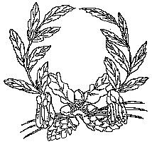

**Ashill V.C. Primary School**

My Learning Discovery

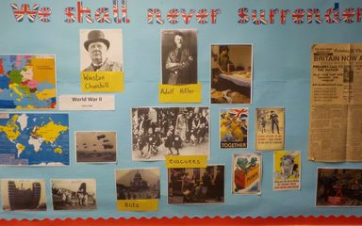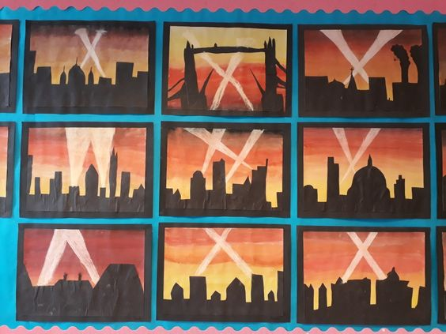

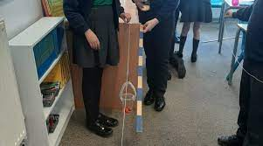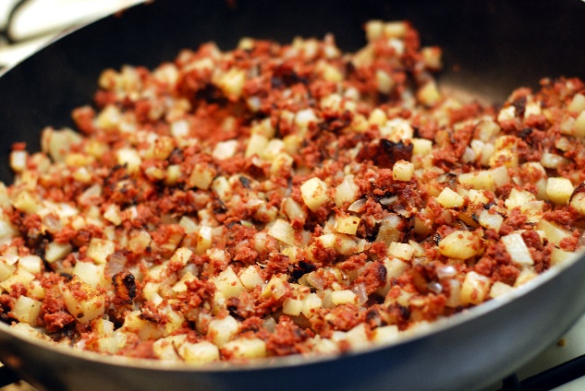

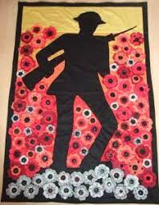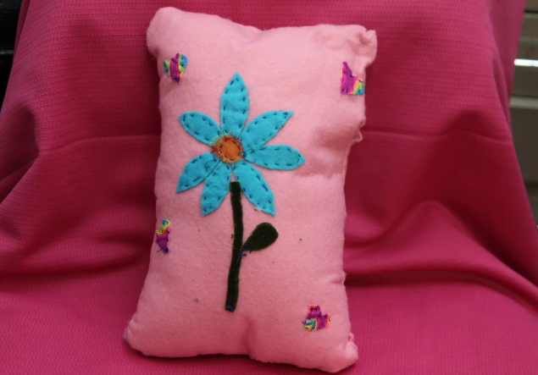

**Year 5/6**

WW2-Autumn Term 2025

**World War 11**

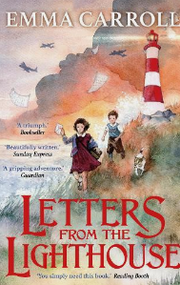

*When Hitler Stole Pink Rabbit* written by Judith Kerr tells the story of a Jewish family escaping Nazi Germany in the days before WW2 broke out and is written from the authors own experience of life during the second world war. This is a semi-autobiographical book that covers themes of politics, family, fleeing, loneliness, identity, survival and the challenges of growing up in an ever-changing world. In contrast to Goodnight Mr Tom, this story will help the children see the evacuee process from a Jewish perspective, rather than an English.

Additional text extracts that will be used throughout our unit of work.

We have chosen the text Letters from the Lighthouse because it is an excellent book to study alongside our World War Two topic in UKS2. It brings history to life through a gripping story. Set during the war, it follows the lives of children evacuated to the countryside, giving readers a vivid picture of the challenges, dangers and emotions people faced. The mystery element keeps us hooked, while the themes of friendship, courage and kindness help us understand the human side of wartime Britain.

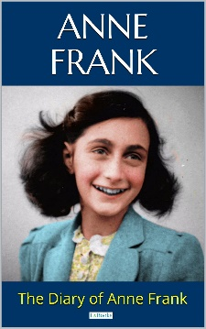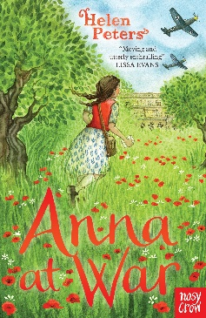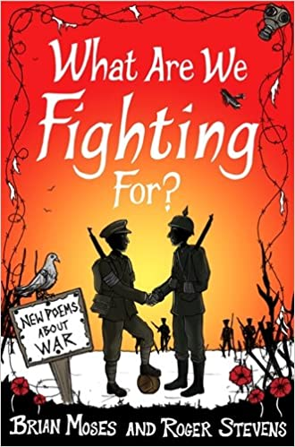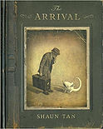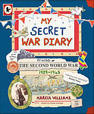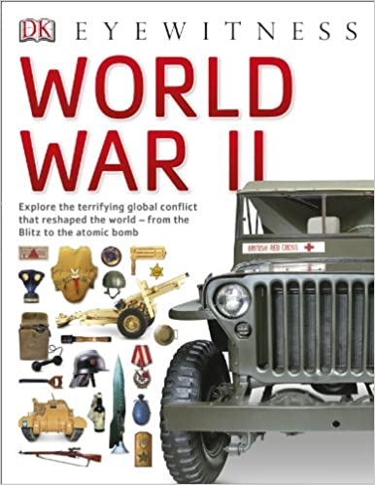

Visual Literacy

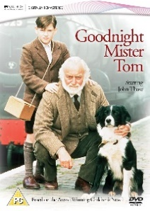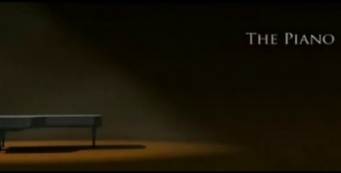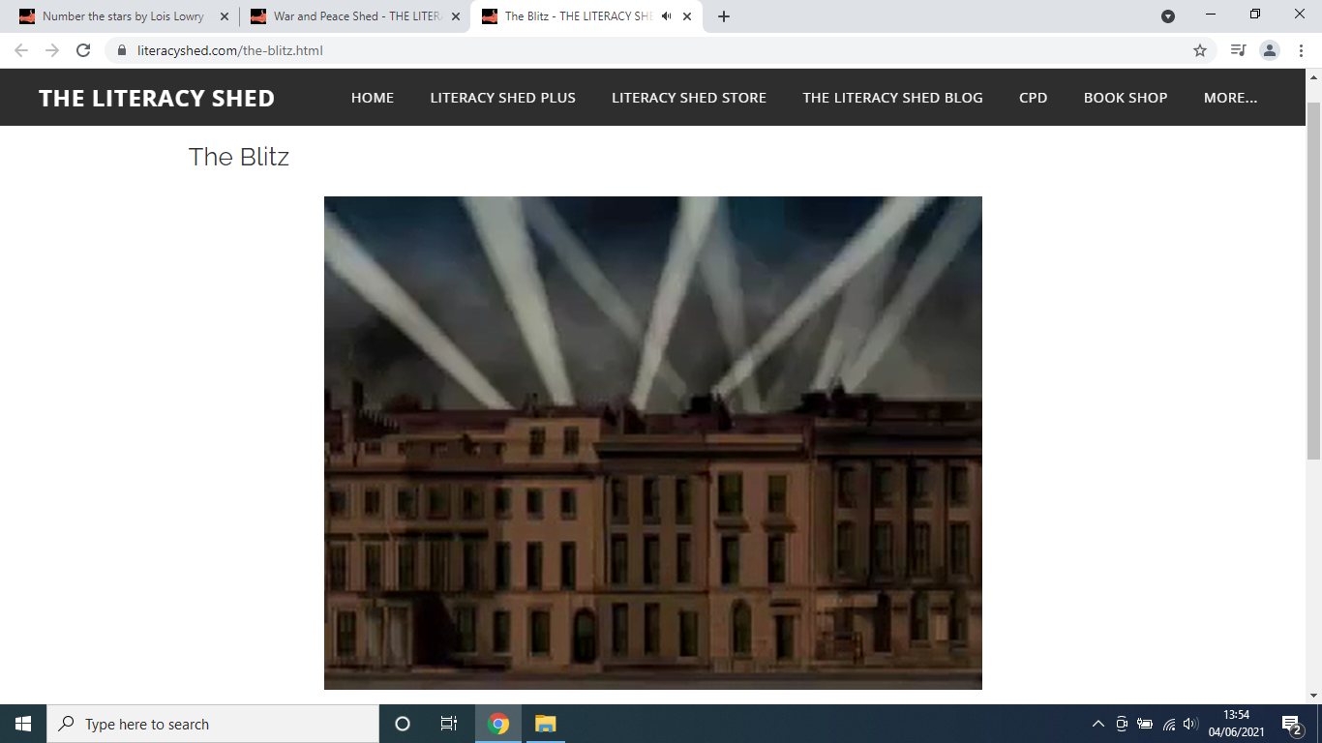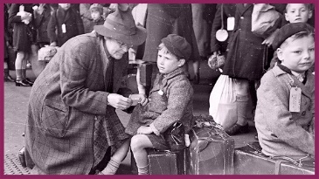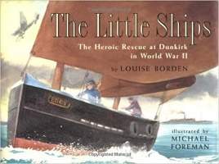

**Further opportunities in Maths and English:**

|  |  |
| --- | --- |
| **Maths** | **English** |
| * Battle of Britain statistics – manipulating data. * Ration books and allowances. - Measure out quantities of food allowed (P.o.S. 4a) * Conversions of change of measure since WW2 i.e. miles to Kilometres, pounds, ounces, to kilograms, grams (P.o.S Ma 3. -4a,b) Costing of recipes * Calculate distances travelled by evacuees, soldiers. * Using dates on time line calculate length of war (P.o.S. Ma 2- 3a) * Time and metric measures (shadows and forces) | * Analyse Churchill’s speeches and link them to Dunkirk, Battle of Britain, or the Blitz. * Diary entries – Evacuation and Anderson Shelters during the Blitz * Write a class poem that reflects on the events at Dunkirk. |

In Science, during Autumn 1, we are studying ‘Forces’. We will be able to explain that unsupported objects fall towards the Earth because of the force of gravity acting between the Earth and the falling object; identify the effects of air resistance, water resistance and friction, that act between moving surfaces; and recognise that some mechanisms, including levers, pulleys and gears, allow a smaller force to have a greater effect.

|  |  |
| --- | --- |
| **Science: Autumn 1** | |
| **Year 5** | **Year 6** |
| Showing my understanding   * I know a force causes an object to start moving, stop moving, speed up, slow down or change direction. * I understand that gravity is a force that acts at a distance, everything is pulled to the Earth by gravity and this causes unsupported objects to fall. * I can demonstrate the effect of gravity acting on an unsupported object * I can research how the work of scientists such as Galileo Galilei and Isaac Newton helped to develop the theory of gravitation * I understand that air resistance, water resistance and friction are contact forces that act between moving surfaces. The object may be moving through the air or water or the air and water may be moving over a stationary object. * I can give examples of friction, water resistance and air resistance. * I can give examples of when it is beneficial to have high or low friction, water resistance and air resistance * I understand a mechanism is a device that allows a small force to be increased to a larger force. The pay back is that it requires a greater movement. The small force moves a long distance and the resulting large force moves a small distance, e.g. a crowbar or bottle top remover. Pulleys, levers and gears are all mechanisms, also known as simple machines. * I can demonstrate how pulleys, levers and gears work   Applying knowledge   * I can investigate the effect of friction in a range of contexts e.g. trainers, bath mats, mats for a helter-skelter. * I can investigate the effects of water resistance in a range of contexts e.g. dropping shapes through water, pulling shapes e.g. boats along the surface of water * I can investigate the effects of air resistance in a range of contexts e.g. parachutes, spinners, sails on boats * I can make a product that involves a lever, pulley or gear | |

In Science, during Autumn 2, we will learn to recognise that light appears to travel in straight lines. We will use the idea that light travels in straight lines to explain that objects are seen because they give out or reflect light into the eye. We will explain that we see things because light travels from light sources to our eyes or from light sources to objects and then to our eyes. We will use the idea that light travels in straight lines to explain why shadows have the same shape as the objects that cast them.

|  |  |
| --- | --- |
| **Science: Autumn 2** | |
| **Year 5** | **Year 6** |
| Showing my understanding   * I understand light appears to travel in straight lines and we see objects when light from them goes into our eyes. The light may come directly from light sources but for other objects some light must be reflected from the object into our eyes for the object to be seen. * I know objects that block light (are not fully transparent) will cause shadows. Because light travels in straight lines the shape of the shadow will be the same as the outline shape of the object and the size of the shadow is larger when the light source and object move closer to each other as more of the light is blocked. * I can use diagrams to explain my understanding.   Applying knowledge   * I can observe objects in different lighting conditions – using light from sources that can be moved, reflected and blocked in different ways. * I can observe shadows of different objects as the object and the light source are moved so that the distance between them and their distance from the surface where the light is falling changes. * I can predict or explain some uses or behaviours of light, reflection and shadows such as periscope design, shadow puppets, bending of light in water. * I can use diagrams or models to predict and explain my understanding such as how the path of light rays can be directed by reflection to be seen, for example, reflection in car rear view mirrors or in a periscope. * I can use diagrams and models to predict and explain with diagrams or models, as appropriate, how the shape and size of shadows can be varied. | |

In Design Technology, we will be engaging in creative and practical activities, we will use our knowledge, understanding and skills needed to engage in an iterative process of designing and making. We will research, analyse, design, make and evaluate a ‘Make Do cushion cover, using their developing knowledge of and skills in a variety of sewing techniques for joining and decorating fabric.

|  |  |
| --- | --- |
| **Design Technology** | |
| **Year 5** | **Year 6** |
| Developing, planning and communicating ideas   * I can take a user’s view into account when designing. * I can provide several ideas to meet my brief and highlight the benefits and drawbacks of each. * I can produce a step-by-step plan on how to create my design.   Working with tools, materials and components   * I can use a range of tools and equipment with accuracy and effectiveness. * I can produce a simple prototype. * I can transfer a drawing into a finished article. * I can join materials using a range of techniques, and accurate measurements to ensure precision.   Evaluation   * I can assess how well my product works in relation to the purpose, design and appearance. * I can suggest a way in which my final product can be improved. | Developing, planning and communicating ideas   * I can use a range of information to help develop my design. * I can produce a detailed step-by step plan of how to create my design, justifying my choices. * I can consider culture and society in my design.   Working with tools, materials and components   * I can choose appropriate tools and materials to ensure that my final product will appeal to my audience. * I can work with safety parameters and use a range of tools and equipment with greater accuracy. * I can create a clear prototype of my design, using labels to show my intentions. * I can join different materials using a range of techniques and achieve precision through accurate measurements and reforming ideas whilst working.   Evaluation   * I can test and evaluate my final products against the design criteria and against the constraints. * I can suggest different ways on how to improve my final design, including what information would be required to make it even better. |

In History, we will *l*earn about the Second World War in Europe and why the Battle of Britain was such a significant turning point in British History. We will learn about the timeline of events such as the outbreak of the war, the Battle of Britain, the heroic rescue at Dunkirk, the Blitz, the D-Day landings, the liberation of the concentration camps and the celebrations of VE Day. We will then research the lives of the ordinary people who faced the Blitz and coped with rationing and evacuation. We will also learn about the inspiring stories and achievements of significant people such as Anne Frank and Winston Churchill.

|  |  |
| --- | --- |
| **History** | |
| **Year 5** | **Year 6** |
| Historical understanding   * I can pose an historical hypothesis using primary and secondary sources to give a reasoned conclusion. * I can explain how historical artefacts have helped us understand more about people’s lives in the present and past.   Knowledge and understanding of events, people and changes in the past   * I can describe how historical events affect/influence life today.   Chronological understanding   * I can order significant events, movements and dates on a timeline.   Historical interpretation   * I can evaluate evidence to choose the most reliable form. | Historical understanding   * I can pose and answer my own historical questions using primary and secondary sources as evidence to justify my opinions.   Knowledge and understanding of events, people and changes in the past   * I can suggest why certain events, people and changes might be seen as more significant than others   Chronological understanding   * I can identify and compare changes within and across different periods.   Historical interpretation   * I can suggest why there may be   different interpretations of events.   * I can identify and explain propaganda. |

In Geography, we will develop a familiarity with the location of the countries involved in the first year of World War 2. We will look at the roles they played and locate them using a map of 1939 Europe. We will identify and define allies and axis, and look in to greater depth of their locality, identifying continents and countries surrounding them. We will understand more of the Luftwaffe’s plans for invading Britain and the role the British pilots played. We will be able to locate the Channel, the south-east coast of England and some Luftwaffe targets in the UK.

|  |  |
| --- | --- |
| **Geography** | |
| **Year 5** | **Year 6** |
| Geographical enquiry   * I can find possible answers to my own geographical questions.   Locational knowledge   * I can locate the world’s countries, using maps to focus on Europe. * I can name and locate some counties and cities of the United Kingdom. * I can, linking with history, compare land use maps of UK from past with present. | Geographical enquiry   * I can use maps to answer questions.   Locational knowledge   * I can use maps to locate European countries and major cities; to name and locate some counties and cities of the UK. * I can use maps, atlases, globes and digital/computer mapping to locate countries. * I can confidently explain scale and use maps with a range of scales. * I can use maps, aerial photos, plans and web resources to describe what a locality might be like. |

In Art, we will explore the work of artists who were officially commissioned to record the war in WW1 and WW2. We will look at Paul Nash and Henry Moore’s artwork, discover how art was used as a propaganda tool in the form of posters, find out about the amazing dazzling camouflage which was invented during WW1 and continued to be used until the beginning of WW2 and at the end of the project, we will create our own remembrance silhouette art based on the poem ‘In Flanders Fields’ where the children will use various mediums.

|  |  |
| --- | --- |
| **Art** | |
| **Year 5** | **Year 6** |
| Painting   * I understand the different properties of watercolour paints, acrylic paints and pastels. * I can create a range of shades using the above 3 mediums. * I can create mood and depth in a painting * I can identify different painting styles and how these have artists are influenced by these styles over time   3D Modelling   * I can experiment with and combine materials and processes to design and make 3D form * I can turn a 2D drawing into a 3D form * I can produce shape using a variety of mouldable materials   Knowledge   * I can learn about the work of others by looking at their work in books, the Internet and sharing ideas as a class * I can critic other's work as a way of developing and supporting my ideas * I understand how different medias can be combined and work together * I know to develop an idea through exploration and experimentation   Sketch book   * I can use my sketchbooks to explore and practice a range of materials, record ideas, and experiment. | Painting   * I have a strong understanding of colour theory and how to use it to create a balanced painting   3D Modelling   * I can create models on a range of scales. * I can create work which is open to interpretation by the audience * I can include both visual and tactile elements in my work. * I know the properties of a wide range of different sculptural materials and how to use them.   Knowledge   * I can make a record about the styles and qualities in my pieces. * I can say what my work is influenced by. * I can include technical aspects in my work, e.g. architectural design * I have knowledge of a wide range of artists and have formed my own opinions on their different styles.   Sketch book   * My sketch book contains detailed notes, and quotes explaining my drawings and ideas * I can compare my methods to those of others and keep notes in their sketch books. * I can adapt and refine my work to reflect its meaning and purpose, keeping notes and annotations in my sketch books |

In Music, we will be composing our own wartime soundscapes based on the different sounds and surroundings that children faced during the war. We will also have the chance to listen to and learn some WW2 songs and look at how these helped motivate and comfort those living through this era.

|  |  |
| --- | --- |
| **Music** | |
| **Year 5** | **Year 6** |
| Performing   * I can sing and use their understanding of meaning to add expression * I can perform ‘by ear’ and from simple notations   Composing   * I can choose the most appropriate tempo for a piece of music * I can use technology to compose music which meets a specific criterion   Appraising   * I can describe, compare and evaluate music using musical vocabulary * I can identify and begin to evaluate the features within different pieces of music * I can contrast the work of established composers and show preferences | Performing   * I can sing a harmony part confidently and accurately * I can take the lead in a performance * I can take on a solo part * I can provide rhythmic support * I can perform parts from memory   Composing   * I recognise that different forms of notation serve different purposes * I can use technology to support their notation   Appraising   * I can compare and contrast the impact that different composers from different times will have had on the people of the time * I can analyse features within different pieces of music |

In Physical Education, we will be exploring the outdoors and developing a range of physical skills. We will be drawing upon mental as well as physical skills including leadership, critical thinking, and problem-solving. During Autumn 2, we will be learning about different dance styles that were popular before and during the wartime period, and have the opportunity to choreograph our own interpretive dances based on an event from the time. We will learn steps from [the Charleston Dance](https://www.twinkl.co.uk/teaching-wiki/charleston-dance), [the Lambeth Walk Dance](https://www.twinkl.co.uk/teaching-wiki/lambeth-walk-dance) and [the Lindy Hop](https://www.twinkl.co.uk/teaching-wiki/lindy-hop).

|  |  |
| --- | --- |
| **Physical Education** | |
| **Year 5** | **Year 6** |
| **Autumn 1: OAA**  Physical skills   * I can work cooperatively to put strategies and solutions into action * I can develop and refine orienteering and problem-solving skills when working in groups and on their own   Thinking skills   * I appreciate riles need to be fair and consistent * I can in cooperative groups to use different techniques, speeds and effort to meet challenges   Personal skills   * I can work and compete individually and with others   **Autumn 1: Tag Rugby**  **Physical skills**   * I can use a use a large range of sending, receiving and travelling techniques in games, with varied control * I can demonstrate a range of throwing actions using modified equipment with some accuracy and control   **Thinking skills**   * I know and can apply the basic strategic and tactical principles of some games and adapt them to different situations * I show good awareness of space and the actions of others * I appreciate that rules need to be consistent and fair, using this knowledge to create rules and teach them to others * I can identify good performances and suggest ideas for practices that will improve my play   **Personal skills**   * I can compete in small sided games fairly showing good sportsmanship   **Health skills**   * I can develop calming techniques and self-regulate emotions   **Dance**  **Physical skills**   * I can perform dances using a range of movement patterns * I can perform combinations of gymnastic actions with different levels, speeds and directions   **Personal skills**   * I can evaluate a sequence and suggest improvements to speed, direction and level, applying some basic criteria   **Thinking skills**   * I recognise that strength and suppleness are important parts of fitness   **Personal skills**   * I can develop both competence and confidence in Dance   **Health skills**  I understand fully why exercise is good for fitness, health and wellbeing | **Autumn 2: Dance**  Physical skills   * I can perform dances using a range of movement patterns * I can work with a partner or small group to practise and refine a sequence   Personal skills   * I can develop competence and confidence |

In PSHE, we will be following the PATHs unit of work. We will look at ways to solve problems and different strategies for dealing with our uncomfortable emotions. We will then look at what makes a good learner, how we can develop our study skills. We will focus on the terms respect, friendship, family, history, culture, death and empathy.

|  |  |
| --- | --- |
| **Personal, Social and Health Education** | |
| **Year 5** | **Year 6** |
| PATH Strategies – dealing with emotions   * I can recognise and verbalise the different types of feelings. * I can recall the steps of calming down, using a range of different problem solving strategies including how to control my breathing. * I can discuss the signs of stress, how stress levels can be related to our methods of self-control and suggest ways of reducing this feeling. * I can discuss strategies to resist peer pressure and the importance of independent decision-making. * I can recognise the need to rely on others to help to manage or solve some problems and can name those that I can turn to for support.   Study and organisational skills   * I can recall the four study skills that will help me to become an independent learner. * To develop procedures that will support the focusing of attention. * I understand the importance of good listening and can display this in my own practice. * I can suggest factors that motivate successful and unsuccessful approaches to my school work. * I understand the acronym S.E.T and can show these skills in my own learning. * I can evaluate my organisational skills and suggest ways that I can develop them further. * I can set my own goal on how I can do something generous for others.   Respect   * I understand the meaning behind ‘The Golden Rule’. * I can define the difference between respectful and disrespectful behaviours. * I can explore how we show respect to other members of our community. * I will be able to discuss the differences and similarities between people from different countries and cultural backgrounds, and discuss ways in which we can all show respect. | |

In Computing this term we will be exploring how we can use technology to help us capture and manage data and information. In the first half term, we will look at simple databases and learn how to use them to manage data and present summaries. We will be using **J2E J2data** software. In the second half term we will take a look at spreadsheets. We will learn the basics of creating a spreadsheet and then develop skills in manipulating the data within it to produce answers to questions. We will use **Microsoft Excel** software for this.

|  |  |
| --- | --- |
| **Computing** | |
| **Year 5** | **Year 6** |
| **Data and Information - Flat-file databases**  Using a database to order data and create charts to answer questions   * To use a form to record information   - I can create a database using cards  - I can explain how information can be recorded  - I can order, sort, and group my data cards   * To compare paper and computer-based databases   - I can choose which field to sort data by to answer a given question  - I can explain what a field and a record is in a database  - I can navigate a flat-file database to compare different views of information   * To outline how you can answer questions by grouping and then sorting data   - I can combine grouping and sorting to answer specific questions  - I can explain that data can be grouped using chosen values  - I can group information using a database   * To explain that tools can be used to select specific data   - I can choose multiple criteria to answer a given question  - I can choose which field and value are required to answer a given question  - I can outline how ‘AND’ and ‘OR’ can be used to refine data selection   * To explain that computer programs can be used to compare data visually   - I can explain the benefits of using a computer to create charts  - I can refine a chart by selecting a particular filter  - I can select an appropriate chart to visually compare data   * To use a real-world database to answer questions   - I can ask questions that will need more than one field to answer  - I can present my findings to a group  - I can refine a search in a real-world context | **Data and Information - Introduction to spreadsheets**  Answering questions by using spreadsheets to organise and calculate data   * To create a data set in a spreadsheet   - I can collect data  - I can enter data into a spreadsheet  - I can suggest how to structure my data   * To build a data set in a spreadsheet   - I can apply an appropriate format to a cell  - I can choose an appropriate format for a cell  - I can explain what an item of data is   * To explain that formulas can be used to produce calculated data   - I can construct a formula in a spreadsheet  - I can explain which data types can be used in calculations  - I can identify that changing inputs changes outputs   * To apply formulas to data   - I can apply a formula to multiple cells by duplicating it  - I can calculate data using different operations  - I can create a formula which includes a range of cells   * To create a spreadsheet to plan an event   - I can apply a formula to calculate the data I need to answer questions  - I can explain why data should be organised  - I can use a spreadsheet to answer questions   * To choose suitable ways to present data   - I can produce a chart  - I can suggest when to use a table or chart  - I can use a chart to show the answer to questions |

We will be investigating different religious examples of engagement with conflict and peace. We will explore the moral issues and the impact these have on individual, community and society. We will look at the life and work of different individuals whose faith have impacted on their actions. During the second half term, we will be exploring the comparison of Christian and scientific approaches in explaining how the world was created. We will begin to analyse and evaluate different ideas of how the universe came to be, including The Big Bang and Biblical accounts of creation. We aim to explain the connections and divergence between different theories, and how they may fit together or disagree entirely and begin to analyse the reliability of the sources of the different ideas of how the universe came to be.

|  |  |
| --- | --- |
| **Does religion bring peace, conflict or both? Autumn 1** | |
| **Year 5** | **Year 6** |
| * I can give examples of peace making people or projects from Sikhs, Muslims or Christians * I can explain reasons why religion can be seen as a power for peace in the world * I can give examples of how religion can contribute to conflict * I can give examples of reasons why religion can be seen as a cause of conflict in the world * I can give examples of people who have used their religion and faith to make peace | * I can present a coherent account of why some people see religion as a power for peace, supported by evidence * I can present a coherent account of why some people see religion as a cause of conflict, supported by evidence * I can use examples of case studies of peace and conflict from Sikh, Muslim or Christian sources to explain how religions can contribute to peace * I can consider the teaching of religious texts from Sikh, Muslim or Christian sources in relation to peace and conflict, giving reasoned interpretations * I can evaluate views of religion in relation to peace and conflict, based on evidence and reasoning * I can examine how Sikhs, Muslims or Christians are affected by the way their religions are portrayed in the media * I can examine reasonably the atheist critique that religion is often a cause of conflict, and the world would be better off without religion * I can evaluate the ways diverse religious communities are affected by anti-religious prejudices |
| **Religious Education** | |
| Creation and science: conflicting or complementary? Autumn 2 | |
| Year 5 | Year 6 |
| * Outline the importance of Creation on the timeline of the ‘big story’ of the Bible. * Identify what type of text some Christians say Genesis 1 is, and its purpose. * Make clear connections between Genesis 1 and Christian belief about God as Creator. * Show understanding of why many Christians find science and faith go together. * Identify the type of text that Psalm 8 is, and its purpose. * Make clear connections between Psalm 8 and some ways Christians respond to God as Creator. * Respond to the idea that humans have great responsibility for the Earth. | * Taking account of the context, suggest what Genesis 1 might mean, and compare their ideas with ways in which Christians interpret it, showing awareness of different interpretations. * Identify key ideas arising from their study of Genesis 1 and comment on how far these are helpful or inspiring, justifying their responses. * Weigh up how far the Genesis 1 creation narrative is in conflict, or is complementary, with a scientific account. * Show understanding of why some Christians find science and faith compatible. * Explain what Psalm 8 has to say about the idea of God as Creator and the place of humans in Creation. * Weigh up how well humans are responding to this responsibility, taking into account religious and nonreligious viewpoints. |

In Languages we will be continuing to learn French. In Autumn 1 we will be looking at language associated with ‘Presenting Myself’. By the end of this unit pupils will have the knowledge and skills to present themselves both orally and in written form in French. In this unit pupils focus on asking questions as well as providing accurate replies. They will demonstrate a growing understanding of grammar to manipulate language and start to create sentences of their own using a range of personal details including name, age, where they live and nationality. As we move into Autumn 2 we will be concentrating on language associated with Family. By the end of this unit pupils will have the knowledge and skills to make a presentation about their own/a fictitious family in both spoken and written form in French. Pupils will demonstrate an increasing knowledge of grammar and the use of the possessive in French to manipulate language, thus starting to create more personalised responses as the unit supports the change from 1st person singular to 3rd person singular.

|  |
| --- |
| **Modern Foreign Languages** |
| * I can use basic greetings in French. * I can ask somebody how they are feeling and reply when asked. * I can ask somebody their name in French and reply when asked. * I can recall numbers 1-20. * I can ask somebody how old they are and reply when asked. * I can ask somebody where they live and reply when asked. * I can express my nationality and understand basic gender agreement rules (le / la) * I can remember the nouns for different family members. * I can describe my own or a fictitious family by name, age and relationship. * I can learn numbers up to 70 and multiples of 10 (10-100). |