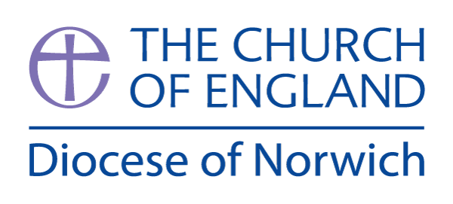
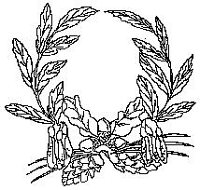

Ashill V.C. Primary School
My Learning Discovery
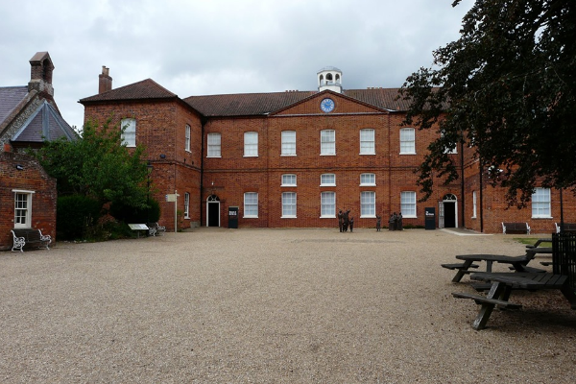
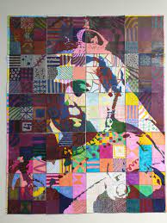

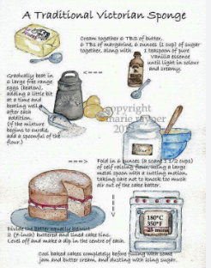
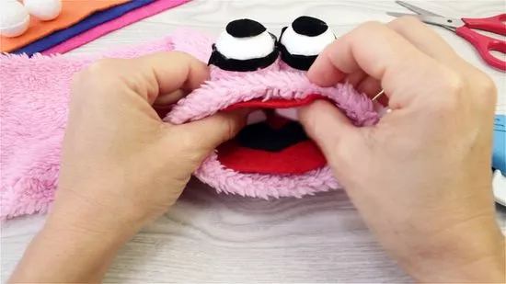

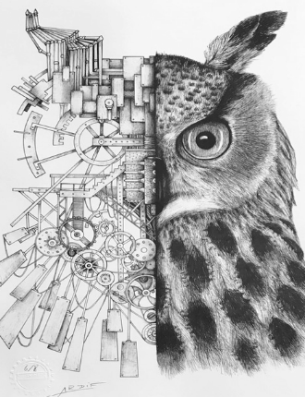
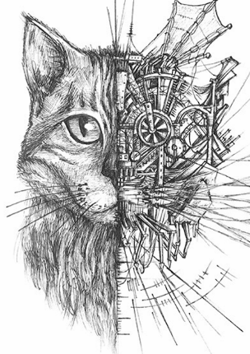
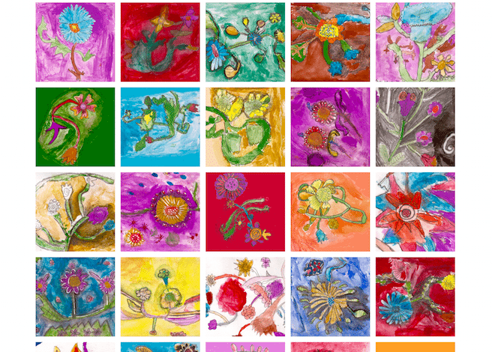
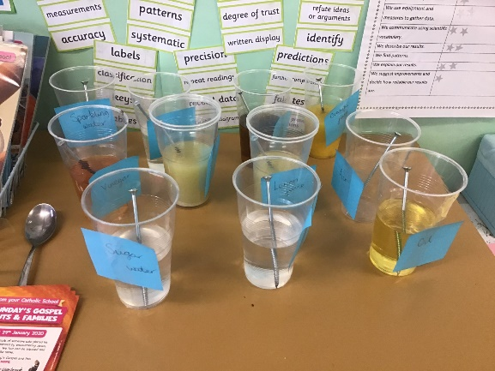

Badger Class
Victorians - Autumn Term 2026

Victorians
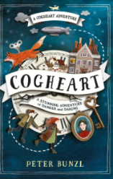
We have chosen the text ‘Cogheart’ by Paul Bunzl as our first class text of the year. It is an action-packed, Victorian-set steampunk adventure that follows 13-year-old Lily Hartman, whose world turns upside down after her inventor father goes missing following a Zeppelin crash.
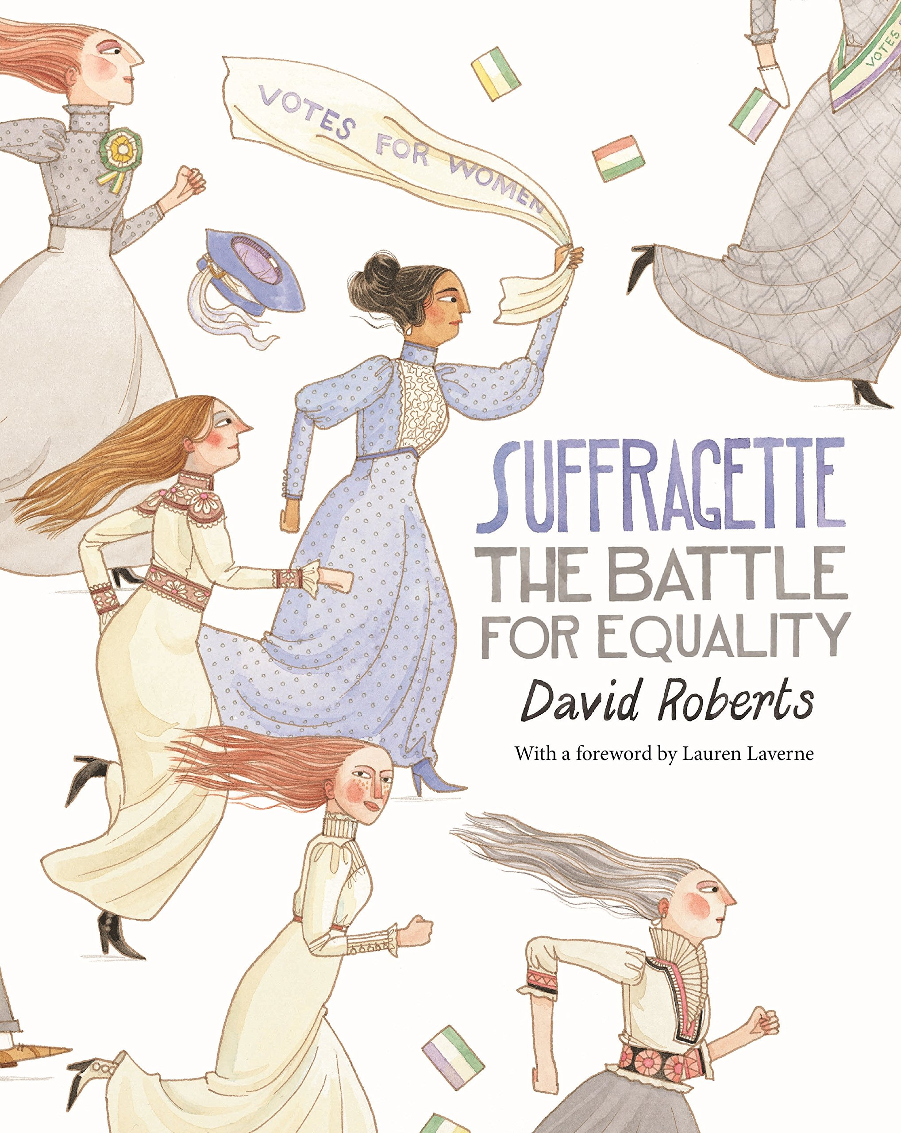
We will also be using the book, ‘Suffragette – the battle for equality’. In this ‘labour of love’ by David Roberts, the author and illustrator has created a carefully crafted study of one of the most significant periods in history in the UK in which the right for equal suffrage was long fought for and won. The exquisite illustrations work with the text to add meaning and draw the reader in through a timeline in which leading and less renowned characters from the past are brought to life to inspire and engage young readers today as they once did Roberts.

Visual Literacy.
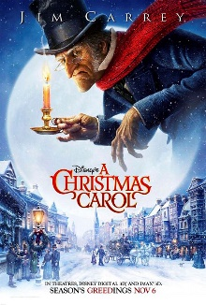
Further opportunities in Maths and English:
Maths | English
- Problem solving related to key dates, figures and facts related to Victorian era.  - Looking at imperial measurements and comparing and converting to metric measures  - Timelines and ordering of dates and significant events | - Diary entries- Queen Victoria’s coronation, viewpoint of child workers,  - Persuasive advertisements for Victorian jobs  - Researching railways

In Science, we will be looking at ‘Properties and Changes of Materials’. This unit will teach your child about different materials, their uses and their properties, as well as dissolving, separating mixtures and irreversible changes. The children will sort and classify objects according to their properties. They will explore the properties of materials to find the most suitable material for different purposes. The children will work scientifically and collaboratively to investigate the best thermal insulator to make a lunch box, making predictions and forming conclusions. Furthermore, they will have the chance to find the best electrical conductor, in the context of making floodlights brighter. They will have the opportunity to work in a hands-on way to explore dissolving, identifying the different variables in their own investigations. They will find out about different ways to separate mixtures of materials, using filtering, sieving and evaporating. Finally, they will learn about irreversible changes, and participate in two exciting investigations to create new materials.
Science
Year 5 | Year 6
- I understand that materials have different uses depending on their properties and state (liquid, solid, gas).  - I can identify properties of materials including hardness, transparency, electrical and thermal conductivity and attraction to magnets.  - I know that some materials will dissolve in a liquid and form a solution while others are insoluble and form sediment.  - I can explore how some mixtures can be separated by filtering, sieving and evaporation.  - I understand that some changes to materials such as dissolving, mixing and changes of state are reversible, but some changes such as burning wood, rusting and mixing vinegar with bicarbonate of soda result in the formation of new materials and these are not reversible. | - I can investigate the properties of different materials in order to recommend materials for particular functions depending on these properties e.g. test waterproofness and thermal insulation to identify a suitable fabric for a coat  - I can explore the effects of adding a range of solids to water and other liquids e.g. cooking oil.  - I can investigate the rates of dissolving by carrying out a comparative and fair test.  - I can separate mixtures by sieving, filtering and evaporation, choosing the most suitable method and equipment for each mixture  - I can explore a range of non-reversible changes e.g. rusting, adding fizzy tablets to water, burning  - I can carry out comparative and fair tests involving non-reversible changes e.g. What affects the rate of rusting? What affects the amount of gas produced?  - I can research new materials produced by chemists e.g. Spencer Silver (glue of sticky notes) and Ruth Benerito (wrinkle free cotton)

In Design Technology, we will be engaging in creative and practical activities. We will use our knowledge, understanding and skills needed to engage in a process of designing and making. We will be designing, making and evaluating a traditional Punch and Judy puppet. We will also get to make our own Victorian recipes to host a Victorian banquet for our parents / carers.
Design Technology
Year 5 | Year 6
Developing, planning and communicating ideas  - I can produce a detailed step-by-step plan for my design method  - I can suggest some alternative designs and compare the benefits and drawbacks to inform the design process and outcome  Working with tools, equipment, materials and components  - I can choose appropriate tools and materials to ensure the final product will appeal to the audience  - I can use a range of tools and equipment with good accuracy and effectiveness, within established safety parameters.  Evaluating processes and products  - I can evaluate appearance and function against the original design criteria  Textiles  - I can devise a template or pattern for my product  - I can explore a range of textures using textiles  - I can transfer a drawing into a textile design  - I can experiment with different ways of exploring textiles  - I can use artists to influence my textile | Developing, planning and communicating ideas  - I can use a range of information to inform my design  - I can justify my plan to someone else.  Working with tools, equipment, materials and components  - I can choose appropriate tools and materials to ensure the final product will appeal to the audience  - I can use a range of tools and equipment with good accuracy and effectiveness, within established safety parameters.  Evaluating processes and products  - I can state whether my product could be improved by using different materials  - I can consider whether my product meet all design criteria  Textiles  - I can consider the audience when choosing my textiles  - I can make up a prototype first  - I can use a range of joining techniques

In History, our Victorians topic facilitates the study of Queen Victoria - her life, family, portraits and homes. In addition, we learn about major inventions of the period as well as other aspects of the daily lives of Victoria’s subjects. Workhouses and child labour are studied through fiction. Census data, maps, buildings and the advent of railways provide the basis for developing an understanding of local history.

History
Year 5 | Year 6
Historical interpretation  - I can evaluate evidence to choose the most reliable form.  Knowledge and understanding of events, people and changes in the past  - I can describe how historical events affect/influence life today.  Chronological understanding  - I can order significant events, movements and dates on a timeline.  Historical understanding  - I can pose an historical hypothesis using primary and secondary sources to give a reasoned conclusion.  - I can explain how historical artefacts have helped us understand more about people’s lives in the present and past. | Historical interpretation  - I can suggest why there may be  different interpretations of events.  Knowledge and understanding of events, people and changes in the past  - I can suggest why certain events, people and changes might be seen as more significant than others.  Chronological understanding  - I can identify and compare changes within and across different periods.  Historical understanding  - I can pose and answer their own historical questions using primary and secondary sources as evidence to justify their opinions.

We will briefly look at ‘What was the British Empire?’ We will be Investigating the countries that were a part of the British Empire during the Victorian era - Locating and identifying countries and continents on a map. We will look at how maps of the world and UK has changed from this era to now.
Geography
Year 5 | Year 6
Geographical enquiry  - I can find possible answers to my own geographical questions  Locational knowledge  - I can locate different countries and continents on a world map  - I can, linking with history, compare land use maps of UK from the past with the present | Geographical enquiry and skills  - I can use maps to answer questions  Locational knowledge  - I can locate different countries and continents on a world map  - I can use maps, aerial photos, plans and web resources to describe what a locality might be like or how it has changed over time

In Art, we will be using our knowledge of our English text, Cogheart, to create our own mechanimal images. We will mainly be focusing on sketching and how different types of lines can add detail to a drawing and how shading can change the effect.
Art
Year 5 | Year 6
Year 5  Drawing  - I understand how drawing can be used to support other medias  - I can develop a series of drawings that explore a theme  Sketch books  - I can experiment with different styles which artists have used  - I can use my sketchbook as a mode to record my learning journey  - I can compare sketchbook ideas and give supported and constructive feedback on peers development  Knowledge  - I can learn about the work of others by looking at their work in books, the internet and sharing ideas | Year 6  Drawing  - I can create accurate and experimental drawings  - I can produce sketches to communicate ideas and convey a sense of individual style  Sketch books  - I can produce a sketchbook that contains detailed notes, and quotes explain my drawings and ideas  - I can compare my methods to those of others and keep notes in my sketch book  - I can adapt and refine my work  Knowledge  - I can include technical aspects in my work  - I have knowledge of a wide range of artists and have formed my own opinions on their different styles

To begin our year of Music, we will be starting Autumn 1 completing a Reggae scheme of work. The children will be exposed to a brief history of reggae, seeing it is an important music genre. Pupils will learn about the key reggae musical features and will listen to and appraise music by reggae artists. Pupils will recap and expand upon features such as chord patterns, riffs, bass line, melody and rhythm, creating in small groups, their own chord structures with which to fit bass lines and phrase melodic lines. Pupils will have the opportunity to perform drum groove patterns following given rhythm notation. In Autumn 2, we will look at a Rock and Roll scheme of work where pupils will explore the genre of rock and roll music through singing, instrumental playing, composition and improvisation, and listening and appraising. The children will learn about the different instruments that typically play in a rock and roll band and their role within the band; exploring lead and backing vocals, chords, lead guitar and bass guitar. They will consolidate their learning on rhythm and pitch notation.
Music
Year 5 – Rock and Roll | Year 6 - Reggae
- I can improvise and use rhythmic and melodic ideas of greater length and musical shape.  - I can recognise a broader range of instruments relating to the music genre.  - I can confidently demonstrate a secure sense of pulse when playing and singing.  - I can confidently match pitches across a wider range of notes, leaps, lengths and rhythmic complexity.  - I can recognise and perform from an increasing range of Western notation.  - I can sing and play to convey mood and emotion to enhance the intended effect. | - I can self correct when a performance goes wrong.  - I can place music within both time and place, identifying features specific to justify the placement.  - I can confidently justify opinions of different styles of music, using knowledge of musical conventions and instrumental knowledge.  - I can demonstrate a secure sense of pulse when singing and playing in unison and within an ensemble.  - I can demonstrate musicality in the control and production of sound using expression.  - I can sing confidently with control and accurately match pitch across a range of notes; leaps, lengths and rhythmic complexity.  - I can understand that the way the performance is represented to the audience influences the quality of the performance and the messages the music is trying to convey.

During the first half term, we will be learning the skills and tactics required to play Hockey. We will be introduced to hockey, where the children will learn correct grip, how to pass, receive, travel with the ball, tackle and shoot. Hockey helps the children to improve their teamwork skills and develop an understanding of attacking and defending. During the second half of the term, we will be focusing on Dance, and the theme will be linked to Victorians. Throughout our history lessons, we will learn how the Industrial Revolution saw Victorians enjoying great innovation. However, life for children was also hard and dangerous, where they had to work in mines & factories. Through dance, we will explore machines, transport and childhood jobs.
Physical Education
Year 5 | Year 6
Hockey  Physical skills  - I can use a use a large range of sending, receiving and travelling techniques in games, with varied control  - I can demonstrate a range of passing actions using modified equipment with some accuracy and control  Thinking skills  - I know and can apply the basic strategic and tactical principles of some games and adapt them to different situations  - I show good awareness of space and the actions of others  - I appreciate that rules need to be consistent and fair, using this knowledge to create rules and teach them to others  - I can identify good performances and suggest ideas for practices that will improve my play  Personal skills  - I can compete in small sided games fairly showing good sportsmanship  Health skills  - I can develop calming techniques and self-regulate emotions  Dance  Physical skills  - I can perform dances using a range of movement patterns  - I can perform combinations of gymnastic actions with different levels, speeds and directions  Personal skills  - I can evaluate a sequence and suggest improvements to speed, direction and level, applying some basic criteria  Thinking skills  - I recognise that strength and suppleness are important parts of fitness  Personal skills  - I can develop both competence and confidence in Dance  Health skills  - I understand fully why exercise is good for fitness, health and wellbeing | Hockey  Physical skills  - I can use a large range of sending, receiving and travelling techniques in games, with varied control.  - I can perform skills with greater speed, fluency and accuracy in invasion games  Thinking skills  - I understand, can choose and apply a range of tactics and strategies for defence and attack  - With help, I can devise warm up and cool down activities and justify my choices  - I appreciate that rules need to be consistent and fair, using this knowledge to create rules and teach them to others  - I can develop my ability to evaluate my own and others’ work, and to suggest ways to improve it using appropriate terminology  Personal skills  - I can compete in small sided games fairly showing good sportsmanship  Health skills  - I can identify activities that help develop stamina or power and suggest how some can be used in other types of activities  Dance  Physical skills  - I can perform dances using a range of movement patterns  - I can work with a partner or small group to practise and refine a sequence  Thinking skills  - With help, I can devise warm up and cool down activities and justify their choices  Personal skills  - I can develop both competence and confidence in Dance  Health skills  - I understand fully why exercise is good for fitness, health and wellbeing

During the first half of the term, we will be exploring the theme, ‘It is good to be me’. This theme will focus specifically on feelings. It explores feelings in the context of the child as an individual, developing self-awareness and helping the child to realise that it really is ‘Good to be me’. The theme is about understanding our feelings as well as considering our strengths and weaknesses as learners. It aims to develop knowledge, understanding and skills in three key social and emotional aspects of learning: self-awareness, managing feelings and empathy. We will explore the importance of good growth mindset. During the second half of the term, we will look at Bullying. During this theme, we will develop and revisit four of the key social and emotional aspects of learning covered in previous themes through a focus on bullying – what it is; how it feels; why people bully; how we can prevent and respond to it; and how children can use their social, emotional and behavioural skills to tackle this crucial problem. The four aspects of learning in which knowledge, skills and understanding are developed are self-awareness, empathy, managing feelings and social skills.

Personal, Social and Health Education
Good to be me
Year 5 | Year 6
- I can talk and write about my opinions, and explain my views, on issues that affect myself and society  - I can recognise how people’s emotions change and develop strategies on how to deal with my feelings  - I can resolve differences by looking at alternatives, making decisions and explaining choices  - I can recognise the different risks in different situations and then decide how to behave responsibly, including judging what kind of physical contact is acceptable or unacceptable  - I understand that my actions affect myself and others, and I need to care about other people’s feelings and to try to see things from their point of view  - I am aware of different types of relationships, including marriage, and those between 2 friends and families  - I can develop the skills to be effective in relationships. | - I recognise my worth as individuals, by identifying positive things about myself and my achievements  - I recognise my mistakes, can make amends and set personal goals  - I am aware of pressure to behave in an unacceptable or risky way can come from a variety of sources, including people I know  - I know how to ask for help, and use basic techniques for resisting pressure to do wrong  - I can reflect on spiritual, moral, social and cultural issues, using my imagination to understand other people’s experiences  - I know that my actions affect myself and others, and that I need to care about other people’s feelings and to try to see things from their point of view  - I am aware of different types of relationships, including marriage, and those between friends and families  - I can develop the skills to be effective in relationships.
Say no to bullying
Year 5 | Year 6
- I recognise my worth as individuals, by identifying positive things about myself and my achievements, seeing their mistakes, making amends and setting personal goals
- I can face new challenges positively by collecting information, looking for help, making responsible choices and taking action
- I realise the consequences of anti-social and aggressive behaviours, such as bullying and racism, on individuals and communities
- I can reflect on spiritual, moral, social and cultural issues, using imagination to understand other people’s experiences
- I can resolve differences by looking at alternatives, making decisions and explaining choices
- I recognise the different risks in different situations and then decide how to behave responsibly
- I understand that pressure to behave in an unacceptable or risky way can come from a variety of sources, including people I know
- I know how to ask for help and use basic techniques for resisting pressure to do wrong
- I understand school rules about health and safety, basic emergency aid procedures and where to get help
- I know that my actions affect myself and others, and that I need to care about other people’s feelings and to try to see things from their points of view
- I realise the nature and consequences of racism, teasing, bullying, and aggressive behaviours and how to respond to them and ask for help
- I recognise and can challenge stereotypes
- I know that differences and similarities between people arise from a number of factors, including cultural, ethnic, racial and religious diversity, gender and disability
- I know where individuals, families and groups can get help and support.

In Computing this term we will focus on Programming. Initially, we will be learning how to write code to control the small computing devices - Microbits. This will involve developing our knowledge of algorithms and code loops. In the second half term we will continue to develop coding skills that involve selection and conditional programming to reach desired outcomes. We will use Scratch software.
Computing
Year 5 | Year 5
Programming - Selection in physical computing  Exploring conditions and selection using a programmable microcontroller  - To control a simple circuit connected to a computer  - I can create a simple circuit and connect it to a microcontroller  - I can explain what an infinite loop does  - I can program a microcontroller to make an LED  switch on  - To write a program that includes count-controlled loops  - I can connect more than one output component  to a microcontroller  - I can design sequences that use count-controlled  loops  - I can use a count-controlled loop to control outputs  - To explain that a loop can stop when a condition is met  - I can design a conditional loop  - I can explain that a condition is either true or  false  - I can program a microcontroller to respond to an  input  - To explain that a loop can be used to repeatedly check whether a condition has been met  - I can explain that a condition being met can start  an action  - I can identify a condition and an action in my  project  - I can use selection (an ‘if…then…’ statement) to  direct the flow of a program  - To design a physical project that includes selection  - I can create a detailed drawing of my project  - I can describe what my project will do  - I can identify a real-world example of a condition starting an action  - To create a program that controls a physical computing project  - I can test and debug my project  - I can use selection to produce an intended  outcome  - I can write an algorithm that describes what my model will do | Programming - Selection in quizzes  Exploring selection in programming to design and code an interactive quiz.  - To explain how selection is used in computer programs  - I can identify conditions in a program  - I can modify a condition in a program  - I can recall how conditions are used in selection  - To relate that a conditional statement connects a condition to an outcome  - I can create a program with different outcomes using selection  - I can identify the condition and outcomes in an 'if... then… else...' statement  - I can use selection in an infinite loop to check a  condition  - To explain how selection directs the flow of a program  - I can design the flow of a program which contains ‘if… then… else…’  - I can explain that program flow can branch according to a condition  - I can show that a condition can direct program flow in one of two ways  - To design a program which uses selection  - I can identify the outcome of user input in an algorithm  - I can outline a given task  - I can use a design format to outline my project  - To create a program which uses selection  - I can implement my algorithm to create the first section of my program  - I can share my program with others  - I can test my program  - To evaluate my program  - I can extend my program further  - I can identify the setup code I need in my program  - I can identify ways the program could be  improved
During the first half of the term, we will be looking at whether ‘Believing in God is reasonable’. We will analyse and evaluate the Biblical evidence and other sources of authority (e.g., creeds) for the incarnation and how this belief in the Incarnation is central to Christianity as a religion. We will explore different philosophical answers to questions relating to meaning and existence, and begin to explain some of the different ways in which philosophers understand abstract concepts such as arguments for the existence of God: Ontological, Cosmological or Teleological arguments as found in the work of St. Thomas Aquinas for example.

During the second half of the term, we will be looking at exploring ‘How do beliefs shape identity for Muslims?’ We will explore the ways in which the Qur’an and Hadith form a source of authority and the key distinctions between the 3 main Muslim traditions (Sunni, Shia and Sufi). The children will learn about Muslim perspectives on moral issues including the idea of ‘intention’. We will look at the role of the mosque and the impact of the Five Pillars of Islam as well as the importance of Ramadan, the two Eid festivals and Jummah Prayers.

Religious Education
Is believing in God reasonable?
Year 5 | Year 6
- I can explain different philosophical answers to questions about the world around me, including questions relating to meaning and existence.  - I can explain some of the different ways in which philosophers understand abstract concepts.  - I can explain, using a range of reasons, whether a position or argument is coherent and logical.  - I can link a range of different pieces of evidence together to form a coherent argument  - I can explain a range of answers to ethical and moral questions and issues, drawing conclusions and showing awareness of diversity of opinion and why there are differences. | - I can begin to analyse and evaluate a range of philosophical answers to questions about the world around me, including questions relating to meaning and existence.  - I can begin to analyse and evaluate different ways in which philosophers understand abstract concepts  - I can begin to analyse and evaluate whether a position or argument is coherent and logical and show increasing awareness of divergence of opinion.  - I can use well-chosen pieces of evidence to support and counter a particular argument.  - I can begin to analyse and evaluate a range of different answers to ethical and moral questions/issues, showing an understanding of the connections between beliefs, practices and behaviour
How do beliefs shape identity for Muslims?

Year 5 | Year 6
- I can describe different sources of authority and how they link with beliefs  - I can describe a range of different interpretations of sources of authority and consider the reliability of these sources for groups of believers  - I can describe how events in history and society have influenced some religious and non-religious worldviews  - I can describe the connections between different beliefs being studied and link them to sources of authority  - I can describe the ways in which beliefs shape the way Muslims view the world in which they live in.  - I can explain the different ways in which the terms ‘religion’ and ‘belief’ are used by followers from within a religion  - I can explain some of the varying ways in which religions and beliefs are practised locally.  - I can explain how beliefs impact on and influence individual lives, communities and society | - I can explain different sources of authority and connections with beliefs  - I can begin to discuss the reliability and authenticity of texts that are authoritative for a group of believers  - I can explain how events in history and society have influenced some religious and non-religious worldviews  - I can explain the connections between different beliefs being studied and link them to sources of authority using theological terms  - I can explain and discuss the ways in which beliefs shape the way Muslims view the world in which they live in.  - I can begin to analyse and evaluate the different ways in which the terms ‘religion’ and ‘belief’ are used by followers from within a religion  - I can recognise some areas of controversy when interpreting and explaining the nature of religion and belief  - I can begin to analyse and evaluate some of the varying ways in which religions and beliefs are practised locally.  - I can begin to analyse and evaluate how beliefs impact on and influence individual lives, communities and society

In Modern Foreign Languages we will continue to develop our conversational French. We will learn days of the week, months of the year and numbers 1-31 will be introduced, revised and consolidated. We will also be looking at the unit, ‘As-tu un animal?’ By the end of this unit pupils will have the knowledge and skills to present both orally and in written form about the pets they have and/or do not have in French. They will move from 1st person singular to 3rd person singular verb usage so they are able to say what the pet is called and use conjunctions more confidently.
Modern Foreign Languages: French
- I can recognise and recall the 7 days of the week in French.
- I can recognise and recall the 12 months of the year in French.
- I can recognise and recall numbers 1-31 in French.
- I can ask what the date is and say the date in French.
- I can know the nouns and indefinite articles for 8 common pets.
- I can ask somebody if they have a pet and give an answer back.
- I can say in French wat pet I have / do not have and give our pet’s name.

