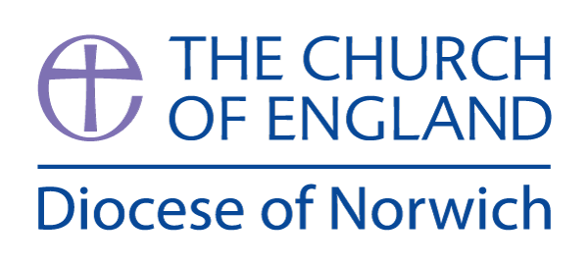
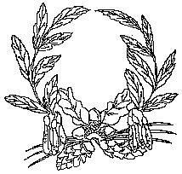

Ashill V.C. Primary School
My Learning Discovery
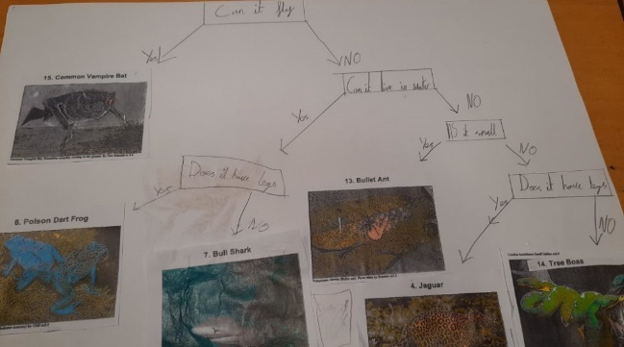
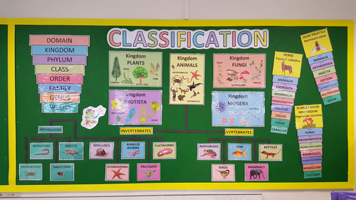

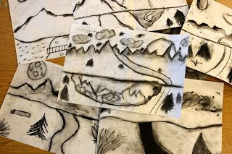
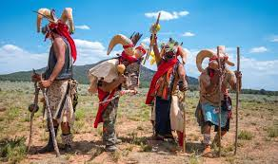

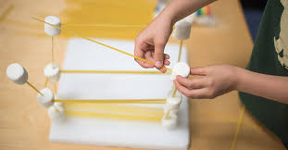
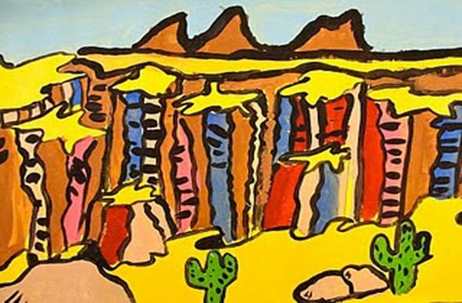

Year 5/6
The Great Americas- Spring Term 2026

The Great Americas
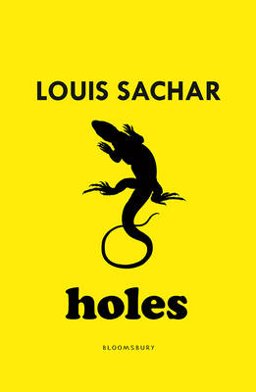
We have chosen the text Holes by Louis Sachar. The book centres on Stanley Yelnats, who is sent to Camp Green Lake, a juvenile detention centre in a desert in Texas, after being falsely accused of theft. The plot explores the history of the area and how the actions of several characters in the past have affected Stanley's life in the present. These interconnecting stories touch on themes such as the consequence of choices resulting from fate and destiny, racism, homelessness, illiteracy, friendship and arranged marriage.
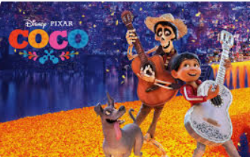
During the second half term, we will look at using the Disney film ‘Coco’ to inspire our narrative writing. Coco is a Disney/Pixar animated fantasy film centered on a 12-year-old boy, Miguel, who dreams of becoming a musician despite his family's generations-old ban on music. The story is a vibrant celebration of Mexican culture, particularly the Día de los Muertos (Day of the Dead) holiday. As part of their writing, the children will be working towards writing an alternative ending to this story.

Additional text extracts that will be used throughout our unit of work.
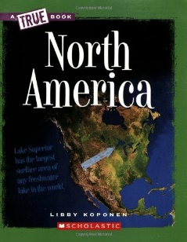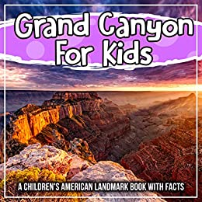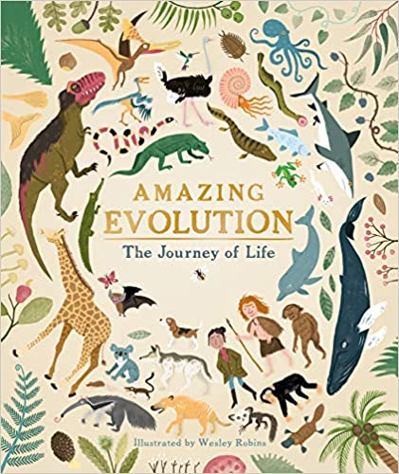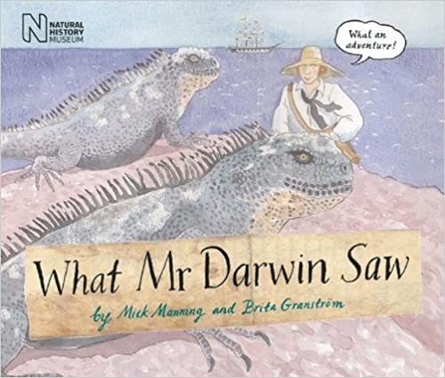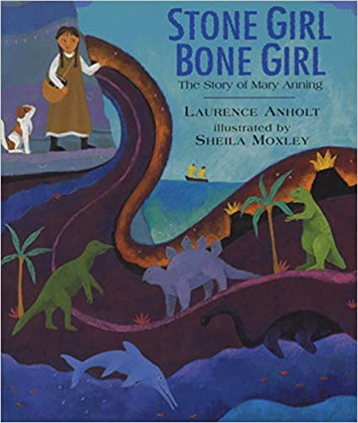

Visual Literacy
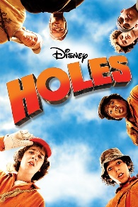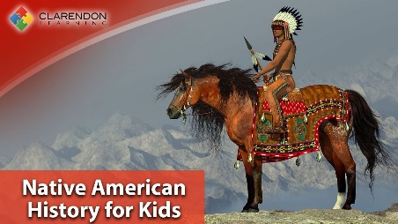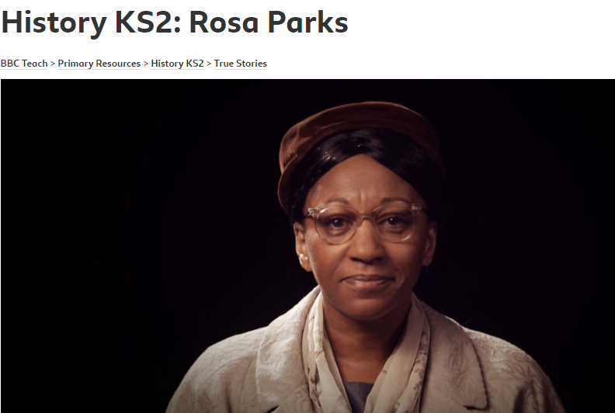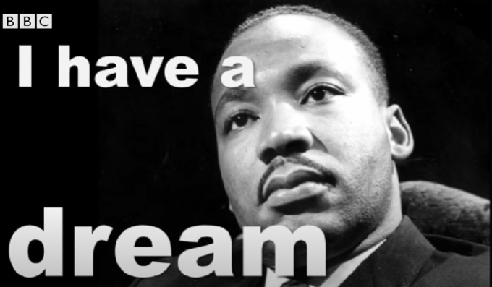

Further opportunities in Maths and English:
Maths | English
- Time zones across the world  - Statistical information – analysing climatic zones and interpreting  - Construct, read and interpret information in tables, pie charts and line graphs and use these to solve problems.  - Ordering larger numbers (population)  - Timelines | - Persuasive speeches  - Researching, note-taking and creating non-chronological texts  - Creating tourist brochures  - Storyboarding evolution and fossil creation over time

During the first half term, in Science, we will begin to think about evolution and inheritance and how characteristics pass from one generation to the next and how species have adapted to suit their environments. We will go on to explore the process of natural selection and consider how our knowledge of the process of evolution has developed over time thanks to the work of scientists and palaeontologists.
Science
Year 5 | Year 6
- I can identify the key ideas of the theory of evolution
- I can explain the process of evolution
- I can understand how human beings have evolved.
- I can identify evidence for evolution from fossil records.
- I can give examples of living things that lived millions of years ago and the fossil evidence we have to support this
- I can give examples of fossil evidence that can be used to support the theory of evolution.
- I can explain the scientific concept of inheritance.
- I can demonstrate understanding of the scientific meaning of adaptation.
- I can give examples of how plants and animals are suited to an environment
- I can identify characteristics that will make a plant or animal suited or not suited to a particular habitat
- I can give examples of how an animal or plant has evolved over time e.g. penguin, peppered moth
- I can explain why the dominant colour of the peppered moth changed over a very short period of time
- I can link the patterns seen in the model to the real examples
- I can explain how adaptations can result in both advantages and disadvantages.
- I can explain how human intervention affects evolution.

During the second half term, in Science, we will be focusing on 'living things and their habitats'. We will take an in-depth view at classifying animals, plants and micro-organisms. We will begin our unit on recapping our knowledge of broad groups of organisms before taking a much more detailed look at the Linnaeus classification system, how it works and how different species of organisms that are closely related can be identified. We will then continue this unit after the Easter holidays too.
Science
Year 5 | Year 6
- I know that organisms can be grouped according to their characteristics.
- I can describe the characteristics of different classifications of animals.
- I can match animals to their group according to their characteristics.
- I can classify organisms according to broad characteristics.
- I can find ways to distinguish between organisms that are similar.
- I can use appropriate scientific vocabulary to describe organisms and their features.
- I know that plants can be sorted into groups according to their characteristics.
- I can explain the difference between vascular and non-vascular plants.
- I can explain the difference between flowering and non-flowering plants.
- I know who Carl Linnaeus is and how he contributed to science.
- I can give reasons for why classification systems are important.
- I know what micro-organisms are.
- I know that micro-organisms can be classified into groups.
- I understand that some micro-organisms can be harmful and others can be helpful.
- I can identify and classify a variety of different organisms found in their local environment.
- I can use a variety of sources of information to identify organisms I am unfamiliar with.

In Design Technology we will learn about structures. We will learn that structures can fail when loaded, and the use of techniques for reinforcing and strengthening structures. We will then research and design our own Mayan Temple which will be effective within a certain setting or for a specific scenario. We will then work with our parents/carers at our curriculum café at the end of term to build our temples together.
Design Technology
Year 5 | Year 6
Developing, Planning and communicating ideas  - I can take a user’s view into account when designing  - I can produce a detailed step-by-step plan for my design method  - I can suggest some alternative designs and compare the benefits and drawbacks to inform the design process and outcome  Working with tools, equipment, materials and components to make quality products  - I can choose appropriate tools and materials to ensure that the final product will appeal to the audience  - I can use a range of tools and equipment with good accuracy and effectiveness, within established safety parameters  Construction  - I can ensure my measurements are accurate  enough to ensure precision  - I can demonstrate my product is strong and  fit for purpose  - I can refine and further refine my product  during the making stage  Evaluating processes and products  - I can continuously check that my design is effective and fit for purpose  - I can assess how well my product works in relation to the design criteria and the intended purpose and suggest improvements  - I can evaluate appearance and function against the original design criteria | Developing, Planning and communicating ideas  - I can use a range of information to inform my design  - I can work within constraints  - I can justify my plan to someone else  - I can consider culture and society in my  designs  - I can considered the use of the product  when selecting materials  Working with tools, equipment, materials and components to make quality products  - I can choose appropriate tools and  materials to ensure that the final product will  appeal to the audience  - I can use a range of tools and equipment with  good accuracy and effectiveness, within 8  established safety parameters  Construction  - I can ensure my measurements are accurate  enough to ensure precision  - I can demonstrate my product is strong and  fit for purpose  - I can refine and further refine my product  during the making stage  Evaluating processes and products  - I can test and evaluate my final product,  and state whether my product meet all  design criteria

In History we will be covering the Mayan civilisation. We will learn who the ancient Maya people were and where and when they lived. We will use maps and atlases to locate Maya cities and identify countries in Mesoamerica. We will also learn about the religious beliefs and rituals of the ancient Maya people and find out more about some of the many gods they worshipped. The children will learn about the Maya number system and have the opportunity to read and write Maya numbers and solve number problems. We will look at the Maya writing system and practise writing words using logograms and syllabograms. We will look at the explorers John Lloyd Stephens and Frederick Catherwood and look at historical pictures of cities they discovered.

History
Year 5 | Year 6
Historical interpretation  - I can evaluate evidence to choose the most reliable form.  Knowledge and understanding of events, people and changes in the past  - I can describe how historical events affect/influence life today?  Chronological understanding  - I can order significant events, movements and dates on a timeline.  Historical understanding  - I can explain how historical artefacts have helped us understand more about people’s lives in the present and past. | Historical interpretation  - I can suggest why there may be  different interpretations of events.  Knowledge and understanding of events, people and changes in the past  - I can suggest why certain events, people and changes might be seen as more significant than others.  Chronological understanding  - I can identify and compare changes within and across different periods.  Historical understanding  - I can pose and answer their own historical questions using primary and secondary sources as evidence to justify their opinions.

In Geography we will voyage across the Atlantic as we discover the continent of North America and all its amazing countries, cities and landscapes. We will identify the 23 countries of North America, from the vast lands of the USA and Canada down through Central America. On the way we will explore the various geographical features of different areas of North America and compare them with our own locality, including the National Parks and Great Lakes.
Geography
Year 5 | Year 6
Geographical enquiry  - I can research and collect information about a place and present it. e.g. a report, a poster, a brochure  - I can find possible answers to  their own geographical questions.  Geography skills and fieldwork  - I can plan a journey to another part of the  world, taking in to account variables such as transport, money, clothes, time, distance, circumstances  Human and physical geography  - I can describe how the Great Lakes were  formed  Place knowledge  - I can identify and discuss the climate conditions and different environments in and around the Great Lakes. | Geographical enquiry  - I can choose the best way to collect  information needed and decide the most  appropriate units of measure.  - I can present their research through self-selected representations. E.g reports, leaflets, drama, art, multimedia.  Locational knowledge  - I can use maps, aerial photos, plans and web  resources to describe what a locality might be  like.  Geography skills and fieldwork  - I can confidently explain scale and use maps  with a range of scales.  - I can use maps to answer questions.  Human and physical geography  - I can describe how the Great Lakes were  formed  Place knowledge  - I can identify and discuss the climate conditions and different environments in and around the Great Lakes.

In Art we will study the great photographer, Ansel Adams, and explore the geological and aesthetic beauty of his Grand Canyon shots. We will then use photographs and paintings of the Grand Canyon, to create a mixed media (photography and drawing/painting) piece of art that highlights contrasting local geographic features and this wonderful natural wonder of our world.

Art
Year 5 | Year 6
Sketch books  - I can use their sketchbooks to explore and practice a range of materials, record ideas, and experiment.  Knowledge  - I can experiment with different styles which artists have used.  - I can overlap materials to build an image, combining pattern, tone and shape.  Collage  - I can use collage to create a mood boards of ideas and as a tool to develop a piece in mixed media.  Use of IT  - I can create a piece of art work which includes the integration of digital images I have taken.  - I can combine graphics and text based on their research.  - I can scan images and take digital photos, and use software to alter them, adapt them. | Sketch books  - I can use my sketch books to record detailed notes, and quotes explaining my ideas.  Knowledge  - I can say what their work is influenced by.  - I have knowledge of a wide range of artists and have formed their own opinions on their different styles.  Collage  - I can use collage as a tool as part of a mixed media project.  - I can express their ideas through collage.  Use of IT  - I can use software packages to create pieces of digital art to design.  - I can create a piece of artwork which can be used as part of a wider presentation
In Music we will be learning to compose and perform rhythmic pieces of music using given musical conventions found in traditional African music. The children will explore call and answers, ostinato, polyrhythms and the use of mnemonics, through games, songs and whole class ensemble performance.
Music
- I can copy and improvise rhythms through musical games and song.
- I can perform an independent part within a whole class ensemble.
- I can apply and use key features of African music to create rhythmic compositions.
- I can develop a piece of music considering the structure.
- I can refine and perform our composition and critically appraise it.
- I can perform a group composition with confidence, using key features of African music.

In Physical Education, we will start the term looking at gymnastics and learn how to perform a variety of floor and vault movements. We will learn stag jumps, split leaps, pike rolls, round-offs and the squat through vault while developing their understanding of the necessary flexibility, strength and control needed to perform the movements successfully. We will also have the opportunity to choreograph our own sequences and routines and perform individually and as part of a pair or group
Physical Education
Year 5 | Year 6
Physical skills  - I can perform combinations of gymnastic actions with different levels, speeds and directions  Thinking skills  - I can evaluate a sequence and suggest improvements to speed, direction and level, applying some basic criteria  - I can show good awareness of space and the actions of others  Personal skills  - I can work and compete individually and with others  - I can develop my competence and confidence  Health skills  - I can recognise that strength and suppleness are important parts of fitness  - I can recognise when their body is warmer or cooler and when their heartbeats faster and slower | Physical skills  - I can show control and power in take-off and landing activities  Thinking skills  - With help, I can devise warm up and cool down activities and justify their choices  - I can develop my ability to evaluate my own and others’ work, and to suggest ways to improve it using appropriate terminology  Personal skills  - I can work with a partner or small group to practise and refine a sequence  - I can work and compete individually and with others  - I can develop my competence and confidence  Health skills  - I understand fully why exercise is good for fitness, health and wellbeing
During the second half of term, we will build on some of the skills visited in previous Net and Wall units, as well as introducing a variety of new skills and techniques associated with tennis. In this unit, we will further develop our striking and hitting skills by learning how to hit different groundstrokes. We will be introduced to the overhead tennis serve, where we will use this in conjunction with developing a volley shot. Throughout the term, we will gain experience in a match environment by competing in a variety of tennis mini-games, applying the skills we have learnt, while developing an understanding of the rules and scoring in tennis. The unit will be rounded off with the children evaluating their own performance and identifying areas where they can improve
Physical Education
Year 5 |  | Year 6
Physical skills  - I can use a large range of sending, receiving and travelling techniques in games, with varied control  - I can demonstrate a range of throwing actions using modified equipment with some accuracy and control  - I know and apply the basic strategic and tactical principles of asome games and adapt them to different situations  - I can show good awareness of space and the actions of others  Thinking skills  - I can identify good performances and suggest ideas for practices that will improve their play  Personal skills  - I appreciate that rules need to be consistent and fair, using this knowledge to create rules and teach them to others  - I can work and compete individually and with others  - I can develop my competence and confidence  - I can compete in small sided games fairly showing good sportsmanship  Health skills  - Developing calming techniques and self-regulate emotions | Physical skills  - I can use a large range of sending, receiving and travelling techniques in games, with varied control  - I can perform skills with greater speed, fluency and accuracy in invasion, striking and net games  - I can choose appropriate techniques for specific events  - I understand, choose and apply a range of tactics and strategies for defence and attack  Thinking skills  - I can develop my ability to evaluate my own and others’ work, and to suggest ways to improve it using appropriate terminology  Personal skills  - I appreciate that rules need to be consistent and fair, using this knowledge to create rules and teach them to others  - I can work and compete individually and with others  - I can develop my competence and confidence  - I can compete in small sided games fairly showing good sportsmanship  Health skills  - I can identify activities that develop stamina or power and suggest how some can be used in other types of activities

In PSHE we will be learning the meaning of conflict, including interpersonal conflict, and how this is a natural part of living. We will be developing our understanding of our own conflicts and how these can be escalated or de-escalated, and how friends can help with conflict resolutions. We will recognise the importance that effective listening can play within de-escalating situations and conflicts. During the second half of Spring Term, we will be learning about the importance of financial planning and independence and using lesson plans from the Bank of England to support this understanding.
Personal, Social and Health Education
Year 5 | Year 6
Conflict and resolution
- To discuss the concept and process related to interpersonal conflict
- To understand that conflict is a natural part of living
- To understand three different ways of conflicting: Okay conflict, negative conflict and violent conflict
- To understand the concepts of escalation and de-escalation of conflict
- To become aware of their own conflicts and those around them.
- To discuss factors that escalate or de-escalate conflict
- To recognise that there are many factors that can escalate a conflict (eg. Put downs, disrespect, negative tone of voice, body language, crowd of bystanders
- To recognise that a person who encourages you to resolve your conflict is a better friend than one who encourages you to escalate them
- To be introduced to a conflict resolution process and the concept of apologising
- To discuss different ways of resolving conflict
- To discuss a specific procedure for resolving conflict
- To explore the role and skills related to being an effective listener during conflict situations

Financial Planning & Independence
- Introduction to banking
- What the Bank of England is and how inflation works
- Supply and demand and how prices change over time
- Why money is so important

In Computing, in the first half term we will be progressing our programming skills. We will be learning about variables and how we can utilize this knowledge when creating a program. We will then create our own game. We will use Scratch software for this. In the second half term we will further develop our programming skills. We will be connecting software to a physical device and learning how to handle inputs and outputs from it. We will use our knowledge of algorithms, programs and variables to create a project. We will use MakeCode software for this and utilise BBC Micro:Bit devices.
Computing
Year 6 | Year 6
Programming - Variables in games  Exploring variables when designing and coding a game  - To define a ‘variable’ as something that is changeable  - I can explain that the way a variable changes can be defined  - I can identify examples of information that is variable  - I can identify that variables can hold numbers or letters  - To explain why a variable is used in a program  - I can explain that a variable has a name and a value  - I can identify a program variable as a placeholder in memory for a single value  - I can recognise that the value of a variable can be changed  - To choose how to improve a game by using variables  - I can decide where in a program to change a variable  - I can make use of an event in a program to set a variable  - I can recognise that the value of a variable can be used by a program  - To design a project that builds on a given example  - I can choose the artwork for my project  - I can create algorithms for my project  - I can explain my design choices  - To use my design to create a project  - I can choose a name that identifies the role of a variable  - I can create the artwork for my project  - I can test the code that I have written  - To evaluate my project  - I can identify ways that my game could be improved  - I can share my game with others  - I can use variables to extend my game | Programming - Sensing movement  Designing and coding a project that captures inputs from a physical device.  - To create a program to run on a controllable device  - I can apply my knowledge of programming to a new environment  - I can test my program on an emulator  - I can transfer my program to a controllable device  - To explain that selection can control the flow of a program  - I can determine the flow of a program using selection  - I can identify examples of conditions in the real world  - I can use a variable in an if, then, else statement to select the flow of a program  - To update a variable with a user input  - I can experiment with different physical inputs  - I can explain that checking a variable doesn’t change its value  - I can use a condition to change a variable  - To use a conditional statement to compare a variable to a value  - I can explain the importance of the order of conditions in else, if statements  - I can modify a program to achieve a different outcome  - I can use an operand (e.g. <>=) in an if, then statement  - To design a project that uses inputs and outputs on a controllable device  - I can decide what variables to include in a project  - I can design the algorithm for my project  - I can design the program flow for my project  - To develop a program to use inputs and outputs on a controllable device  - I can create a program based on my design  - I can test my program against my design  - I can use a range of approaches to find and fix bugs

During the first half of the term, we will look at how belief in Christianity and Islam has impacted on music and art through history. Then, in the second half term, will be looking at the similarities and differences between the Gospel accounts of Jesus’ death and resurrection. We will begin to describe the significance of resurrection and how it shapes how Christians see the world and others, and how the resurrection effects how Christians might live their lives.
Religious Education
How has belief in Christianity/Islam impacted on music and art throughout history? (Christian/Muslim)
Year 5 | Year 6
- I can show awareness that talking about religion and belief can be complex.
- I can explain how beliefs impact on and influence individual lives, communities and society, and how individuals, communities and society can also shape beliefs.
- I can describe ways in which beliefs shape the way Christians/Muslims view the world in which they live and how they view others
Religious Education
What does resurrection mean to Christians?
- I can describe a range of different interpretations of sources of authority and consider the reliability of these sources for a group of believers.  - I can describe ways in which beliefs shape the way Christians view the world in which they live and how they view others.  I can explain how beliefs impact on and influence individual lives, communities and society, and how individuals, communities and society can also shape beliefs. | - I can begin to discuss the reliability and authenticity of texts that are authoritative for a group of believers  - I can explain and discuss how beliefs shape the way Christians view the world in which they live and how they view others  I can begin to analyse and evaluate how beliefs impact on, influence and change individual lives, communities and society, and how individuals, communities and society can also shape beliefs.

In French, we will continue to develop our conversational speaking by learning how to order what you would like to eat and drink in a French tea room and language associated around the Olympics.
Modern Foreign Languages: French
In the tearoom / café / restaurant
- I can recall from memory a wider range of nouns for common foods, snacks and drinks.
- I can understand better how to make nouns plural in French.
- I can improve my knowledge of the French currency.
- I can order in French what I would like to eat and drink in a role-play.

Olympics
- I can understand the key facts of the ancient and modern Olympics recounted in French.
- I can learn 10 nouns for common Olympic sports.
- I can explore the full present tense conjugation of the high frequency verb ‘faire’.
- I can look at the gendered nouns and the agreement rules involved when you describe a male Olympian or female Olympian.

