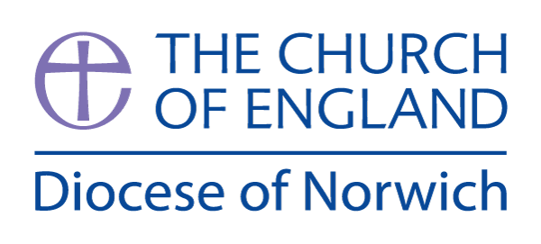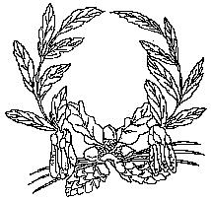

**Ashill V.C. Primary School**

My Learning Discovery

**Year R**

Dinosaurs

Spring Term (first half)

We have chosen the following texts to explore the theme of ‘Dinosaurs.’ In Reception, children primarily learn through play-based opportunities. Therefore, there will always be a balance of adult-led activities and child-initiated learning. During the first half of the Spring term, we will be sharing lots of fiction and non-fiction books related to our theme and depending on the children’s interests, we will plan activities linked to these, such as creating dinosaur skeleton pictures using art straws or creating our own dinosaur worlds.

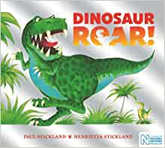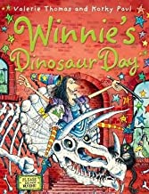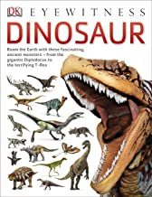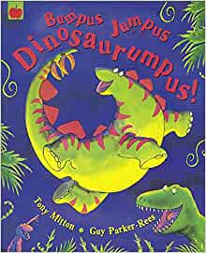

**Prime Areas of Learning:**

In **Communication and Language,** we will spend time sharing non-fiction books to learn about dinosaurs and what different dinosaurs are called.

|  |
| --- |
| **Communication and Language** |
| **Year R** |
| * Develop their pronunciation of trickier sounds and multi-syllabic words such as ‘hippopotamus’. * Be able to express a point of view and to debate when they disagree with someone. * Understand how to listen carefully and why listening is important. * Use a wider range of vocabulary * Develop social phrases. * Engage in story times. |

In **Personal, Social and Emotional Development**, we will develop our understanding of how others may be feeling and we will learn to show perseverance when things don’t go right first time. We will learn about the feelings calm, scared and excited. We will also learn about the importance of sharing.

|  |
| --- |
| **Personal, Social and Emotional Development** |
| **Year R** |
| * Understand gradually how others might be feeling. * See themselves as a valuable individual. * Become more outgoing with unfamiliar people in the safe context of their setting. * Develop appropriate ways of being assertive, talking with others to solve conflict. |

In **Physical Development,** we will continue to develop both our fine and gross motor skills. We will use construction sets to build models, such as houses for the three little pigs. In addition to daily freeflow provision in the EYFS outside area, we will develop our physical skills outside or in the hall, through regular PE sessions.

|  |
| --- |
| **Physical Development** |
| **Year R** |
| * Choose the right resources to carry out their plan. * Collaborate with others to manage large items, such as large wooden planks, safely. * Show a preference for a dominant hand. * Develop their small motor skills so that they can use a range of tools, including pencils, competently. * Use their core muscle strength to achieve good posture when sitting at a table or sitting on the floor. * Develop the overall body strength, co-ordination, balance and agility needed to engage successfully with future physical education. * Develop the foundations of a handwriting style which is fast, accurate and efficient. |

**Specific Areas of Learning:**

In **Literacy**, we will use our phonics knowledge to read and write more words at the appropriate level. We will learn to read a simple phrase and draw a quick picture that matches what we have read, e.g. “a red hat.” We will be learning to recognise ‘tricky words’ which cannot be sounded out, e.g. “I” and “the.”

We will also begin to learn new sounds such as: ai, ee, igh, oa, oo, ar, or, ur, ow (as in cow), oi, ear, air, ure, er.

|  |
| --- |
| **Literacy** |
| **Year R** |
| * Read individual letters by saying the sounds for them, at speed. * Blend sound into words. * Read some letter groups that each represent one sound, e.g. “ch” “sh” “th.” * Read a few common exception words. * Read simple phrases and sentences made up of words/sounds that children are familiar with. * Write their first name. * Form lower case letters correctly. |

In **Mathematics,** we will explore the weights of different objects using a balance scale. We will explore the capacity of different containers using sand, water and other small objects. We will learn that numbers can be composed of different numbers – e.g. 5 can be made with 4 and 1 or 3 and 2. We will develop our understanding of language associated with time, including the days of the week.

|  |
| --- |
| **Mathematics** |
| **Year R** |
| * Learn about zero. * Make comparisons between objects relating to size, length, weight and capacity. * Count objects, actions and sounds – say how many you think there might be before you count. * Subitise – show small quantities in both familiar (e.g. spots on a dice) and random arrangements. * Explore the composition of numbers to 10 - starting with small numbers before moving onto larger numbers. * Understand the ‘one more than/one less than’ relationship between consecutive numbers. * Link numerals and amounts. * Know that the last number reached when counting a small set of objects tells you how many there are in total. |

In **Understanding the World**, children will be making sense of their physical surroundings and their community as well as the wider world. We will teach the children about the celebration of Lunar New Year and how this happens in lots of different parts of the world.

|  |
| --- |
| **Understanding the World** |
| **Year R** |
| * Explore collections of materials with similar and/or different properties. * Explore and talk about different forces. * Recognise that people have different beliefs and celebrate special times in different ways. * Know that there are different countries in the world and talk about the differences they see in photos. * Explore how things work. |

In **Expressive Arts and Design**, we will be drawing dinosaurs and making art straw dinosaur skeletons. We will use junk materials to make our own models, joining materials using different techniques. We will be developing our singing skills and will explore how we can change our pitch and volume when singing.

|  |
| --- |
| **Expressive Arts and Design** |
| **Year R** |
| * Explore different materials freely in order to develop their ideas about how to use them and what to make. * Make imaginative and complex ‘small worlds’ with blocks and construction kits. * Develop their own ideas and then decide which materials to use to express them. * Join different materials and explore different textures. * Respond to what they have heard, expressing their thoughts and feelings. * Sing the melodic shape of familiar songs. * Create their own songs or improvise a song around one they know. * Create collaboratively, sharing ideas, resources and skills. |