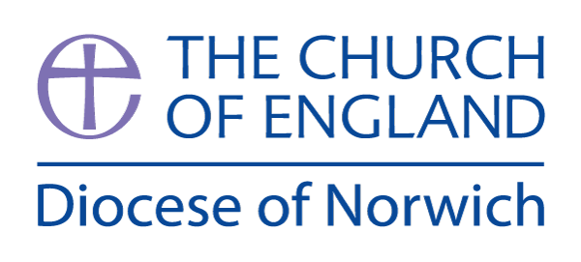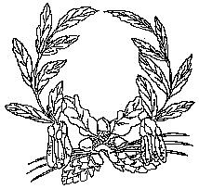

**Ashill V.C. Primary School**

My Learning Discovery

**Year R**

Celebrations

Autumn Term (second half)

We have chosen the following texts to explore the theme of ‘Celebrations.’ In Reception, children primarily learn through play-based opportunities. Therefore, there will always be a balance of adult-led activities and child-initiated learning. During the second half of the Autumn term, we will explore the themes/festivals of Bonfire Night and Diwali. We will share the Nativity story and we will learn about how Christians celebrate Christmas. We will share lots of picture books about winter and Christmas.

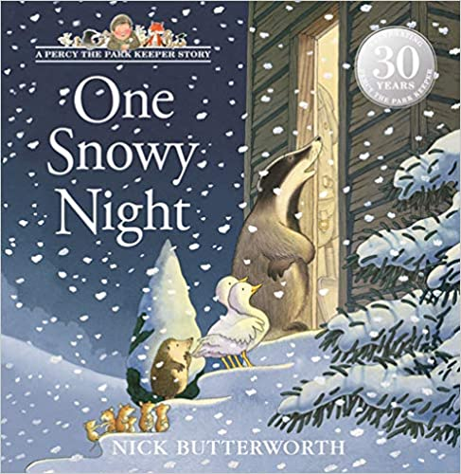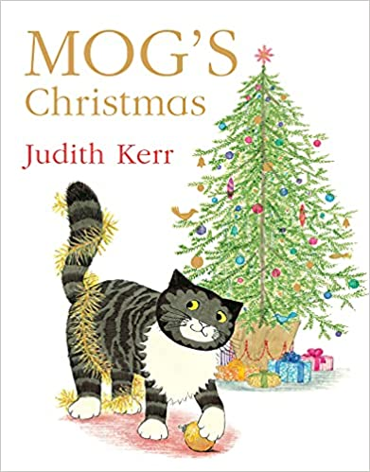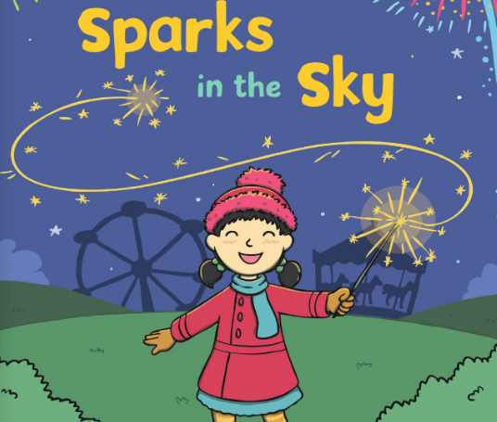 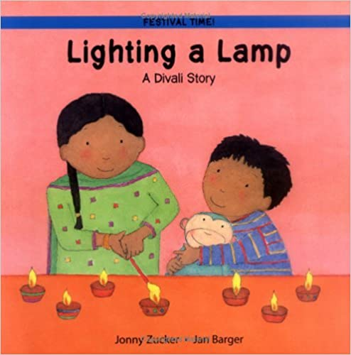 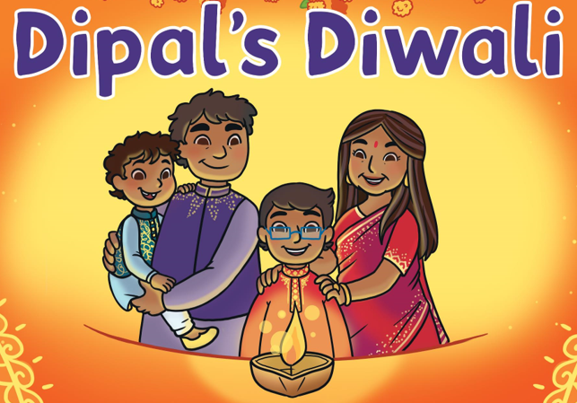 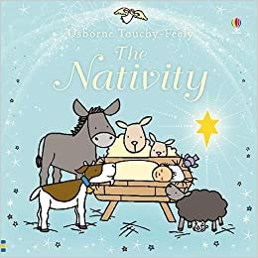 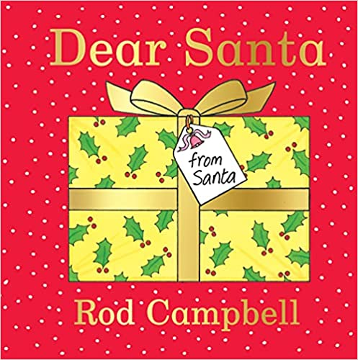

**Prime Areas of Learning:**

In **Communication and Language,** we will listen to firework poems and we will learn many new songs in preparation for our Nativity play. We will learn about the Christmas story and will be able to identify the characters and retell the story in our own words.

|  |
| --- |
| **Communication and Language** |
| **Year R** |
| * Pay attention to more than one thing at a time. * Listen carefully and learn rhymes and songs. * Sing a large repertoire of songs. * Be able to tell a long story. * Develop their communication, using correct pronunciation most of the time. * Use longer sentences of 4-6 words. * Use talk to organise themselves and their play. |

In **Personal, Social and Emotional Development**, we will work on developing our relationships with adults and peers. We will learn about the feelings happy, sad and angry. With the help of Twiggle the Turtle, we will learn how we can calm down if we get upset.

|  |
| --- |
| **Personal, Social and Emotional Development** |
| **Year R** |
| * Talk about their feelings using words such as ‘happy’ or ‘sad’ or ‘angry’. * Show more confidence in new social situations. * Play with other children, extending and elaborating their play ideas. * Find solutions to conflicts by talking. * Remember rules without needing an adult to remind them. * Know and talk about different factors that support their health and wellbeing such as being a safe pedestrian. |

In **Physical Development,** we will continue to work on both our fine and gross motor skills. We will use different tools and equipment to strengthen our hand muscles as well as learning how to hold a pencil effectively for drawing and writing. We will hammer golf tees into pumpkins using real hammers. We will manipulate clay with our hands and use clay tools as well as using syringes as water squirters. In addition to daily freeflow provision in the EYFS outside area, we will develop our physical skills outside or in the hall, through regular PE sessions.

|  |
| --- |
| **Physical Development** |
| **Year R** |
| * Use a comfortable grip with good control when holding pens and pencils. * Be increasingly independent, for example, putting coats on and doing up zips. * Increasingly able to use and remember movement sequences. * Confidently and safely use a range of large and small apparatus indoors and outside, alone and in a group. * Match their developing physical skills to tasks and activities. * Develop overall body strength, balance, co-ordination and agility. |

**Specific Areas of Learning:**

In **Literacy**, we will continue to learn the Set 1 sounds, understanding that each letter makes a sound. We will be blending sounds together to read words. We will share different types of texts and demonstrate our understanding of these.

|  |
| --- |
| **Literacy** |
| **Year R** |
| * Recognise some words start with the same initial sound. * Develop their phonological awareness so that they can spot and suggest rhymes, and count or clap the syllables in a word. * Engage in extended conversations about stories, learning new vocabulary. * Use some of their print and letter knowledge in their early writing, e.g. writing a pretend shopping list using ‘b’ for ‘bananas’ or label a picture of Mary from the nativity story using ‘m’. * Write their first name. |

In **Mathematics,** we will be practising recognising how many objects there are (up to 3) without needing to count them (subitising). We will learn all about circles, triangles, squares and rectangles and we will use positional language when describing where things are (e.g. under the table, next to the chair).

|  |
| --- |
| **Mathematics** |
| **Year R** |
| * Develop fast recognition of up to 3 objects (subitising). * Recite numbers beyond 5. * Talk about and explore 2D shapes. * Understand position through words alone. * Know that the last number reached when counting a set of objects tells you how many there are in total (‘cardinal principle’.) * Experiment with their own symbols and marks as well as numerals. * Solve real world mathematical problems with numbers up to 5. * Begin to describe a sequence of events, real of fictional, using words such as ‘first’ and ‘then…’ * Describe a familiar route. * Discuss routes and locations, using words like ‘in front of’ and ‘behind’. * Understand the ‘one more than/one less than’ relationship between consecutive numbers. |

In **Understanding the World**, we will be learning about different festivals and celebrations. We will learn about Diwali and how the festival of light is important to many people. We will learn about the Nativity story and how Christmas is an important celebration for Christians around the world. We will visit our local church for the Christmas church service. We will plant tulip bulbs and await their blooms in the spring. We will notice what is happening outside during Autumn and we will talk about why people wear poppies for Remembrance.

|  |
| --- |
| **Understanding the World** |
| **Year R** |
| * Use all their senses in hands-on exploration of natural materials, e.g. leaves, sticks, pebbles. * Explore collections of materials with similar or different properties. * Understand the effect of changing seasons on the natural world around them. * Talk about what they see, using a wide vocabulary. * Plant bulbs and care for growing plants. * Understand that some places are special to members of their community. * Recognise that people have different beliefs and celebrate special times in different ways. |

In **Expressive Arts and Design**, we will be creating firework pictures and making a Diwa lamp out of clay before decorating it when dry. We will also make paper lanterns to mark the festival of light. We will help to make scenery for our Nativity play and we will learn new songs for our Nativity performance.

|  |
| --- |
| **Expressive Arts and Design** |
| **Year R** |
| * Begin to develop complex stories using small world equipment. * Create closed shapes with continuous lines and begin to use these shapes to represent objects. * Listen with increased attention to sounds. * Remember and sing entire songs. * Sing the pitch of a tone sung by another person. * Explore colour and colour-mixing. |