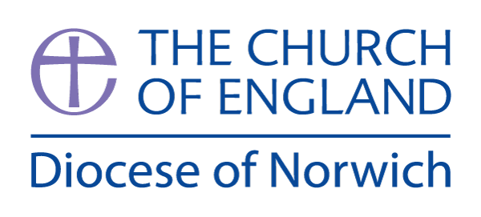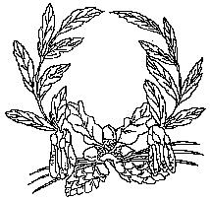

**Ashill V.C. Primary School**

My Learning Discovery

**Year R**

Ourselves

Autumn Term (first half)

We have chosen the following texts to explore the theme of ‘Ourselves’. We will talk about what we can do now that we couldn’t do when we were babies. We will share stories about Birthdays and talk about what makes Birthdays special. We will learn about harvest and farming and will learn new songs, such as ‘Big Red Combine Harvester.’ We will also talk about the importance of making healthy choices about food, drink, activity and teeth brushing.

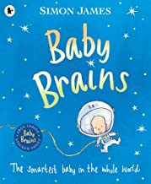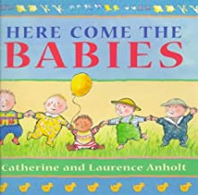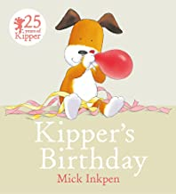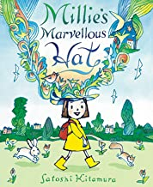

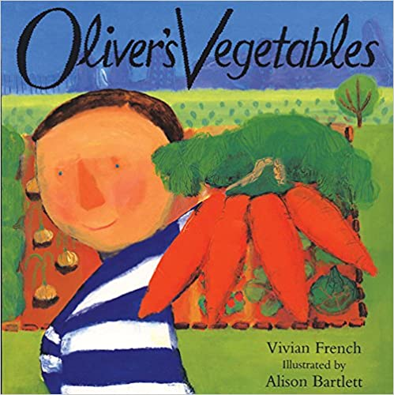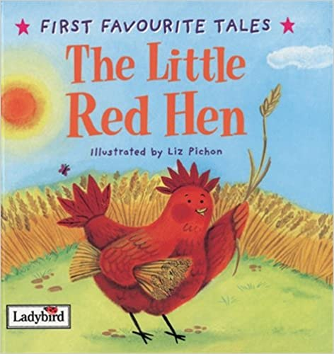

In

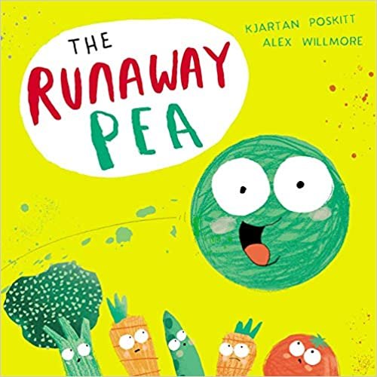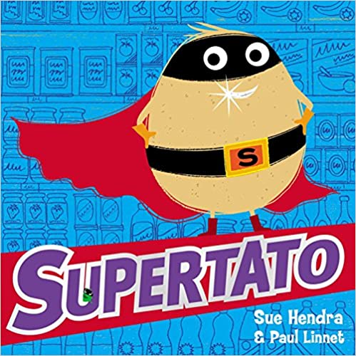

In Reception, children primarily learn through play-based opportunities. There will be a mix of adult-led activities and child-initiated learning. During the first half of the Autumn term, the children will take part in a range of activities that will enable the teachers to assess their knowledge and skills across all areas of the curriculum.

**Prime Areas of Learning:**

In **Communication and Language,** we will share our ‘All about me’ booklets, encouraging children to talk in full sentences. We will share lots of picture books and encourage children to be attentive and show basic listening skills. We will play a variety of fun listening games to support this.

|  |
| --- |
| **Communication and Language** |
| **Year R** |
| * Enjoys listening to longer stories and can remember what happens. * Initiate conversations with adults and friends. * Understand and carry out a 2-part instruction. * Understand ‘why’ questions. * Learn some rhymes and songs. * Be able to talk about familiar books. |

In **Personal, Social and Emotional Development**, we will work on forming new relationships and will help the children to get to know one another through circle time games. We will learn about the routines of the day as well as the behavioural expectations we have at school. We will learn about the importance of sharing and being kind. We will also talk about the importance of making healthy choices and brushing our teeth regularly.

|  |
| --- |
| **Personal, Social and Emotional Development** |
| **Year R** |
| * Select and use resources with some help. * Develop their sense of belonging to school. * Play with other children that may not be familiar to them. * Follow basic rules, understanding why they are important. * Be increasingly independent in meeting their own care needs, e.g. brushing teeth, healthy eating. |

In **Physical Development,** we will be working on both our fine and gross motor skills. We will use playdough with different tools to strengthen our hand muscles as well as learning how to use scissors and hold a pencil for drawing and writing. We will move energetically outside, running, climbing and jumping.

|  |
| --- |
| **Physical Development** |
| **Year R** |
| * Develop their balancing skills and ride a scooter and 3-wheeled bike. * Use one-handed tools, e.g. scissors. * Skip, hop and stand on one leg during games. * Use large muscle movements when playing. * Go up steps and stairs and climb using alternate feet. |

**Specific Areas of Learning:**

In **Literacy**, we will begin to learn phonics block 1, realising that each letter makes a sound. We will begin to blend sounds together to read simple 2 and 3-letter words. We will share different types of texts and demonstrate our understanding of these.

|  |
| --- |
| **Literacy** |
| **Year R** |
| * Develop an understanding of how a book works –e.g. we read text from left to right, print has purpose and meaning. * Learn rhymes and clap along to a rhythm. * Begin schools synthetic phonics programme. * Attempt to write their first name. * Use marks to communicate meaning and write some letters accurately. |

In **Mathematics,** we will learn number rhymes to develop our understanding of numbers to 10. We will practise counting sets of objects accurately and match them to the correct numeral. We will learn about 2D shapes, go on a shape hunt and use them to make pictures. We will introduce the skills of measuring length and using positional language and we will learn what numbers the Numicon shapes represent.

|  |
| --- |
| **Mathematics** |
| **Year R** |
| * Develop fast recognition of up to 3 objects (subitising). * Say 1 number for each object 1-5. * Use fingers to count and match objects up to 5. * Make comparisons between objects relating to size and length. * Compare quantities using language ‘more than’ or ‘fewer than.’ * Talk about and identify the patterns around them. * Create and extend ABAB patterns. * Notice and correct an error in a repeating pattern. |

In **Understanding the World**, we will be talking about our families and understanding that we are all different and have different likes and dislikes. We will learn about harvest and how farmers help to provide us with the food we eat. We will watch ‘Tractor Ted makes bread’ and will then have a go at making our own bread.

|  |
| --- |
| **Understanding the World** |
| **Year R** |
| * Begin to make sense of their own life story and family’s history. * Talk about member of their immediate family and community. * Name and describe people who are familiar to them. * Develops positive attitudes towards differences between people. * Talk about the differences between materials and changes they notice. |

In **Expressive Arts and Design**, we will be exploring role play scenarios based on the children’s interests. We will provide opportunities and resources for the children to take part in creative activities, such as painting a self-portrait. We will use vegetables to do some printing and we will create Arcimboldo-inspired art work using fruit and vegetable images.

|  |
| --- |
| **Expressive Arts and Design** |
| **Year R** |
| * Explore different materials freely in order to develop their ideas. * Take part in pretend play, pretending that one object can represent something else. * Use drawing and colour to represent their ideas. * Draw with increasing complexity and detail, such as representing a face with a circle and including details. |