SITE NOTICE
Neighbourhood Planning (General) Regulations 2012
Reigate and Banstead Borough Council has approved, under Article 7 of the above Regulations, the following Neighbourhood Planning Area:
Neighbourhood Area Name: Salfords and Sidlow
Relevant Body: Salfords and Sidlow Parish Council
The neighbourhood area is identified in red on the map below:
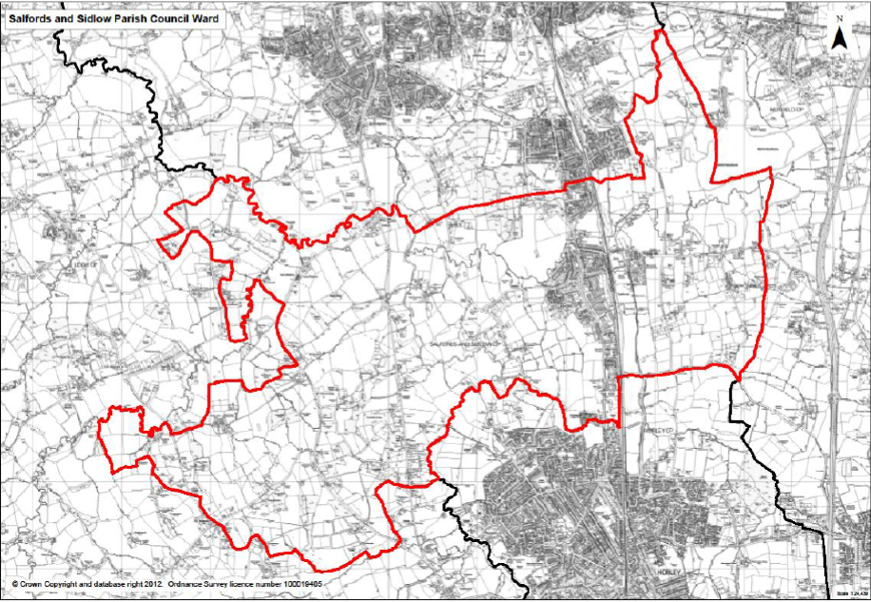
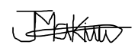
Joyce Hamilton
Strategic Head of Legal and Governance
19th September 2025

