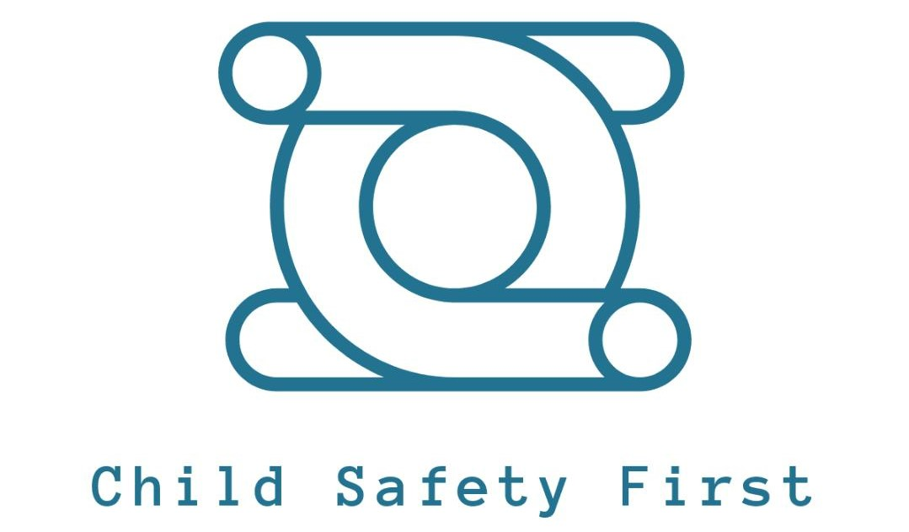

Visiting Parent Intake Form
Visiting Parent Information
- Visiting Parent Name: ____________________________________________________________
- Home Address: _________________________________________________________________
- Phone Number: _________________________________________________________________
- Email Address: __________________________________________________________________
- Relationship to Child(ren) (optional): _______________________________________________
- Date of Intake: _________________________________________________________________
Child(ren) Information
- Child(ren) Name(s) and Age(s): ________________________________________________________________________________________________________________________________________________________________________________________________________________________________________________________________________________________________________________________
Visit Details
- Location of Supervised Visit (Facility/Address or Virtual):______________________________________________________________________________________________________________________________________________________
- Desired Days of the Week & Times (example: Mon/Wed 5:00–7:00): ____________________________________________________________________________________________________________________________________________________________
- Start Time: _____________________________________________________________________
- End Time: ______________________________________________________________________
- Frequency (e.g., weekly, biweekly): ______________________________________________________________________________
- Primary Contact for Visits (if different): _____________________________________________
- Emergency Contact (for visit days):_________________________________________________
Authorized Persons Present at Visits
- Are there other people permitted to participate or be present? ☐Yes ☐No
- If Yes, list authorized persons and their relationship to the child(ren): ____________________________________________________________________________________________________________________________________________________________
Policy note: Any unauthorized persons will be asked to leave; visits may be cancelled and authorities contacted if necessary.
Medication, Health, and Safety
- Medication policy acknowledgment: Custodial parent must provide all medications prior to visitation; staff will not administer medication or perform and medical procedure.
- Child(ren)’s health, allergies, and special needs: ☐NONE Explain health, allergy, special needs ________________________________________________________________________________________________________________________________________________________________________________________________________________________________________________________________________________________________________________________
- Medical restrictions requiring accommodation during visits: ☐NONE Explain if there are restrictions: ________________________________________________________________________________________________________________________________________________________________________________________________________________________________________________________________________________________________________________________
Recordings or photography during visits will be at the discretion of the guardian/custodian, you agree to abide by their agreement: ☐Yes ☐No
Is there a current court order? ☐Yes ☐No
  - If Yes, Court Order County: _________________________________________________
  - What does the court order stipulate about visitation: ________________________________________________________________________________________________________________________________________________________________________________________________________________________________________________________________________________________________
Food & beverages may be provided but will be at the discretion of the child’s current guardian/custodian. You agree you will abide by their agreement? ☐Yes ☐No
If you provide food, drinks, snacks you will provide some healthy options ☐ Yes ☐ No
Do you have any concerns about visits: ____________________________________________________________________________________________________________________________________________________________________________________________________________________________________________________________________________________________________________________________________________________
Release of Information
- I understand Child Safety First may release records/information to official contacts (GAL, attorney, court, police, emergency personnel) on signed Information Request: ☐Yes ☐No
- Child Safety First may provide Original Observational Reports, photos, or videos to court officials upon signed Information Request or subpoena: ☐Yes ☐No
About Child Safety First
- Observers are neutral; they document facts and do not recommend future visitation arrangements. Observers document events, activities, interactions, conversations, behavior, and redirections:
- Weather/inclement weather policy: Follow County school closings or contact for confirmation:
- Safety and responsibilities: Child Safety First is not responsible for actions or inaction of participants; may cease visits to ensure child safety and wellbeing:
Affirmations and Scheduling
- The visit starts at the scheduled start time; if all parties do not arrive within 15 minutes from start time, the visit will be cancelled; the visit ends at the scheduled end time regardless of when it started:
- 24-hour notice of cancellation is required; failure to provide notice may result in full charge for the scheduled visit:
Signatures
Visiting Parent Signature: ______________________________________________________________________________
Date: _________________________
- The supervised visitation services described in this form are provided by Child Safety First and are not a court order. If a current court order governs visitation, that court order controls. This Intake/Agreement does not modify or supersede any court order unless expressly integrated by a court order.
- Observers act as neutral supervisors to support the safety and wellbeing of the child(ren). Child Safety First Observers/Staff are not legal guardians, not decision-makers on custody, and do not determine custody rights. Staff may document events and safety concerns.
- Visits may be canceled, paused, or terminated at any time if safety concerns arise or if participants fail to comply with program rules. Child Safety First reserves the right to deny future visits to protect the child(ren).
- The custodial parent must provide all medications prior to visitation. Child Safety First staff will not administer medications. In a medical emergency, staff may obtain necessary medical treatment for the child and will attempt to contact the custodial parent/guardian as soon as practicable.
- Personal information is used for intake, scheduling, supervision, and safety. Ch may disclose information to GALs, attorneys, courts, police, emergency personnel, and involved family service workers in response to signed Information Requests, subpoenas, or as required by law.
- Recordings or photography of the child(ren) during visits may occur only as permitted by the custodial/guardian of the child(ren) and applicable law. Child Safety First may take photos, audio, or video at any time.
- Child Safety First will retain records per policy and law and share information only as allowed by law or signed Information Requests.
- Cancellations and refunds (if any) follow Child Safety First’s agreement. A 24-hour cancellation rule applies unless policy states otherwise.
- To the fullest extent permitted by Virginia law, Child Safety First and its staff are not liable for ordinary risks of visitation, except for gross negligence or willful misconduct. Participants agree to indemnify Child Safety First from claims arising from participation to the extent permitted by law outside of gross negligence.
- Child Safety First may update these Disclaimers, Terms, and Conditions. Changes take effect upon notice. Continued participation after notice constitutes acceptance of updated terms.
- The program will provide reasonable accommodation for participants with disabilities and will not discriminate against protected characteristics.
- If any provision is invalid, the remaining provisions remain in effect.
- Payment due: Payment is due at the time of service or within 14 days of invoice excluding the last scheduled visit.
- Methods: We accept major credit/debit cards through online portal, ACH, checks.
- Cancellations/no-shows: 24-hour cancellation required to avoid charges; no-shows charged full fee unless waived.
- Refunds/credits: Refunds only when Child Safety First cancels a visit; credits may apply for weather or safety-related cancellations.
- Who pays: The designated payer is agreed upon. If both parties contribute, amounts will be clearly itemized by separate invoices.
- Hardship: A limited sliding scale/waiver process is available on request with documentation.
- Receipts: Receipts are provided for every payment.
- Disputes: Billing disputes go through Child Safety First’s internal process first.
- Compliance: All payment activities comply with applicable laws.
By signing or electronically signing below, you acknowledge you have read and understand these Disclaimers, Terms, and Conditions and agree to them.
Full Name ____________________________________________ Date ______________________

Thank You For Choosing Child Safety First

