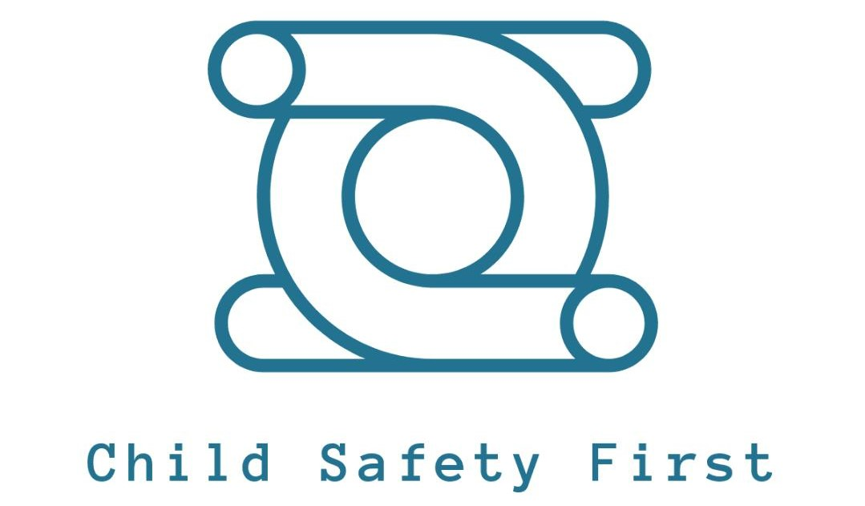
Supervised Contact Visit Intake Form

Disclaimer This form is for Intake and supervision of visitation. It is not a court order. In case of conflict, a court order governs.
Case and Contact Information
- Child(ren) Name(s) and Age(s): Click or tap here to enter text.
- Date of Intake: Click or tap here to enter text.
Custodial Parent/Guardian (Primary Contact for Child Safety First):
- Name: Click or tap here to enter text.
- Home Address: Click or tap here to enter text.
- Phone Number: Click or tap here to enter text.
- Email Address: Click or tap here to enter text.
- Visiting Parent:Click or tap here to enter text.
- Name: Click or tap here to enter text.
- Home Address: Click or tap here to enter text.
- Phone Number: Click or tap here to enter text.
- Email Address: Click or tap here to enter text.
Visit Details:
- Location of Supervised Visit (Facility/Address or Virtual): Click or tap here to enter text.
- Desired Days of the Week & Times (example: Mon/Wed 5:00–7:00): Click or tap here to enter text.
- Start Time: Click or tap here to enter text.
- End Time: Click or tap here to enter text.
- Frequency (e.g., weekly, biweekly): Click or tap here to enter text.
- Primary Contact for Visits (If different from above): Click or tap here to enter text.
Emergency Contact (for visit days): Click or tap here to enter text.
Authorized Persons Present at Visits: Click or tap here to enter text.Are there other people permitted to participate? ☐Yes ☐No
- If Yes, list authorized person(s) and their relationship to the child(ren): Click or tap here to enter text.
Note: Any unauthorized person(s) will be asked to leave; visits may be cancelled and authorities contacted if needed.
Medication, Health, and Safety
- Custodial Parent must provide all medications prior to visitation. No staff will administer medications (including herbal, pharmaceuticals, or topical) or perform any medical procedure.
- Child(ren)’s Health/Allergies or Special Needs (provide details): NONE ☐Click or tap here to enter text.
Medical restrictions requiring accommodations during visits: NONE ☐ If Yes explain Click or tap here to enter text.
Recordings, Court Orders, and Food
- Recordings or photography of the child(ren) during visits: ☐Yes ☐No
- Current court order? ☐Yes ☐No
  - If Yes, What County: Click or tap here to enter text.
  - What does the court order stipulate pertaining to visitation: Click or tap here to enter text.
- Can food & beverages be provided by the visiting parent? ☐Yes ☐No
- Any foods/drinks the child(ren) cannot or should not consume? Click or tap here to enter text.
- Do you have any concerns about the visits?☐ Yes ☐No If yes, please explain: Click or tap here to enter text.

Release of Information
- I understand we may release records/information to official contacts (GAL, attorney, court, police, emergency personnel) when a signed Information Request is received: ☐Yes ☐No
- We may provide Original Observational Reports, photos, or videos to court officials upon signed Information Request or subpoena: ☐Yes ☐No
- All or parts of the visit could be audio and/or video recorded ☐ Check to Knowledge

About Child Safety First
- Observers are neutral, document facts, and do not offer opinions about future visitation arrangements. They document events, activities, interactions, conversations, behavior, and redirections with primary concern being child safety and wellbeing.
- Weather/Inclement Weather: We follow county school closings or confirm via phone.
- Child Safety First is not responsible for actions/inactions of participants. We may cease or refuse future visits to ensure child safety.
Affirmations and Scheduling
- The visit starts at the scheduled start time; visits will be cancelled if all parties do not arrive within 15 minutes of the start time; the visit ends at the scheduled end time: ☐Yes ☐No
- 24-hour notice of cancellation of Supervised Contact is required. Failure to provide notice will result in full charge for the scheduled visit: ☐Yes ☐No
By signing/typing your name below, you acknowledge understanding of all terms and provided information is true and accurate:
Custodial Parent/Guardian Signature (Electronic acceptable): Click or tap here to enter text.
Date: Click or tap here to enter text.
Optional Attachments (check if applicable)
☐ Current court order(s) related to visitation
☐ Medical or legal documents relevant to safety or well-being
☐ Other: Click or tap here to enter text.

Child Safety First Disclaimers, Terms of Conditions, Legal Notice:
This content is for informational purposes and is not legal advice.
- The supervised contact services described in this form are provided by Child Safety First and are not a court order. If there is a current court order governing visitation, that court order controls. This Intake/Agreement does not modify or supersede any court order unless expressly integrated by a court order.
Role of Child Safety First staff:
- Staff serve as neutral supervisors to help ensure the safety and welfare of the child(ren). They are not the child’s guardian, not legal decision-makers, and do not determine custody rights. Staff may document events and safety concerns.
Safety, cancellation, and termination of visits
- Visits may be cancelled, paused, or terminated at any time if safety concerns arise or if participants fail to comply with agreed rules. The program reserves the right to deny future visits if necessary to protect the child(ren).
Medical and emergency consent
- The custodial parent must provide all medications prior to visitation. In a medical emergency, staff may seek emergency medical treatment for the child and will attempt to contact the custodial parent/guardian as soon as practicable. If the parent cannot be reached, staff may authorize emergency treatment to protect the child’s life or wellbeing.
Records, privacy, and disclosures
- Personal information collected is used for intake, scheduling, supervision, and safety. Child Safety First may disclose information to GALs, attorneys, courts, police, emergency personnel, and involved family service workers in response to signed Information Requests, subpoenas, or as otherwise required by law or necessity.
Recordings and photography
- Recordings or photography of the child(ren) by the visiting parent during visits may occur only as permitted by this form and applicable law.
Data retention and privacy
- The program will retain records for a period consistent with policy and law. Information will be shared only as allowed by law or signed Information Requests.
Fees, cancellations, and refunds
- Fees, cancellation rules, and refunds (if any) are governed by Child Safety First posted policies. The 24-hour cancellation rule applies unless otherwise stated in policy.
Limitation of liability and indemnification
- To the fullest extent permitted by Virginia law, Child Safety First, its staff and volunteers are not liable for incidental, indirect, or consequential damages arising from participation in supervised visits, except in cases of gross negligence or willful misconduct. Each participant agrees to indemnify and hold harmless the program from claims arising from participation, except to the extent caused by Child Safety First’s gross negligence or willful misconduct.
Governing law and venue
- This agreement is governed by the laws of the Commonwealth of Virginia. Any disputes shall be resolved according to Child Safety First’s internal grievance process in the first instance, and, if necessary, in Virginia courts.
Amendments and updates
- Child Safety First may update these Disclaimers, Terms, and Conditions. Changes take effect upon notice. Continued participation after notice constitutes acceptance of the updated terms.

Accessibility and non-discrimination
- Child Safety First will provide reasonable accommodation for participants with disabilities and will not discriminate on the basis of protected characteristics.
Severability
- If any provision is found invalid, the remaining provisions stay in effect.
By signing or electronically signing , you acknowledge that you have read, understood, and agreed to these Disclaimers, Terms, and Conditions:

Signature: Click or tap here to enter text. Date: Click or tap here to enter text.

Thank You for Choosing Child Safety First

