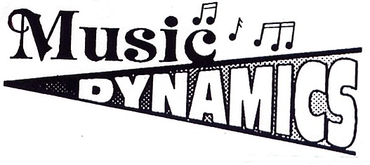
MrsSwen’s Piano Studio
Laura Swenson, NCTM
S43 W32669 Kettlefield Ct.

Waukesha, WI 53189 262-385-

www.mrsswenspianostudio.com email: mrsswen2@yahoo.com

2026-27 SESSION:
SEPT. 1st THRU MAY 20th

Piano Lessons

33 WEEKLY LESSONS ARE SCHEDULED FOR THE 2026-27 SCHOOL YEAR.
Lesson fees are payable in half or full semester increments.
Lesson fees are prorated for students who begin during the school year.
30-min. private lessons: $330 per semester
45-min. private lessons: $495 per semester
60-min. private lessons: $660 per semester

CALENDAR

- The regular academic year begins in September and ends in May.
- The studio is regularly closed for Thanksgiving, Christmas and Easter Vacations

STUDIO OPPORTUNITIES

- Recitals throughout the year
- WMTA District Auditions in the Spring
Sponsored by the Wisconsin Music Teachers Association affiliated with the Music
Teachers National Association
- WSMA Solo and Ensemble Contest
Sponsored by the Wisconsin School Music Association

