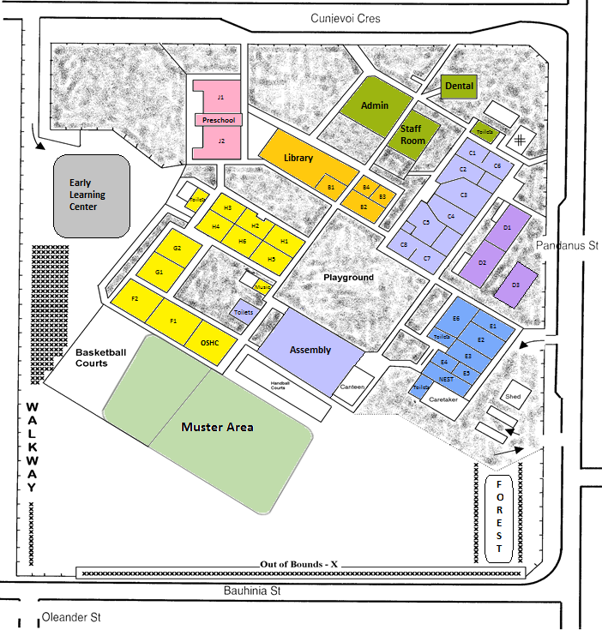

F3

E9

E8

**Bike Rack**

**Bike Rack**

**EMERGENCY EVACUATION DIAGRAM**

**Teacher Classroom Location**

B1 Conference Room E1 6 Mackie G1 2 Wilkinson   
B2 Computer Lab E2 6 Hauser H1 Tr Cotis

C1 4 E Kokkinomagoulos E3 5/6 N K H2 Tr M Politis

C2 - E4 Intervention H3 Tr Kaur

C3 4 S Politis E5 Angelique Kirwin H4 1 Bryson

C4 3 Chan E6 Art - Fanning H5 1 Witte

C5 3 Hardie E7 Nest J1 Preschool – Wall

C6 4 Fladrich E8 5 Fereday J2 Preschool – Park

C7 3 Abbott E9 5 Thompson

C8 - F1 2 Elliott-Hall B1 Conference room - Indonesian

D1 Sarah Ruane D & T F2 2 Bubb

D2 Harnie Johnson D & T F3 OSHC

D3 Nemarluk G2 1 Fraser

****Term 3 2025 Staff**

|  |  |  |  |
| --- | --- | --- | --- |
| **Staff Name** | **Position/Class** | **Staff Name** | **Position/Class** |
| Mrs Ranae Graham | Principal | Ms Lisa Whistler | Business Manager |
| Ms Sarah Behan | Assistant Principal | Mr Jacob Bailey | Administration Officer/ITC |
| Mr Jason Motbey | Assistant Principal | Mrs Donna McIntyre | Administration Officer |
| Ms Megan Norrington | Assistant Principal | Ms Anastasia Nicolakis | Administration Officer |
| **PRIMARY YEARS 3 - 6** |  | **Specialist Teachers** |  |
| Mr Greg Hauser | 6 Hauser | Ms Angelique Kirwin | Special Education – ST1 |
| Mr Nick Kokkinomagoulos | 5/6 N Kokkinomagoulos | Mrs Shirley Neve | Play Therapist (Friday) |
| Miss Alison Mackie | 6 Mackie | Mrs Wendy Fanning | The Arts |
| Ms Kiah Fereday | 5 Fereday | Mrs Harnie Johnson | Technologies |
| Ms Melissa Thompson | 5 Thompson | Ibu Heriati Rafiqi | Language - Indonesian |
| Mr Joel Fladrich | 4 Fladrich | Ms Sarah Ruane | Technologies/Preschool |
| Miss Eleni Kokkinomagoulos | 4 E Kokkinomagoulos | Ms Xanthe Fowler | Library / ERT |
| Ms Sophia Politis | 4 Politis | Mrs Wendy Fanning | The Arts |
| Miss Selina Chan | 3 Chan |  | Physical Education |
| Ms Natasha Hardie | 3 Hardie |  |  |
| Ms Theresa Abbott | 3 Abbott |  |  |
| **EARLY YEARS PRE – Yr. 2** |  | **Support Staff** |  |
| Ms Clare Bubb | 2 Bubb | Mr Tirso De Sagon | Maintenance Officer |
| Ms Giulia Elliott-Hall | 2 Elliott | Mrs Lee-Anne Puddey | Student Support Officer |
| Mrs Deb Wilkinson | 2 Wilkinson |  |  |
| Mrs Kellie Bryson | 1 Bryson | Mrs Lisa Coates | AO & Preschool |
| Mrs Alexandra Fraser | 1 Fraser | Ms Premita Prasad | AO & Preschool |
| Ms Debra Witte | 1 Witte | Ms Sarah Eaton | Classroom Support |
| Mrs Maria Cotis | T Cotis | Ms Rizvana Begum | Classroom Support |
| Mrs Megan Politis | T Politis |  |  |
| Ms Harpreet Kaur | T Kaur |  |  |
| Ms Corinne Britton | Preschool |  |  |
| Mrs Melissa Park | Preschool |  |  |
| Ms. Clare Visentin | Thursday 5/6 K  Friday 2 Wilkinson |  |  |