  - Nightcliff Primary School

As of November 2025
A school that has reached 85% operating capacity must develop an Enrolment Management Plan as outlined in the Department of Education’s (the department) Enrolment management and priority enrolment guidelines. The school has 10 business days to submit its Enrolment Management Plan to the Director School Operations for endorsement. Enrolment Management Plans are to be submitted to the Senior Director School Operations for approval. Independent public school plans are approved by the Chief Executive, or delegate. Approved plans are to be published on the school’s website.
Nightcliff Primary School recognises its obligation to ensure students living within the priority enrolment area have access to educational services and facilities at this school. Current enrolments are at a level requiring the school to place restrictions on out-of-priority enrolment area enrolments to ensure that it meets its educational obligations to local students.
This Enrolment Management Plan is aligned with the Enrolment management and priority enrolment guidelines and outlines the measures that are currently in force at Nightcliff Primary School.

Operational capacity
- The maximum operational capacity of the school is 618 students (T-6).
- The current number of enrolments at the school is 476 students (T-6).
- This equates to 77% operational capacity.

Current statistics
Current student numbers by year level are:
Primary School | Year level | Students from inside PEA | Students from outside PEA | Total students | No. of classrooms
Primary School | Transition | 58 | 12 | 70 | 3
Primary School | 1 | 49 | 18 | 67 | 3
Primary School | 2 | 51 | 16 | 67 | 3
Primary School | 3 | 54 | 19 | 73 | 3
Primary School | 4 | 55 | 18 | 73 | 3
Primary School | 5 | 45 | 25 | 70 | 3
Primary School | 6 | 42 | 14 | 56 | 2
Primary School | Total | 354 | 122 | 476 | 20
Note: Figures provided are taken at a point in time and may fluctuate on a daily basis.

Specialised programs
Program name | Details
Nemarluk School Satellite Room | The school has one room allocated to Nemarluk school. 10 students enrolled.

Priority enrolment area
The priority enrolment area is outlined in the map at Figure 1. The number of students currently enrolled who reside outside the priority enrolment area (PEA) is 122 students.
Figure 1 – Priority enrolment area map
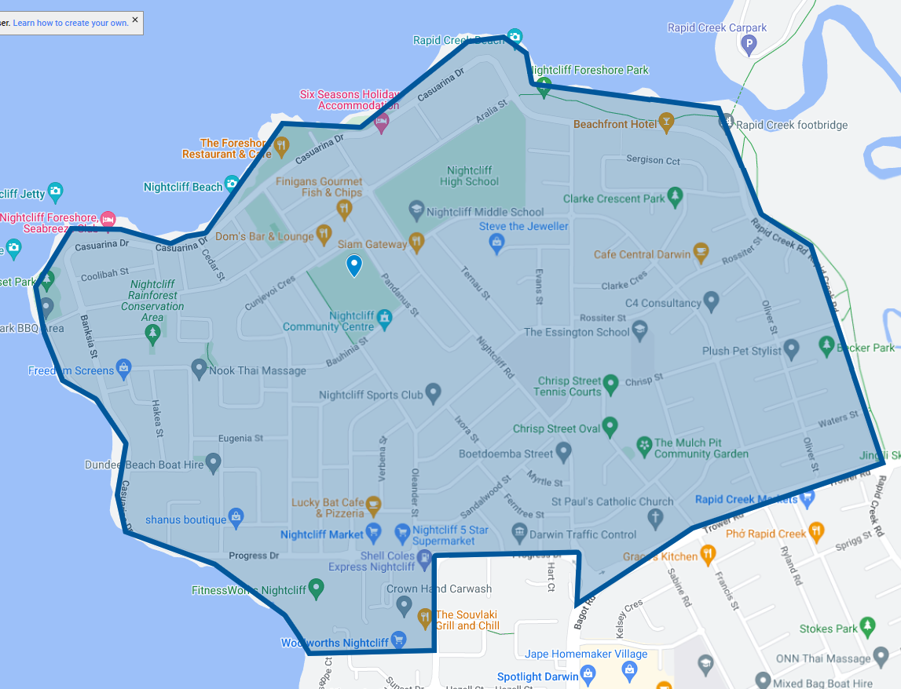

Assessment criteria
Enrolment applications for a student who resides within the priority enrolment area will be accepted. Parents who wish to enrol a child in the school must demonstrate that the student’s primary place of residence is within the priority enrolment area.
All enrolment applications for students who reside outside the priority enrolment area will be assessed using the following criteria:
- siblings of current students at the school
- children of current school staff
- exceptional circumstances evaluated on a case-by-case basis.

Priority enrolment area enrolment contingency
A 90% contingency is reserved for students within the priority enrolment area. Once the operational capacity has reached 10%, all applications for enrolment from students residing outside the priority enrolment area will be declined.

Enrolment management strategies
The following enrolment management strategies will apply while this Enrolment Management Plan is in force:
- Strict adherence to the priority enrolment area assessment criteria for acceptance of future enrolments.
- Advise families, in writing, that acceptance of a student into a preschool outside the priority enrolment area does not guarantee acceptance of that student into the school for transition and beyond.
- Increasing capacity through maximising the use of available infrastructure.
Additional strategies being undertaken by the school include:
- Working with staff to review and adjust year levels e.g. formation of a composite class
- Provision of additional educator support in the event a classroom exceeds 27 students

Date to be published
The Enrolment Management Plan for Nightcliff Primary School will be published on the Nightcliff Primary school’s website in January.

Review
This Enrolment Management Plan will remain in force until enrolments fall to 75% or below of operational capacity. The plan is to be reviewed annually or more frequently if required to reflect a significant change in enrolments or the operational capacity of the school.

Approval – NT Government schools only
Principal – Plan prepared
Principal name | Ranae Graham
Principal signature |  | Date | 13/01/2026
Senior Director Education – Plan approved
Senior Director name | Warren Giles
Senior Director signature |  | Date | 14/1/26

