

Kia ora

The team at Hillmed Health are pleased to be able to offer our patients a modern and easy way to connect to us, using the Well patient portal!

Well has been developed after listening to patients and general practices about what they really need in a patient portal. It’s healthcare that’s centred around you.

Register today to access your health information, book appointments, request repeat prescriptions, and more!

- Download ‘Well NZ’ on the App Store or Google Play*
- Select ‘Create Account’ and enter the invite code: HMHCNZ
- Enter your details – these must match what we hold on file
While Well is best experienced on the app, it can also be accessed on your computer.
Once registered, you can use the same account to access the Well app and the online portal.
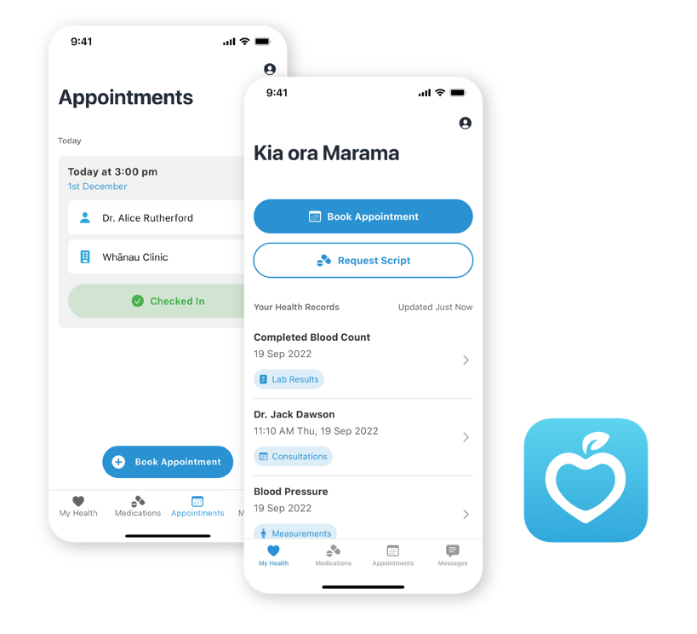

Well makes looking after your health simple:
- Easy to download and register
- Book and manage appointments
- Request repeat prescriptions

- View lab results
- Access your health information
- Receive notifications and reminders on the app
- Passcode, touch/facial recognition – no more forgetting your username and password!
- Available on both Android and iOS, as well as online

We look forward to connecting with you on the Well patient portal!

For further information about Well, visit well.co.nz

If you require any assistance with the Well patient portal, please contact us at Hillmed Health or visit the Well FAQs here.

*Only download apps from the official Apple and Google Play stores

