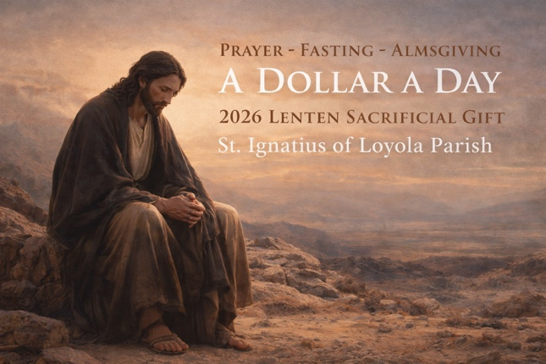

A Dollar a Day

2026 Lenten Sacrificial Gift for St. Ignatius of Loyola Parish

Dear Brothers and Sisters in Christ,
As we approach the holy season of Lent and prepare our hearts to celebrate the Resurrection of our Lord Jesus Christ, I invite you to enter this sacred time with renewed intentionality, generosity, and trust in God’s providence.
On Ash Wednesday, the Church leads us once again into the desert with Christ—a place not of abandonment, but of purification and renewal. For forty days, we are invited to turn away from whatever distracts us from loving God above all things and from loving one another as Christ loves us. Through prayer, fasting, and almsgiving, Lent becomes a season in which our hearts are reordered and our lives realigned with the Gospel.
As part of this Lenten journey, I invite you to participate in A Dollar a Day – 2026 Lenten Sacrificial Gift for St. Ignatius of Loyola Parish.
The season of Lent consists of forty days. Each day, I encourage you to set aside one dollar and place it into the attached envelope as a simple yet meaningful act of gratitude and sacrifice. By the end of Lent, you will have set aside $40.00 as a tangible offering in thanksgiving for the many blessings God has bestowed upon you through our parish community.
Just imagine the collective impact of this shared sacrifice. If 100 parishioners participate, the total gift would be $4,000. If 500 participate, the total would be $20,000. United together, even small daily acts become a powerful witness of faith, generosity, and stewardship.
If you choose to participate, I invite you to place your completed envelope and sacrificial gift in the collection basket when you attend Mass on Holy Thursday or Easter Sunday, together with your Easter donation.
Like many parishes today, St. Ignatius of Loyola Parish continues to face real and ongoing financial challenges. Your participation in this Lenten Sacrificial Gift will directly support the life, mission, and ministries of our parish. Please know that your generosity—whether large or small—is deeply appreciated and never taken for granted.
Be assured of my prayers for you and your family throughout this Lenten season. May the Lord, who sees every hidden sacrifice, bless you abundantly and draw you ever closer to Himself.
With gratitude and pastoral care,
Fr. Francis M.V. Aguilar
Administrator
St. Ignatius of Loyola Parish & School

Please return the following information with your gift to receive credit for your donation:
Name: _______________________________ Gift Amount: ___________________
Address: _____________________________ Envelope #: ___________________

