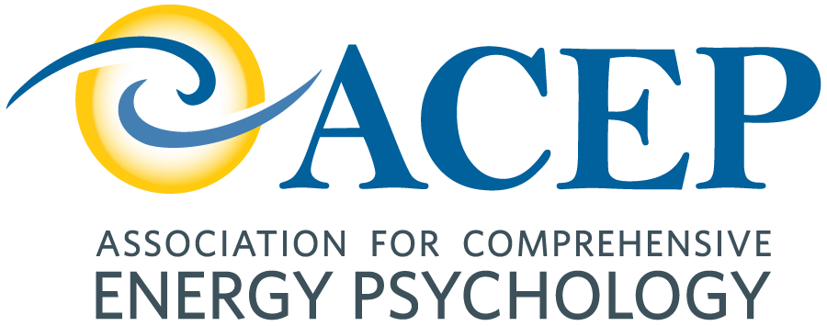

2027 Energy Psychology Research Symposium

CALL FOR PRESENTATIONS
The Association for Comprehensive Energy Psychology will be hosting its 16th Annual Research Symposium next year. We are accepting research studies and papers in the fields of energy psychology and energy medicine to be presented at our international conference; date and location TBA.
We are seeking original empirical research, randomized controlled studies, case studies and theoretical papers. New researchers, professors and graduate students are especially encouraged to present.
Submission Deadline: November 20, 2026.

Submission Details

Please submit your proposal, via email, in THREE attachments:
- Name and credentials (MA, MSW, PhD); Contact information; Brief bio (approx.125 words); and a CV for each researcher.
- Title, Abstract, Introduction, Objectives, Methods, Results (or Expected Results, if not yet completed), and Discussion.
- Supporting documents: Tables, graphs, charts, spreadsheets.
Research studies or papers will be presented via PowerPoint. Presentations will be 28 minutes: 22 minutes for presentation, and 6 minutes for live Q & A.
All proposals should follow CONSORT guidelines (for RCTs) and CARE guidelines (for case studies), insofar as applicable.

See: http://www.equator-network.org/reporting-guidelines/consort/
See http://www.care-statement.org/resources/checklist
Proposals will be evaluated by our Symposium Review Committee. Notification of acceptance or rejection will be made by January 15, 2027.
Please send your submission by November 20,2026 to: John Freedom, freejjii@gmail.com

