KEITH HANLEY
📍 Galway, Ireland ✉️ khanley378@gmail.com 📞 086 275 7599
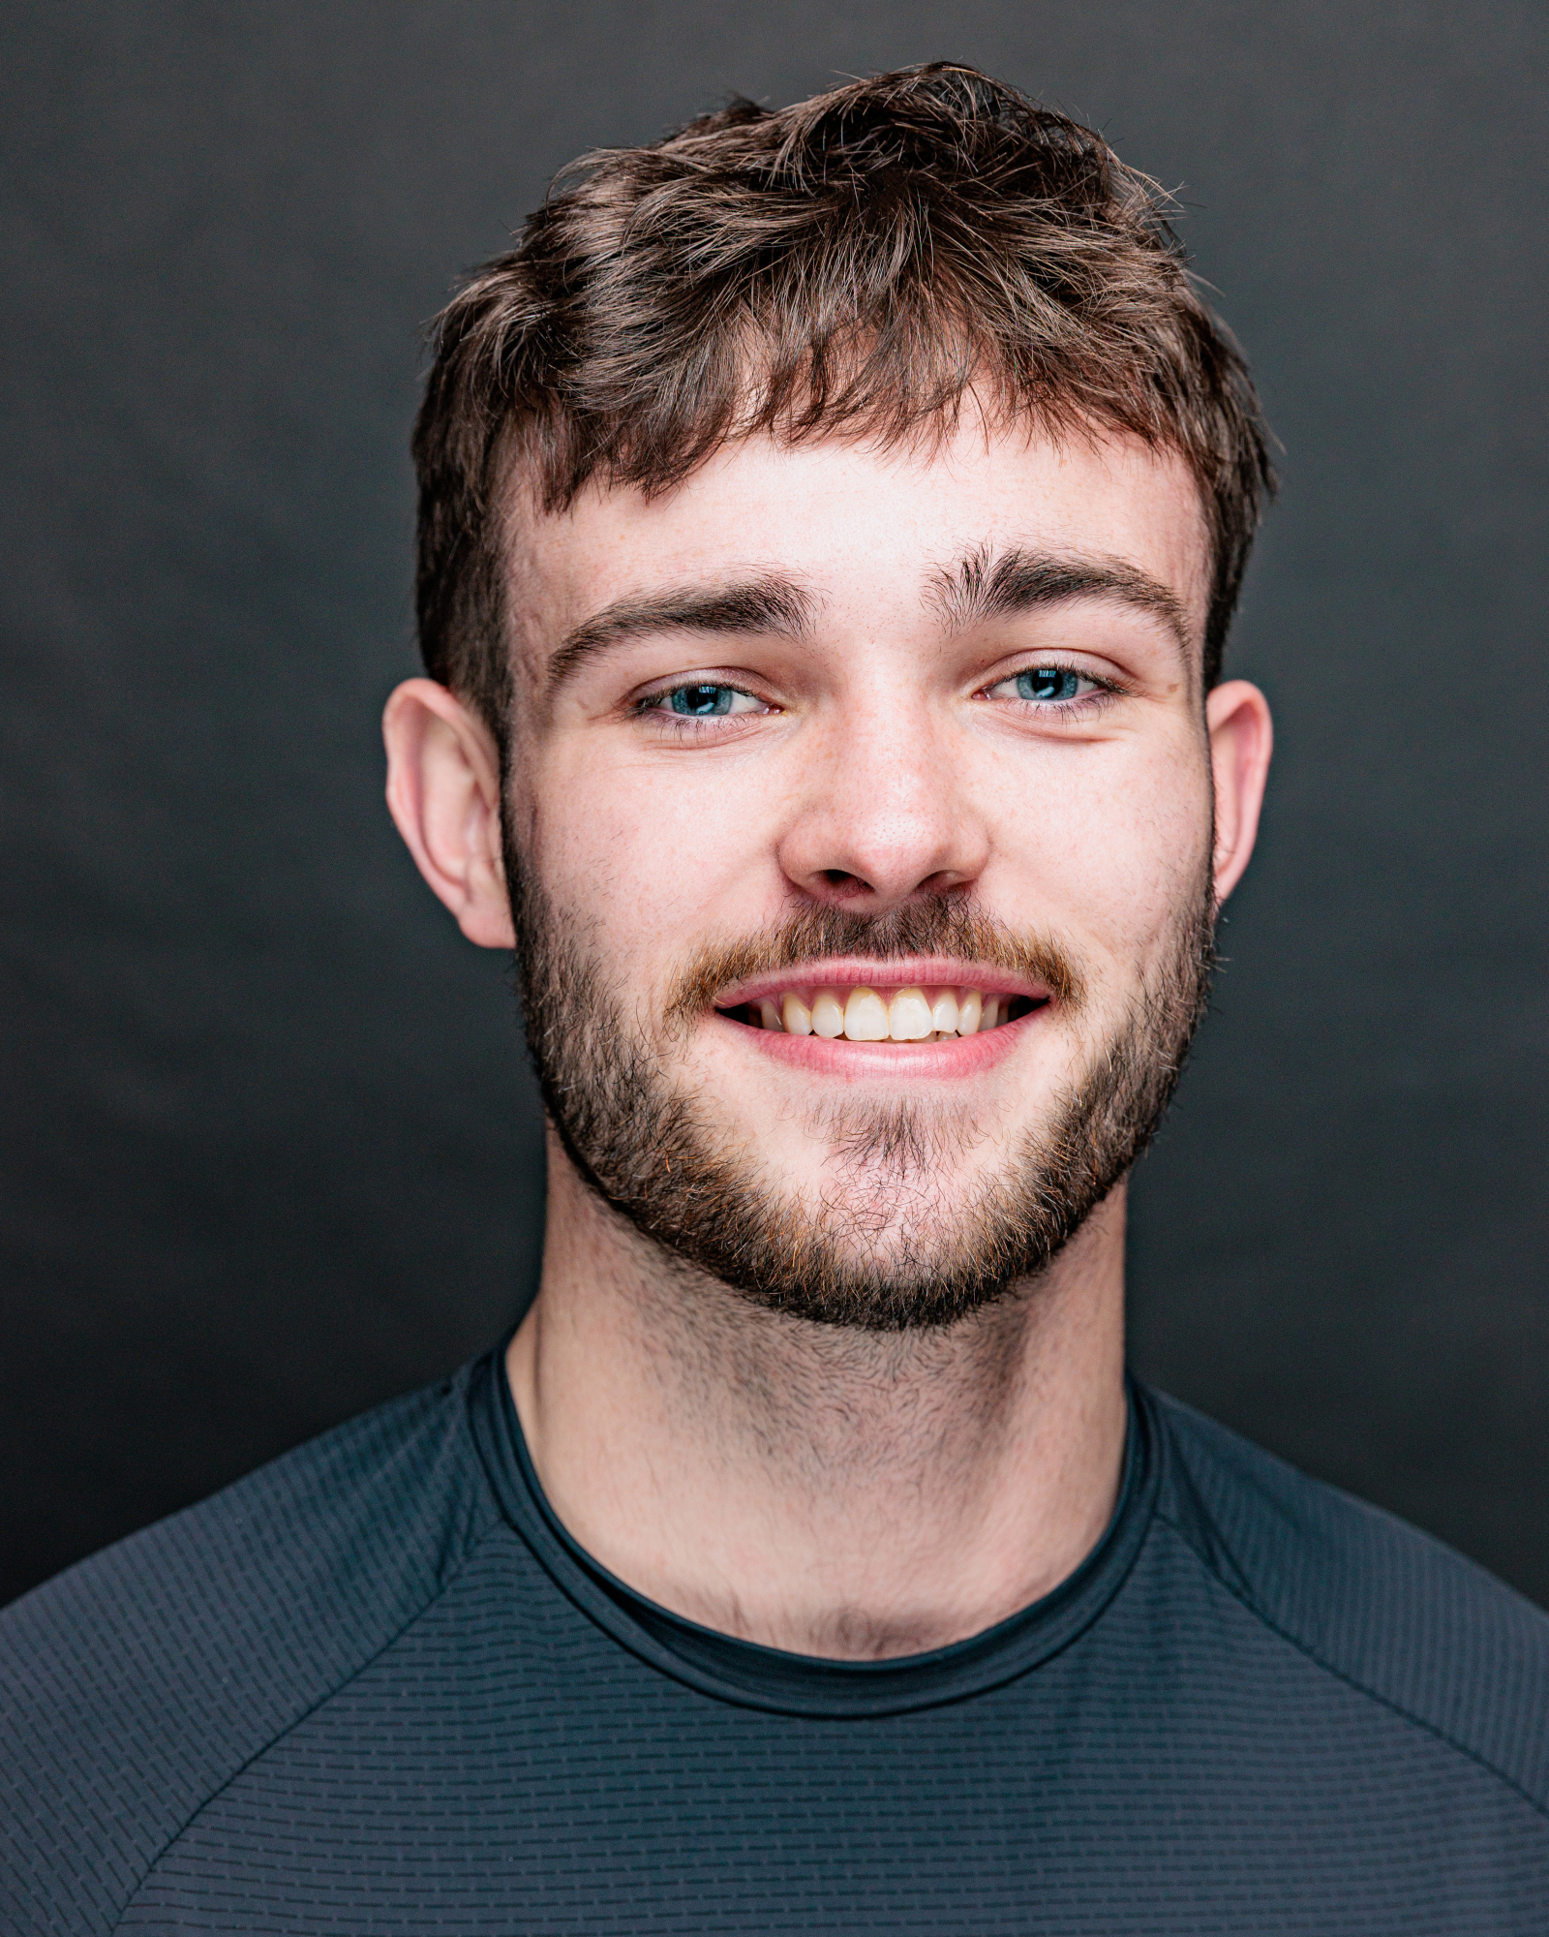 | 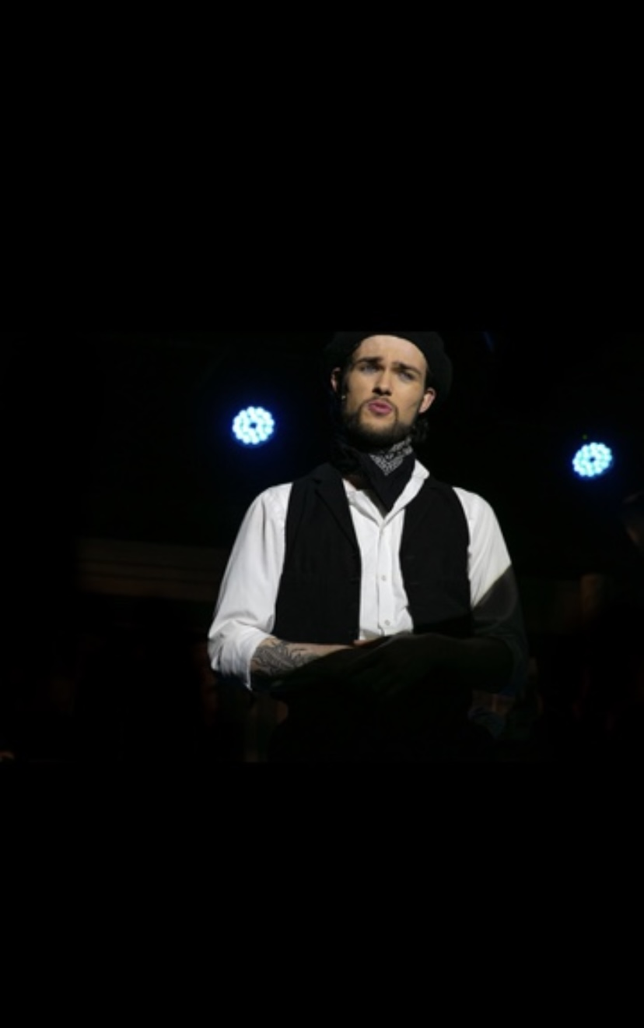 | 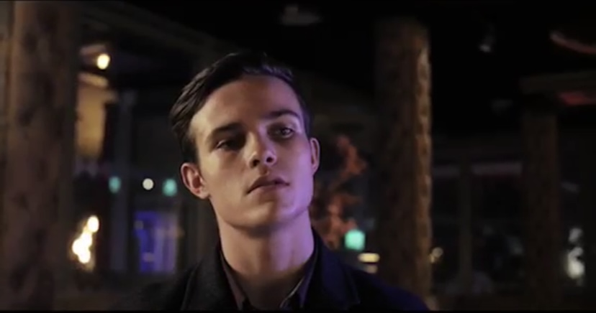

Physical Details
Height: 5'11"
Playing Age: 18–30
Hair: Brown Eyes: Blue
Ethnicity: White Vocal Type: Tenor

Film Credits
Year | Production | Role | Director
2025 | The Chain | Jimmy “The Wolf” | Colum Richardson
2023 | Corridors | Protagonist | Conor Durcan
2023 | Nostalgia | Keith | Hugh Leigh
2021 | The Three Deaths of Eddie | Billy the Kid | Graham Feely

Theatre Credits
Year | Production | Role | Venue / Director
2025 | For the Lack of Laura (UK Tour) | Salvador | Directed by Luke Morgan
2025 | Sweeney Todd | Anthony Hope | Town Hall Theatre, Galway – Paul Norton
2024 | For the Lack of Laura (World Premiere) | Salvador | Town Hall Theatre, Galway – Luke Morgan
2024 | Oliver! | Bill Sykes | Town Hall Theatre, Galway – Paul Norton
2024 | West Side Story | Riff | Temperance Hall – Aoife McClafferty
2023 | Rent | Roger | Town Hall Theatre, Galway – Paul Norton
2023 | Calendar Girls | Tommo | Town Hall Theatre – Pat McElwain
2023 | Evita | Che | St. Jarlath’s College – Ronan Lardner

Training
- Power Performance Academy (2016–2020)
- Galway Community College – Acting & Theatre Studies (2022–2023)
- Galway Voice Studio (2017–2020)

Awards
AIMS Nomination – Best Actor
Che in Evita, Gilbert Section (2024)

Skills
Languages:
English (Fluent), Irish
Accents / Dialects:
Native: Galway / West Ireland
High Standard: North Dublin, Belfast, American (California, New York, Southern), Spanish, RP, Cockney, Scouse, Yorkshire
Sport:
Hurling, Gaelic Football, Rugby, Kickboxing (Brown Belt), Skateboarding, Weightlifting
Dance:
Hip-Hop, Jazz, Contemporary, Musical Theatre, Ballet
Performance:
Hosting, Presenting
Singing:
Musical Theatre, Rock, Pop

