Welcome to
CrossRoads Community Church
A Free Methodist Congregation

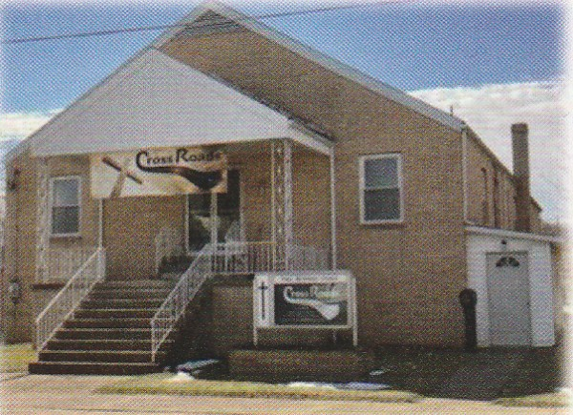
272 South Stewart St.
Blairsville, PA 15717
Ph: (724) 459 – 8181
Email: Crossroadsblairsvillec@gmail.com

New to Crossroads?

You might be wondering what’s is really like at CrossRoads! Simply stated, at CrossRoads, we’re all about Jesus. You won’t be met with shame, guilt or condemnation. And we don’t care how you’re dressed or what candidate you voted for. Our church is made up of imperfect people with every kind of story imaginable.
Want to know the best party? No matter what you’ve been through or what questions you might have about God and faith, our church is a place where you’ll find the love, grace and forgiveness Jesus gives to everyone.
Sunday service times:

Adult Bible study – 9:30 AM

Worship service – 11:00 AM

(Children are dismissed after the opening worship for children’s church)

Thursday Services

Men’s Bible Study: 9:00 AM
Women’s Fellowship & Bible study 11:30 AM

