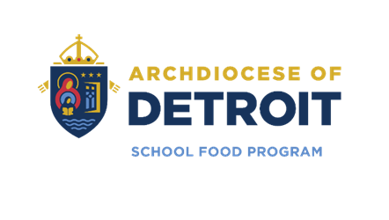

AOD School Food Program Payment Info (2025–2026 SY)

📌 General Info
- Prepayment required to participate in the meal program.
- Payments can be made online or in person (cash/check).
- Checks must be payable to: "AOD School Food Program".
- Any remaining balance carries over or can be transferred to another AOD School Food Program School.
- Negative balances must be paid for in advance.

💻 Option 1: Online Payments via Meal Magic
- Website: https://archdiocesedetroit.familyportal.cloud
- Payment Methods: Visa, MasterCard, Discover, e-funds, debit cards.
- Fee: $3.00 per deposit.
- Free to check balances or view history.
- Student ID format: School ID + ICC (e.g., 12345ICC)
- Transfers allowed between siblings (online payments only).
- Setting up an Online Meal Magic Account:
- Visit the website Online: https://archdiocesedetroit.familyportal.cloud
- Select “My Account.” Enter Email Address (Username)
- New users: Click “I need to register as a Family Portal User.”
- Follow prompts to set up a passphrase (password).
- Add student(s) using their ID Number with “ICC” suffix.
- You may receive a “Waiting for Approval Response.”
Approval may take ~15 minutes (during business hours), please call the AOD School Food Program Office if you are waiting longer than 15 min. or if you have any questions at (313) 883-8742.

💵 Option 2: Cash/Check at School
- No fee for cash/check payments at the school.
- Use an envelope labeled with:
• Student’s Name & ID #
• Teacher’s Name
• Dollar Amount
• Check Number
- Give it to: Cafeteria cashier or school office.

📝 Free & Reduced Meal Application
- Available after July 1, 2025:
• Online: https://archdiocesedetroit.familyportal.cloud (Preferred)
• Paper forms: Available at school upon request.

